SPECIES DATA SHEET
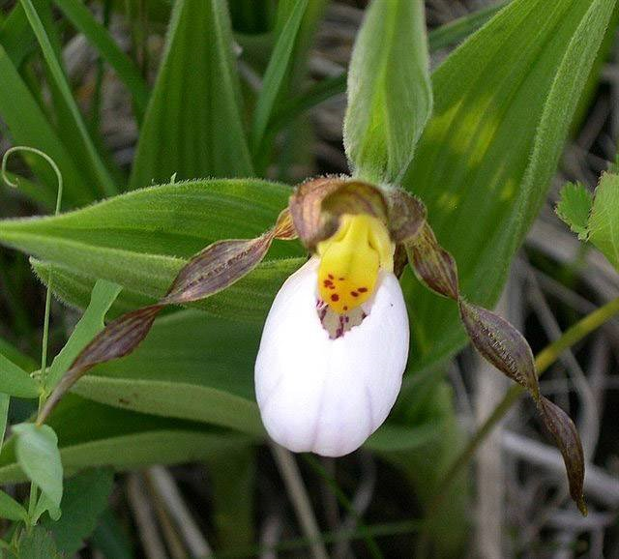
Cypripedium candidum Muhl ex Willd. 1805
Pronounced KAN-did-um
Abbreviation: Cyp.
Common Name Small White Lady's Slipper
Flower Size 3 1/2" [8.75 cm]

Distribution:
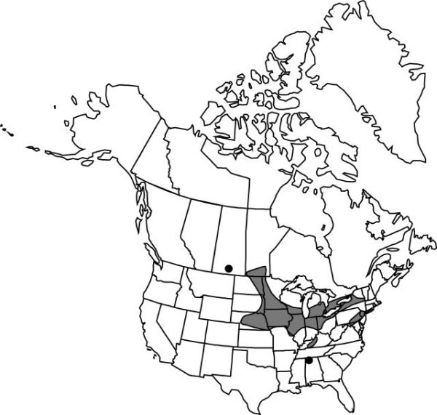
Cypripedium candidum is found from western New York, across southern Ontario to North Dakota, and south to New Jersey, Kentucky and Missouri. There are isolated populations of Cypripedium candidum in Connecticut, Maryland, Manitoba, Virginia, Alabama, and (formerly) Saskatchewan. It is found in wet prairies and fens, in rich, highly calcareous soils, sedge meadow edges, and calcareous ditches.

Description:
Cypripedium candidum grows to a height of 20 to 36 cm (7.9 to 14.2 in) and is one of the smallest species of North American Cypripedium. It blooms from early May to June on a short, terminal, solitary to rarely 2 flowered inflorescence that is subtended by a leaf-like floral bract and carries slightly fragrant flowers. Its white pouch-like lip, sometimes dotted with maroon on the inside, is accented by tan, green or brown lateral sepals and petals, often spotted with red or purple, which twist away in spirals. It has been known to hybridize with the small yellow ladyslipper, C. parviflorum var. makasin, resulting in the natural hybrid Cypripedium × andrewsii. The leaves and stems are slightly pubescent. The plants grow in (generally) long-lived clumps, with some clumps having up to 50 or more flowers. It is a perennial, with horizontal, wiry-rooted rhizomes growing a few centimeters below the surface of the soil, and hence resistant to most prairie fires.
Leaves:
2 to 4 leaves on the upper part of the stem are broad to lance-elliptical, each 2 to 6 inches long, covered with short hairs and parallel veins, are alternately attached and sheath the stem. A few scale-like leaves sheath the lower part of the stem. Dense clumps of up to 50 stems emerge from a single root.

Barbara McNamee Page 1 of 2 2/9/2019

Flowers:
Single to rarely two flowers on slender stem (peduncle), The inflated lower petal (the slipper) is ¾ to 1 inch long, glossy white, sometimes faint purple speckling lining pouch opening and/or faint veination on lower pouch. Bright yellow flower column, often splashed with red, broadens into a flat oval lip, appressed tightly into pouch opening. Lateral petals are narrow, to 1½ inches long, greenish brown and twisted. Sepals are similar in color; lateral sepals are fused behind the lip; upper sepal is broader and erect above the lip. The single leaf-like floral bract is up to 4¼ inches long.
Synonyms:
Calceolus candidus Nieuwl. 1913

AOS Awards: 2CBR Cyp. candidum ‘Elton Roberts’ 8 flowers on 10 inflorescences, 2001HCC Cyp candidum. ‘Mt. Cuba’ 3 flowers on 3 inflorescences, 2013

Hybrids: Total of 16 registered, to the 2nd generation
Of the 16 total progeny, only three have offspring of their own, one each. Very little has been done in hybridizing these small flowers.

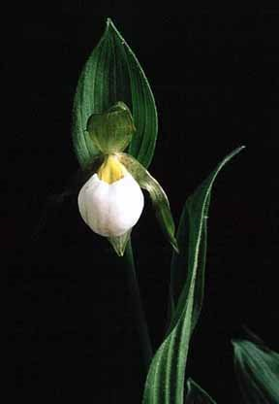

Cypripedium candidum ‘Elton Roberts’ CBR/AOS
References:
OrchidWiz Database X5.1
Orchidspecies.com
Wikipedia
Minnesota Wildflowers Info.
Barbara McNamee Page 2 of 2 2/9/2019

