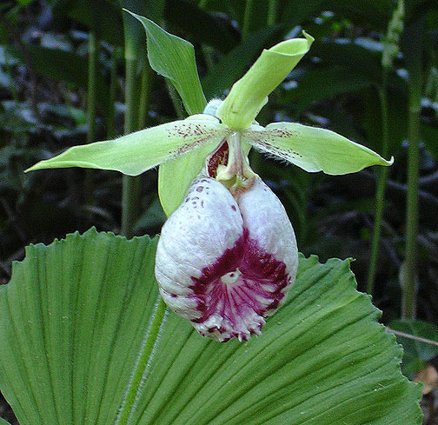
SPECIES DATA SHEET
Cypripedium japonicum Thunb. 1784
Pronounced: juh-PON-ih-kum
Abbreviation: Cyp.
Common Name The Japan Cypripedium - In Japan - Kumagae-So - In China Shan Mai Shao Lan
Flower Size 3.6" to 4" [9 to 10 cm]
Found in Japan, Taiwan and China in humus rich soils in forests and on shady slopes along ravines in bamboo at elevations of 1000 to 2000 meters as a small to medium sized, cold growing terrestrial with an erect 4 to 6" [10 to 15 cm] long inflorescence carrying 2, opposite, orbicular, plicate, serrulate margined leaves that flowers in the spring on an erect, terminal, densely villose, 3" [7.5 cm] long, single flowered inflorescence with a leafy, rhombic-ovate bract. It is deciduous.
This species in particular has been difficult to grow from seed, so virtually all plants being grown are either wild collected or divisions of wild plants. Germination in vitro has been spotty at best, with green pods giving the best yields. Like C. formosanum, it is a temperate species, but can endure hot summer conditions and thrive.
The plant itself is very similar to C. formosanum, but is larger in all respects. Large specimens are often half again the size of its southern neighbor, some standing up to nearly 50 cm high. The stem too is thicker and more pubescent. Similarly, the length of internodes on the rhizome is greater, with as much as 20 cm between growths. The flower is similar size, but different in color and form. The lip has an overall pink base color, but usually not as pastel pink as C. formosanum, and is suffused with purple-red striations and blotches particularly around the lip orifice which is front facing (as in C. formosanum). Chinese specimens tend to have more purple-red color than Japanese plants.
The lip shape is a bit more elongate and has prominent “horns” around its orifice. The sepals and petals have a pleasant light apple green color with a few purple speckles at their bases as well as light green hairs. Alba forms do exist and are exquisite as well as expensive. A flowering size division will set you back $700-$1000 per even here in Japan. The plant being more robust than C. formosanum, can form even larger colonies with thousands of flowering stems represented at just one site.
Synonyms:
Cypripedium cathayenum S.S.Chien 1930
Cypripedium japonicum var. glabrum M.Suzuki 1980
Awards:
1 CHM – Cyp. japonicum ‘Justin’, 1 flower, 7.8cm in 1994
Barbara McNamee Page 1 of 2 2/9/19

Hybrids: total of 2 registered, one generation
No awards or offspring, the latest hybridizing was done in 2010 and the second in 2015.
Other Information: It is on the ‘red’ endangered list

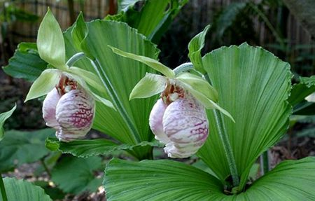

References:
OrchidWiz Database X5.1
Orchidspecies.com
Nature.com/articles/s41598-018-24912-z
Phytesia-orchids.com/en/crypripedium-japonoicum-60316136157.html
Botanyboy.org/two-sister-cypripediums-from-asia-c-japonicum-and-c-formosanum/

Barbara McNamee Page 2 of 2 2/9/19

