Cypripedium kentuckiense C.F.Reed, Phytologia 48: 426 (1981).
The Kentucky Cypripedium
SECTION Cypripedium SUBSECTION Cypripedium
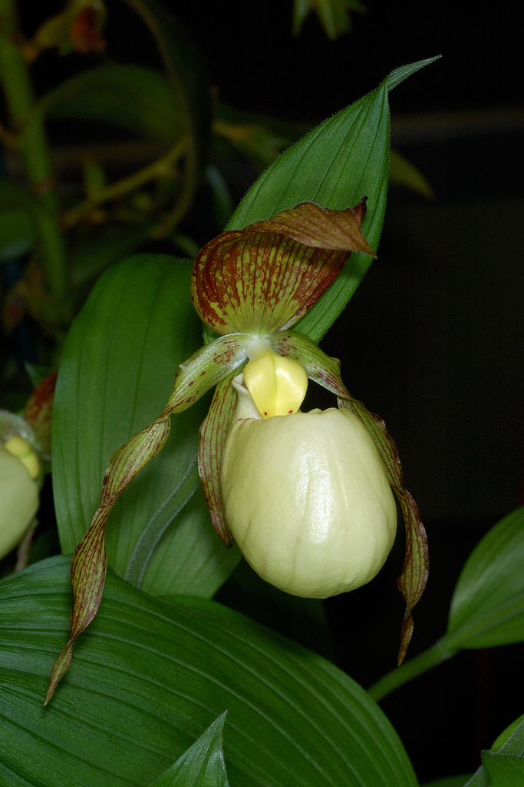
Synonyms
Cypripedium daultonii V.G.Soukup 1977; Cypripedium kentuckiense f. pricei P.M.Br. 1998; Cypripedium kentuckiense f. summersii P.M.Br. 2002 ³
Description
This large sized, cold growing terrestrial species is found in the United States and Canada with broad-ovate, twisted leaves with a narrow apex that blooms in the late spring on an erect, terminal, solitary flowered inflorescence.³ The Kentucky lady's slipper occurs across the southern US from Virginia to Texas in widely separated populations. Cypripedium kentuckiense is a large, showy orchid with stems up to about 28 in. in

length. The stems have about 5 leaves and bear a single flower when mature. The pouch of the large flower is creamy to pale yellow with greenish purple-mottled petals.⁵ C. kentuckiense has the largest flower of in the genus Cypripedium. The petals and sepals are greenish striped and mottled with purple while the very large lip, or pouch, is a creamy ivory or pale yellow. The plant can be up to 70 cm tall and has bract leaf-like leaves that are up to 12 cm long. Each plant is usually single-flowered.⁶ Cypripedium kentuckiense, commonly called southern lady's slipper or Kentucky lady's slipper, is a clump-forming terrestrial orchid with a thick creeping rhizome and hairy stem. It typically grows to 18-30” tall and produces the largest flowers of any known lady’s slipper. Each plant typically grows to 18-30" tall on a single pubescent stem clad with 2-9 (on average 5) pleated, parallel-veined, broad-ovate to ovate-lanceolate, leaves (each to 7" long) which are evenly arranged along the stem. Each leaf is sheathed to the stem at the leaf base. The stem is topped by a single flower which blooms in spring (late April-June). Each flower (to 5” across) features a large, showy, cream to pale yellow pouch (inflated lower petal known as the lip) which is the size of a chicken egg, with two downward twisting, lateral, mottled greenish-purple petals (to 4" long and 1/4" wide) and three wavy-edged sepals which are a contrasting and showy purplish-brown. Fruit is an ellipsoid capsule (to 2" long) with minute but abundant seeds which matures in fall.⁷
Habitat
Cypripedium kentuckiense grows in southern hardwood forests on damp, low-lying areas near springs and in flood plains in acidic, sandy, and well-drained soils.⁵ It is most often found in deep ravines on acidic and sandstone soils.⁶ It is rarely found in the wild, and currently carries the Center for Plant Conservation Global Rank of “G3 Vulnerable” meaning that it is at moderate risk of extinction due to restricted range, few remaining populations (often 80 or fewer), and recent widespread population declines. Fewer than 3,000 plants may still exist in the wild. It is native to damp low woodlands, rich alluvial floodplains, moist woodland slopes, and along streams in widely-scattered areas from Virginia to Kentucky to Alabama and further west to eastern Oklahoma and eastern Texas.⁷
F-1 Hybrids and Progeny
Cypripedium kentuckiense has been crossed with 15 species and four varieties of Cypripedium since 2000. The only two of note are Cypripedium Philipp and Cypripedium Lothar Pinkepank, the former for 3 AOS Awards and the latter for having produced nine offspring. Cyp Phillip is a cross with C. macranthos from the Far East. It retains a very spherical pouch with faint markings. Cym Lothar is a cross with C. parviflorum var pubescens, a yellow species imparting it’s color to the cross.

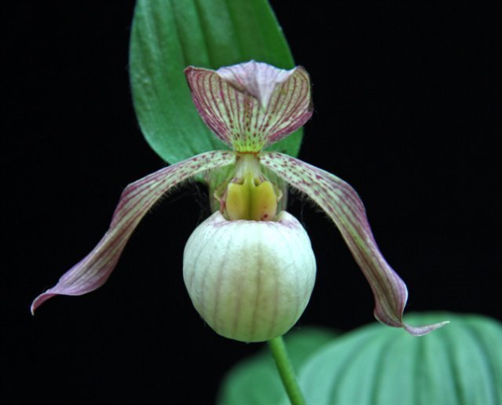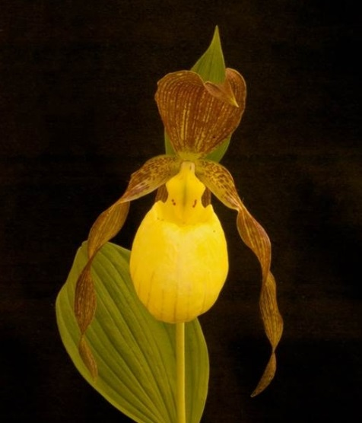
Cypripedium Philipp HCC/AOS Cypripedium Lothar Pinkepank
‘Memoria Madora Gindhart’ HCC/AOS
Awards
Cypripedium kentuckiense has 10 AOS awards. The quality awards include 2 AM, 1 HCC and 2 JC. The cultural awards include 2 CCM and 3 CHM. It’s progeny have received 5 AOS awards, all for flower quality.⁴

Culture
Best grown in rich, well-drained soils in part shade. Likes moist boggy areas. Prefers part shade with 1-2 hours of morning or evening sun in cool summer climates with moderately cold winters. Best performance occurs in USDA Zones 3-7 (Zone 8 if plants are given additional shade). Spreads by creeping rhizomes. May be propagated by seed or division. Never dig plants in the wild, not only because of their rarity but also because they transplant very poorly.⁷
References
Aldridge, Peggy. 2008. An Illustrated Dictionary of Orchid Genera. Selby Botanical Garden Press.
¹la Croix, Isobyl. 2008. The New Encyclopedia of Orchids. Timber Press
²Meisel, Kaufmann, Pupulin 2014. Orchids of Tropical America .Cornel University Press
³ Jay Pfahl's IOSPE at www.orchidspecies.com
⁴OrchidWiz.Database X4.1
⁵ https://www.fs.fed.us/wildflowers/beauty/cypripedium/cypripedium_kentuckiense.shtml

⁶https://en.wikipedia.org/wiki/Cypripedium_kentuckiense
⁷http://www.missouribotanicalgarden.org/PlantFinder/PlantFinderDetails.
http://apps.kew.org/wcsp/qsearch.do
https://secure.aos.org/aqplus/SearchAwards.aspx

