Cypripedium macranthos Sw., Kongl. Vetensk. Acad. Nya Handl. 21: 251 (1800).
The Large Flowered Cypripedium
in Japan - Atsumori-So - In China Da Hua Shao Lan³
SECTION Cypripedium SUBSECTION Macrantha
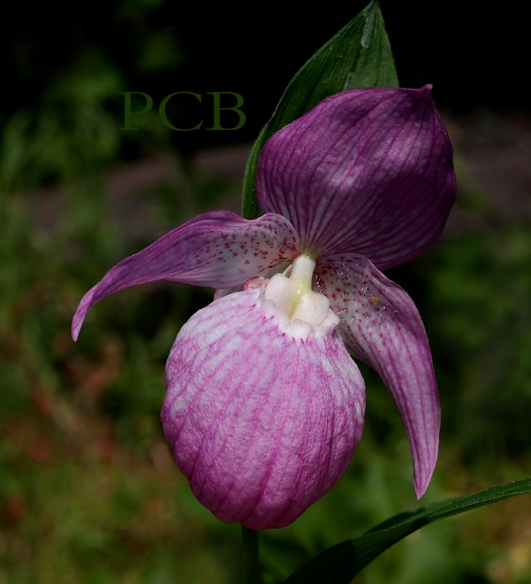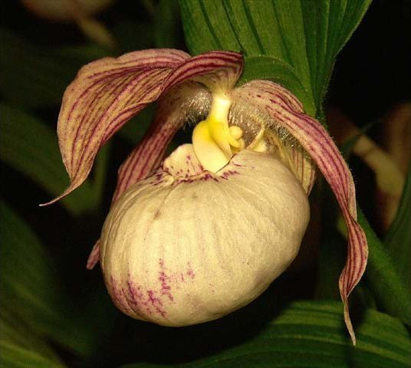
Synonyms
Cypripedium calceolus var. rubrum Georgi 1775; Cypripedium macranthos f. albiflorum (Makino) Ohwi 1965; Cypripedium macranthos f. rebunense (Kudô) Ohwi 1953; Cypripedium macranthos nothof. alboroseum Aver. 1999; Cypripedium macranthos nothof. albostriatum Aver. 1999; Cypripedium macranthos nothof. flavoroseum Aver. 1999; Cypripedium macranthos var. albiflorum Makino 1926 Cypripedium macranthos var. atropurpureum Aver. 1999; Cypripedium macranthos var. flavum Mandl 1924 ; Cypripedium macranthos var. maximum Nakai 1940; Cypripedium macranthos var. speciosum (Rolfe) Koidz. 1926; Cypripedium neoparviflorum Y.N.Lee 2002; Cypripedium speciosum Rolfe 1911; Cypripedium speciosum var. albiflorum Makino 1926; Cypripedium thunbergii Blume 1859; Cypripedium thunbergii f. albiflorum (Makino) Okuyama 1955; Cypripedium ventricosum Sw.; Sacodon macranthon (Sw.) Raf.; Sacodon ventricosum Raf. 1836 ³

Description
A medium sized, cold growing terrestrial with a leaf stem carrying 3 to 6, oblong, alternate, plicate leaves that blooms in the late spring and early summer on a terminal, erect, 1 to 2 flowered inflorescence with large leaf like bracts.³
Plants 25-50 cm tall, with a stout, short rhizome. Stem erect, slightly pubescent or glabrescent, with several sheaths at base and 3 or 4 leaves above. Leaf blade elliptic or elliptic-ovate, 10-15 × 6-8 cm, slightly pubescent or glabrescent on veins on both surfaces, minutely ciliate, apex acuminate or subacute. Inflorescence terminal, 1- or rarely 2- flowered; peduncle pubescent or glabrous; floral bracts foliaceous, elliptic or rarely elliptic-lanceolate, 7-9 × 4-6 cm, both surfaces often puberulent on veins, apex shortly acuminate; pedicel and ovary 3-3.5 cm, glabrous. Flowers large, red or pink, usually with darker stripes, very rarely white. Dorsal sepal broadly ovate-elliptic or ovate-elliptic, 4-5 × 2.5-3 cm, glabrous, apex acuminate; synsepal ovate, 3-4 × 1.5-2 cm, apex shallowly 2-lobed. Petals not twisted, lanceolate, 4.5-6 × 1.5-2.5 cm, villous toward adaxial base, apex acuminate; lip deeply pouched, subglobose or ellipsoid, 4.5-5.5 cm, with a small mouth ca. 1.5 cm in diam., inner bottom hairy. Staminode ovate-oblong, 10-14 × 7-8 mm, abaxially not carinate, base sessile. Capsule narrowly ellipsoid, ca. 4 cm, glabrous.⁸
Range and Habitat
Found in Belarus, eastern Russia, China, Mongolia, Japan, Korea and Taiwan in humus rich and well drained soils in forests and on scrubby slopes at elevations of 500 to 2300 meters.³
China, Japan, Korea, and Russia. Distribution occurs in a rather broad band from European Russia and Asiatic Russia eastward across Siberia to the Kamchatka Peninsula, then southward down the coast of eastern Siberia through Korea and northeastern China as well as the northern Japanese islands. Occurrence of this orchid has been reported from as far south as Taiwan. This orchid usually is found in light shade, growing in meadows, scrub, and forest as well as on slopes and banks from near sea level to about 7850 ft. (2400 m). In China, plants are found in humus-rich, well-drained soil in forests or on shady slopes from 1650-7850 ft. (500-2400 m) in the northeastern provinces of Heilongjiang, Jilin, Liaoning, Nei Mongol, Hebei, Shandong, and Taiwan. -- Source: Charles Baker⁴
Humus-rich soils and well-drained places in forests, forest margins, grassy slopes; 400-2400 m. Hebei, Heilongjiang, Jilin, Liaoning, Nei Mongol, Shandong, Taiwan [Japan, Korea, Russia].⁸

F-1 Hybrids and Progeny
Cypripedium macranthos has been crossed with 23 species of Cypripedium since 1991. It is interesting to note that there have been multiple crosses made with several species, as pollen or seed parent, including C. calceolus, C. fasciolatum, C. franchetii, C parviflorum and C. kentuckiense. In each case a different variety of C. macranthos is used and each gets a unique grex name. Of the F-1 generation, there are 2 stand outs, Sabine and Gisela. Sabine, a cross with C. fasciolatum, has 4 AOS awards including 2 AM and 2 HCC. It has produced 10 offspring with a variety of species and hybrids with 1 offspring and no awards. Gisela, a cross with C. parviflorum, has 2 offspring and has been awarded t times by the AOS. Cyp, Aki is a cross with C. parviflorum var. pubescens. It has 2 AOS HCC and 3 offspring, none of which went anywhere.
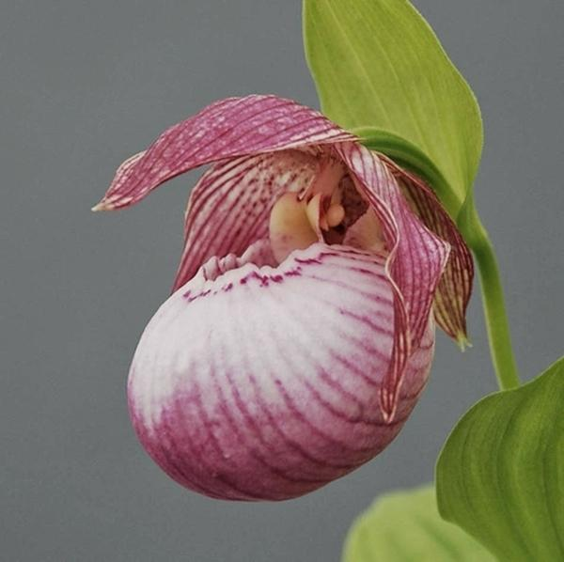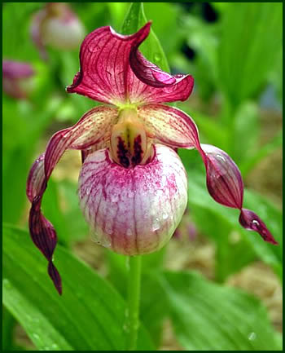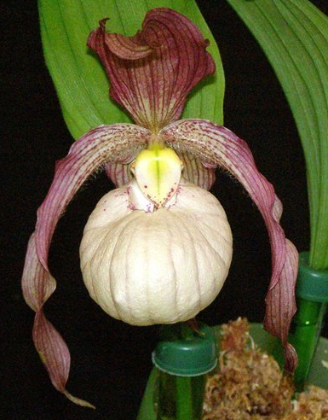
Cypripedium Sabine AM/AOS Cypripedium Gisela AM/AOS Cypripedium Aki HCC/AOS
Awards
Cypripedium macranthos has 4 CHM from the AOS. It’s progeny have garnered 27 awards in, all in the F-1 generation.

Culture

Light:
Cypripedium macranthos needs a light level of 30000-40000 lux. The light should be filtered or scattered, and the plants should never be exposed to the direct sunlight of the midday sun. You need to ensure constant, strong air movement.

Temperature:
The average temperature of the summer day is 21-22 ° C, the night 8-13 ° C, and the daily amplitude 9-13 ° C. The average temperature of the winter day is -13 to -7 ° C, night -21 to -26 ° C, and the daily difference is 12-14 ° C. If we have a cool humidifier, plants grown in pots will grow well close to the outlet of cool, humid air.

Humidity:
In the summer and early autumn, The Large Flowered Cypripedium needs the humidity of 70-80%, and in winter and spring it drops to 50-60%.

Substrate, growing media and repotting:
Cypripedium macranthos are probably the easiest to grow in relatively large pots. The substrate recommended is made of 2 parts of clay garden soil, 2 parts of thick leaf mulch, 1 part of sand and 1 part of cut sphagnum. Such a substrate can be used for plants grown in pots and plants grown in the ground, e.g. in a rock garden. To ensure good drainage, the plants should be repotted every spring when new roots begin to grow.

Watering:
In the summer and early spring the rainfall is moderate, but their average drops quickly in mid-autumn, when the dry season comes, which lasts almost until the end of the next spring. The cultivated plants should be watered abundantly during growth, but when new growths end in the autumn, the amount of water should be reduced.

Fertilizer:
Weekly use 1/4-1/2 of the recommended dose of fertilizer for orchids. You can use sustainable fertilizer throughout the year, but you can also use high-nitrogen fertilizer from spring to mid-summer, and then use high-phosphoric fertilizer until the end of autumn.

Rest period:
If Cypripedium macranthos are grown in the ground, a thick layer of isolation of fallen leaves and similar mulch should be provided in autumn. When grown in pots, the plants can never dry up completely, and the temperature should be kept around 5 ° C, but it can never fall below 0 ° C.⁹

References
Aldridge, Peggy. 2008. An Illustrated Dictionary of Orchid Genera. Selby Botanical Garden Press.
¹la Croix, Isobyl. 2008. The New Encyclopedia of Orchids. Timber Press
²Meisel, Kaufmann, Pupulin 2014. Orchids of Tropical America .Cornel University Press
³Jay Pfahl's IOSPE at www.orchidspecies.com
⁴OrchidWiz.Database X4.1

⁵ https://www.fs.fed.us/wildflowers/beauty/cypripedium/cypripedium_kentuckiense.shtml
⁶https://en.wikipedia.org/wiki/Cypripedium_kentuckiense
⁷http://www.missouribotanicalgarden.org/PlantFinder/PlantFinderDetails.
⁸http://www.efloras.org/Flora of China
⁹https://travaldo.blogspot.com/2018/04/cypripedium-macranthos-care-and-culture.html
http://apps.kew.org/wcsp/qsearch.do
https://secure.aos.org/aqplus/SearchAwards.aspx

