SPECIES DATA SHEET
Cypripedium parviflorum Salisb. 1791 - See Cypripedium calceolus L. var. parviflorum (Salisb.) Fernald 1946
Pronounced: par-vi-FLOR-um (small flowered)
Abbreviation: Cyp.
Common Name Yellow Lady's Slipper - The Shoe-Carrying Cypripedium
Flower Size Up to 6 1/2" [up to 16.25]
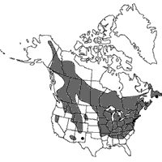
ORIGIN/HABITAT: North America. The widespread distribution extends from extreme eastern Alaska along the border with the Yukon Territory of western Canada with the northern limit arcing southeastward across Canada to Quebec and Newfoundland. Distribution extends southward into southeast Alaska and British Colombia, with a finger of habitat extending into eastern Washington, Oregon, and northern Idaho in the Pacific northwest. The southern boundary of distribution follows fairly closely along the U. S. Canadian border to North Dakota where it curves abruptly southward into Texas and Louisiana where it then curves northeastward through the southern and eastern states and the eastern provinces of Canada to Newfoundland. There is an isolated area of habitat in Arizona, New Mexico, and Colorado. Plants are found in woods where they grow in partial shade in well-drained but heavy, damp, humus-rich soils. They are also found on rocky hillsides, along streams, in meadows and clearings, in shallow depressions in peaty soil on treeless limestone barrens, and in talus of limestone cliffs. Plants seem to thrive in limestone areas, but the soils usually are neutral to slightly acidic. Habitat elevation throughout the range varies from near sea level to as high as 6550 ft. (0-2000 m).

PLANT SIZE AND TYPE: A variable, 4-31 in. (10-80 cm) tall sympodial terrestrial that is more or less densely hairy throughout. Plants often form clumps with growths spaced on a short, creeping rhizome which produces fibrous roots.

PSEUDOBULB/STEM: Up to 31 in. (80 cm) long. The terete stems are erect, leafy toward the top, and covered with 3 more or less hairy sheaths toward the base.

LEAVES: 2-8 in. (5-20 cm) long by 0.8-4.0 in. (2-10 cm) wide. Each growth carries 3-5 elliptic to egg-shaped or egg-shaped to lanceolate leaves arranged in 2 rows along the stem. Leaves are bright green, strongly pleated with many longitudinal nerves, sharply pointed at the tip, and hairy along the veins on both the upper and lower sides. Leaves have bases that sheath the stem. Plants found in open sites with bright light have leaves that are narrow and held in ascending positions. Leaves on plants grown in lower light tend to be wider and more spreading.

INFLORESCENCE: The long, slender flower spike is carried at the apex of the stem, emerging from the base of the uppermost leaf. The rachis is terete and hairy with leaf-like bracts that are hairy, egg-shaped to lanceolate, sharply pointed at the tip, and 1.2-4.0 in. (3-10 cm) long by 0.3-0.4 in. (0.8-1.0 cm) wide. Each blossom is carried on a pedicellate ovary that is reddish in color, hairy, and 0.8-1.3 in. (2.0-3.2 cm) long.

FLOWERS: 1-2 per inflorescence. The variable, showy blossoms are medium- to large-sized with sepals and petals that are yellow or greenish and are usually suffused and streaked with rusty brown or dull brown. The lip is yellow with magenta spots and streaks on the inside, and the staminode is yellow with red spots. The lanceolate dorsal sepal may be somewhat erect or arch forward over the pouch-like lip. It is sharply pointed at the tip, 1.0-3.3 in. (2.5-8.5 cm) long by 0.6-1.4 in. (1.4-3.5 cm) wide, and often undulate with a slightly spiral twist. The synsepal is similar to the dorsal sepal but is 2-toothed at the apex, 0.9-3.1 in. (2.3-8.0 cm) long by 0.6-1.0 in. (1.4-2.5 cm) wide, is incurved behind the lip, and has lateral margins that are somewhat reflexed.

Barbara McNamee Page 1 of 3 2/9/19

Flowers con’t.

Petals are spreading-deflexed, hanging downward at an angle of 45-60 below horizontal. They are linear-tapering, sharply pointed at the tip, 1.2-3.5 in. (3-9 cm) long by 0.2-0.4 in. (0.5-1.0 cm) wide, and are hairy along the midvein and at the base on the inside. Petals usually have 1-2 spiral twists though occasionally they are untwisted, the lip is ellipsoidal, obovoid or somewhat kidney-shaped with a small mouth. It is 0.8-1.1 in. (2.0-5.2 cm) long by 0.6-1.0 in. (1.5-2.5 cm) wide and has apical margins that curve inward. The short column is about 0.4 in. (1 cm) long. The staminode is triangular to egg-shaped, bluntly pointed, concave toward the apex, longitudinally folded, and up to 0.5 in. (1.2 cm) long by 0.3-0.4 in. (0.7-1.0 cm) wide

Synonyms:
Calceolus alternifolius St. Lager 1880
Calceolus alternifolius St.-Lég. 1889
Calceolus marianus Crantz 1769
Calceolus parviflorus (Salisb.) Nieuwl. 1913
Criosanthes parviflora Raf. 1836
Cypripedium alternifolium St.-Lag. 1880
Cypripedium assurgens Raf. 1833
Cypripedium bifidum Raf. 1833
Cypripedium boreale Salisb. 1796
Cypripedium bulbosum var. parviflorum (Salisb.) Farw. 1913
Cypripedium calceolus subsp. parviflorum (Salisb.) Hultén 1967 publ. 1968
Cypripedium cruciatum Dulac 1868
Cypripedium ferrugineum Gray 1821
Cypripedium hirsutum var. parviflorum (Salisb.) Rolfe 1907
Cypripedium luteum Aiton ex Raf. 1828
Cypripedium luteum var. parviflorum (Salisb.) Raf. 1828
Cypripedium makasin Farw. 1918
*Cypripedium parviflorum Salisb. 1791
Cypripedium parviflorum f. albolabium Magrath & J.L.Norman 1989
Cypripedium parviflorum var. exiliens Sheviak 2010
Cypripedium parviflorum var. makasin (Farw.) Sheviak 1993
Cypripedium parviflorum var. parviflorum
Cypripedium parvulum Fedde 1915
Cypripedium pubescens var. makasin Farw. 1918

Botanical Varieties:
Cypripedium bulbosum var. parviflorum (Salisb.) Farw. 1913
Cypripedium hirsutum var. parviflorum (Salisb.) Rolfe 1907
Cypripedium luteum var. parviflorum (Salisb.) Raf. 1828
Cypripedium parviflorum var. exiliens Sheviak 2010
Cypripedium parviflorum var. makasin (Farw.) Sheviak 1993
Cypripedium parviflorum var. parviflorum; Cypripedium parvulum Fedde 1915
Cypripedium pubescens var. makasin Farw. 1918

Awards:
Origin | AM | HCC | CCM | CHM | CBR | CBM | Total
AOS | 8 | 3 | 5 | 4 | 1 | 1 | 22

Barbara McNamee Page 2 of 3 2/9/19
Hybrids: total of 86 registered, to the 3rd generation
Cyp. Gisela (Cyp. parviflorum x Cyp. macranthos) 50% each, the most highly awarded of the hybrids with 7 awards: 2 CCMs, an AM, 3HCCs and an AD, Gisela has 7 total progeny, unfortunately none have any offspring or awards, they are registered from 2004 to 2012.

Cypripedium Gisela ‘Tenshy’ SM/DOG
Cyp. Lothar Pinkepank (Cyp. parviflorum var. pubescens x Cyp. kentuckiense) used 9 times in hybridizing, 1 award – HCC
Cyp. Aki (Cyp. parviflorum var. pubescens x Cyp. macranthos) used three times, 2 HCCs,
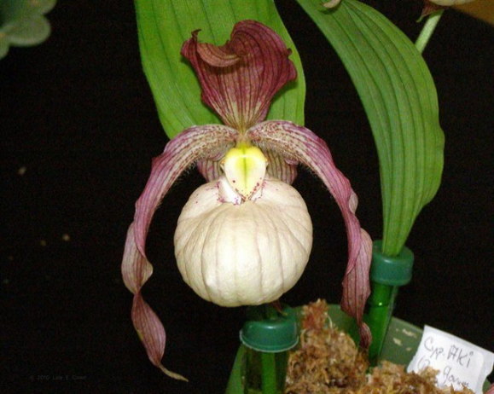

Cypripedium Aki ‘Dusty’s Spring Slipper’

References:
OrchidWiz Database X5.1
Orchidspecies.com
Nature.com/articles/s41598-018-24912-z
Phytesia-orchids.com/en/crypripedium-japonoicum-60316136157.html
Botanyboy.org/two-sister-cypripediums-from-asia-c-japonicum-and-c-formosanum/

Barbara McNamee Page 3 of 3 2/9/19

