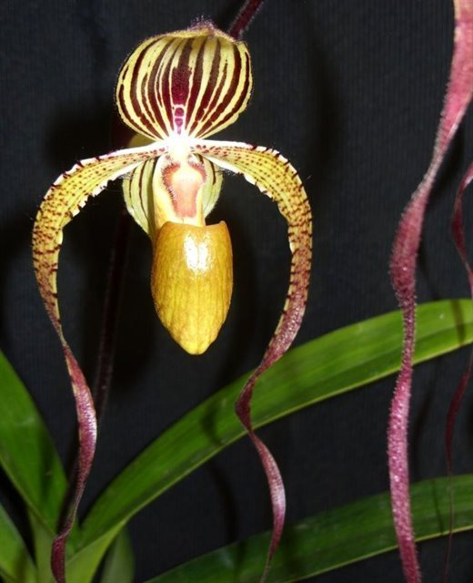
Paphiopedilum Angel Hair AM 87 pts.
(P. St. Swithin X P. sanderianum)

Nine beautifully arranged flowers, two buds on three arched, dark burgundy 50-cm inflorescences; sepals chartreuse, dorsal sepal boldly striped dark maroon, synsepal finely striped dark maroon; petals chartreuse, gently twisted, spotted and striped purple, distal two-thirds solid purple; pouch chartreuse, finely veined purple; staminode rose, purple centrally; substance firm; texture matte; pouch satin.

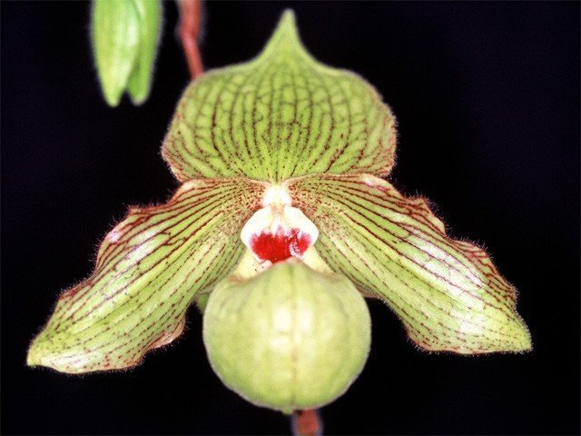
Paphiopedilum Jade Dragon AM
(P. fairrieanum x P. malipoense)

Two well-held, symmetrical yellow-green flowers, one bud on one 33-cm inflorescence; dorsal sepal tessellated and spotted maroon, pinched apically; petals superior half veined maroon, inferior half tessellated and spotted maroon; pouch veined maroon; staminode cream-color, distal half marked raspberry; substance firm; texture matte.

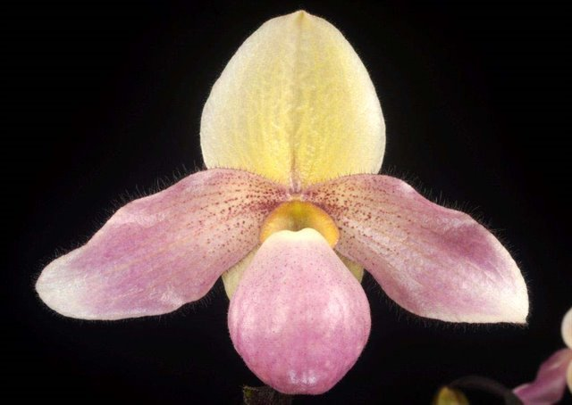
Paphiopedilum Deperle ‘Lehua’s Pink Pearls’ AM
(P. primulinum x P. delenatii)

Two elegant, pastel flowers, four buds on two 35-cm staked inflorescences; sepals cream-yellow, dorsal sepal suffused mauve centrally; petals rose-pink, dark mauve stippling proximally; pouch rose-pink, staminode cream-yellow, rose pink blush, green centrally; substance soft; texture satiny.

Barbara McNamee Page 1 of 2 10/12/19
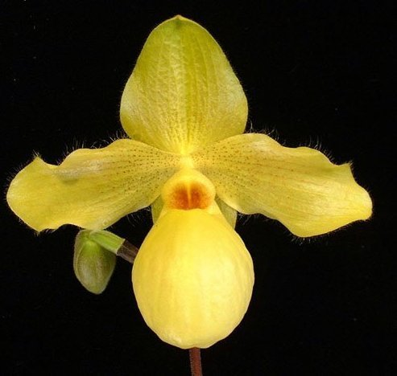
Paphiopedilum Mary Ott AM
(P. glaucophyllum x P. armeniacum)

One striking canary-yellow flower, one bud on one 40-cm upright inflorescence; dorsal sepal ovate, raised tessellations, reflexed apically; petals undulate, hirsute, veined and spotted maroon proximally; pouch full, well-shaped; staminode round, burnt-orange centrally; substance medium; texture matte.

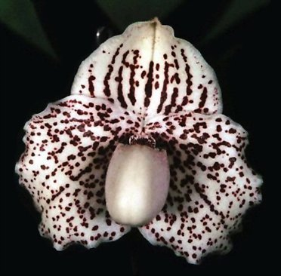
Paphiopedilum Skip Bartlett
(P. godefroyae x P. F. C. Puddle)

One round, sweet, cream-colored flower on one upright inflorescence; sepals and petals beautifully ruffled; dorsal sepal boldly spotted dark maroon, pinched apically; petals heavily spotted dark maroon; pouch cream-colored; staminode spotted dark maroon; substance firm; texture satin.

Barbara McNamee Page 2 of 2 10/12/19

