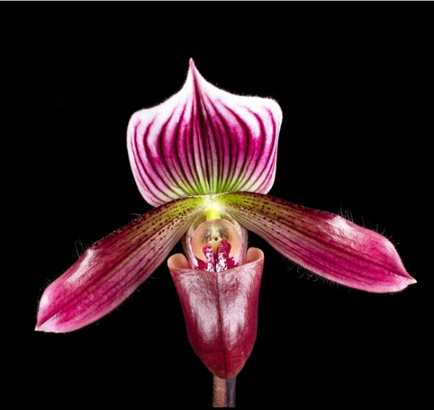
Paphiopedilum Cosmopolitan ‘Ingelore’ HCC
(P. purpuratum x P. callosum)

One flower on one 20-cm upright inflorescence; sepals white, dorsal sepal vividly striped burgundy, suffused green-colored halo basally, transitioning to red-violet medially, lateral margins recurved, apex sharply pointed; petals downswept, central white spot, lime-green basally, suffused burgundy distally, minute black warts, striped dark burgundy, margins undulate; pouch dark plum; staminode pink, dark plum centrally; substance firm; texture satin.
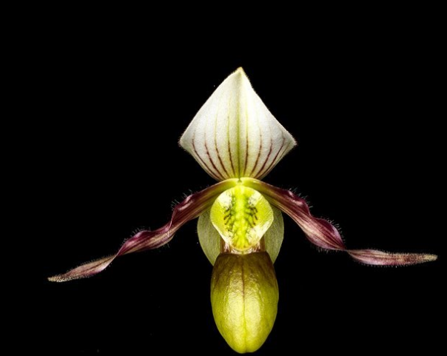
Paphiopedilum canhii AM
One unique flower on one 4.5-cm inflorescence; sepals cream-colored, dorsal sepal chartreuse basally and centrally suffused chartreuse, plum stripes medially, proximal margins recurved, apex pinched, synsepal overlaid chartreuse; petals cream-colored, overlaid chartreuse basally, striped plum longitudinally, margins hirsute, pleasingly twisted; pouch chartreuse basally, rim and veins plum; staminode chartreuse, large, shield-shaped, black veins centrally; substance firm; texture satin.

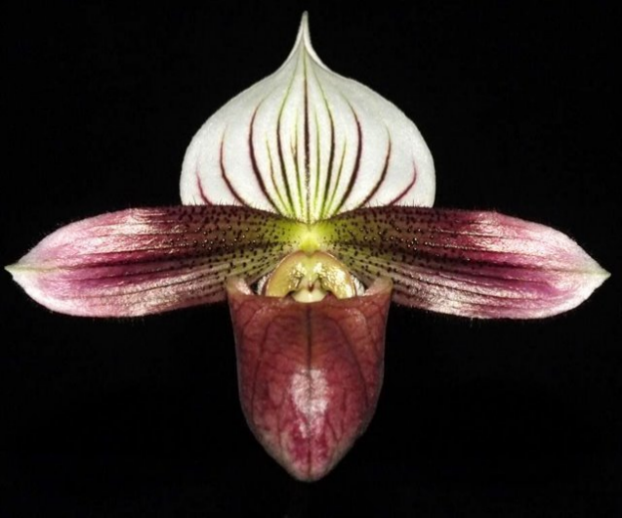
Paphiopedilum purpuratum CCM, AM
Nine well-presented flat flowers two buds on 11, 15-cm inflorescences; plant 15-cm high by 28-cm wide grown in a 6-cm plastic pot, foliage mottled green, exceptionally clean; dorsal sepal white, veined maroon, blushed chartreuse centrally; petals chartreuse, overlaid purple basally, light purple distally, minute black spots basally, horizontal dark purple veins, margins hirsute, gently ruffled; pouch maroon veined darker maroon; staminode pink; substance firm; texture satin, dorsal sepal texture diamond dust; plant also received an AM award number xxxxxxxx.

Barbara McNamee Page 1 of 2 11/9/19
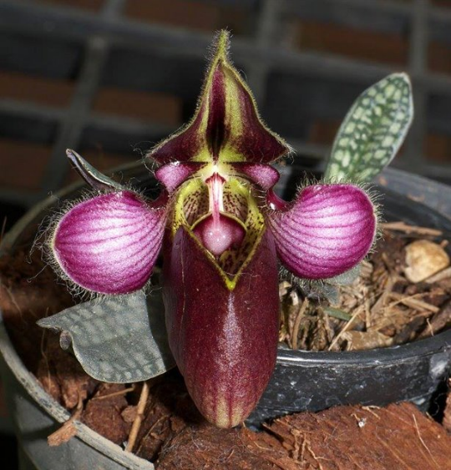
Paphiopedilum rungsuriyanum HCC
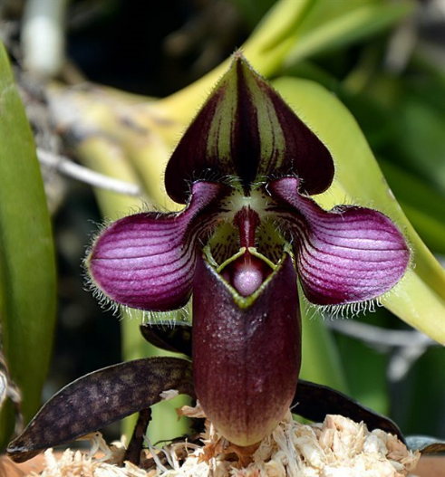
One unique flower on one 2-cm inflorescence; dorsal sepal chartreuse overlaid mahogany, dark mahogany central blotch, chartreuse pictee, margins hirsute, apex pinched; petals round, pink, striped magenta, coalescing at margins, margins hirsute; pouch large, chartreuse overlaid dark mahogany, interior spotted mahogany; column white; staminode magenta, pink centrally, spotted magenta; substance firm; texture matte; dorsal sepal and petals diamond dust. (better photo of dorsal)

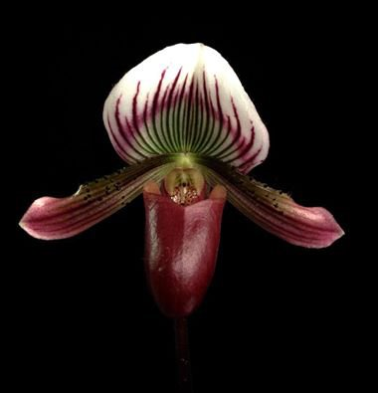
Paphiopedilum barbatum
Two full flowers, one bud on three upright inflorescences; dorsal sepal white, striped rich plum, green halo basally transitioning to plum medially, slightly reflexed; petals plum, lime-green centrally, striped plum horizontally, minute black spots on proximal two-thirds, margins undulate; pouch plum, pink interior; staminode pink; substance firm; texture satin.

Barbara McNamee Page 2 of 2 11/9/19

