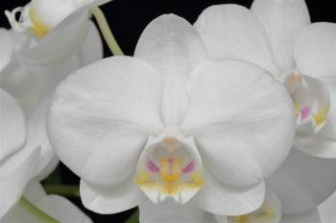
Phalaenopsis amabilis
Twenty-five full, round flowers, five buds well displayed on two arched, branched 15 cm inflorescences; sepals and petals white; lip white, side lobes striped magenta, callus white overlaid yellow, spotted magenta, midlobe yellow; column white; anther cap yellow; substance firm; texture crystalline.

* H. R. Sweet used leaf color to separate P. amabilis from P. aphrodite suggesting the undersurface of leaves were green in P. amabilis and purple in P. aphrodite. Christenson found the color variable in both species.
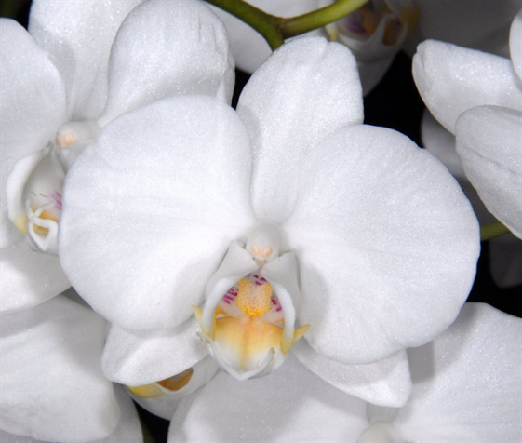
* The callus structures are distinct – P. aphrodite has the posterior edge of the callus divided into four teeth (subequal, outer teeth slightly taller than the inner two) and P. amabilis has only two.
Phalaenopsis aphrodite
Seventy-five full, flat flowers, 12 buds on six arching, branched inflorescences; sepals and petals white; lip white, side lobes striped violet, callus yellow, midlobe yellow centrally; column white; anther cap yellow; substance firm; texture sparkling.

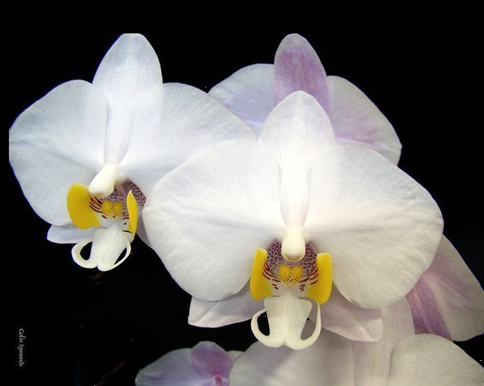
Phalaenopsis philippinensis

Twelve full, flat flowers on one gently arched 50 cm inflorescence; sepals and petals white, suffused light pink on reverse side; lip white, callus yellow, side lobes distal two-thirds bright yellow, striped maroon basally; anther cap pink; substance medium firm; texture matte.

Barbara McNamee Page 1 of 2 2/8/2020
Phalaenopsis schilleriana
Seventy-eight flat flowers, eight buds well displayed on three branched, cascaded inflorescences; sepals and petals light pink, darker pink centrally, lateral sepals spotted maroon; lip pink, spotted yellow and maroon distally, side lobes white, spotted maroon basally; callus yellow, spotted maroon; column and anther cap dark pink; substance medium firm; texture matte.
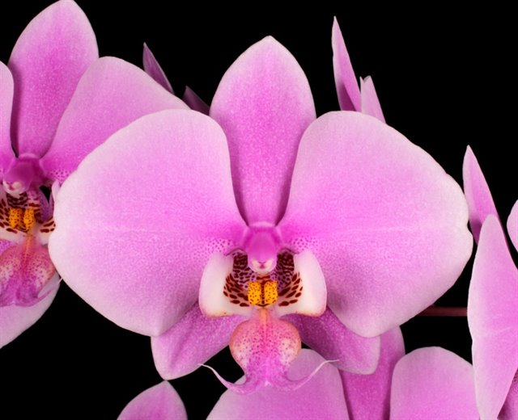

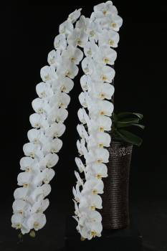
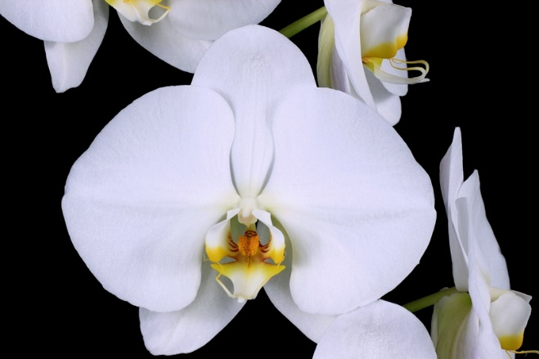
Phalaenopsis Sogo Yukiden
(P. Yukimai x P. Taisuco Kochdian)

Fifty-nine flat flowers, four buds dramatically cascading on two long, arched inflorescences to 183 cm long; sepals and petals white; lip white, yellow proximally, white distally, throat striped red ; callus golden yellow, spotted red; column and anther cap white; substance firm; texture crystalline.

Terminology:
Keel – ridges
Crest – toothed, fringed or hairy thick portion of disc (callus)
Shingled – see photo above right
Keikis – offshoot from a plant
Callus – looks like a butterfly
Lip shape – triangular
Cascading – similar to shingled
Branched inflorescence
Waterfall presentation – similar to shingled
Crowns – seems to be a term used mostly in Taiwan
Fenestrations – windows or holes

References:
OrchidPro
OrchidWiz Database 5.3
AOS Glossary

Barbara McNamee Page 2 of 2 2/8/2020

