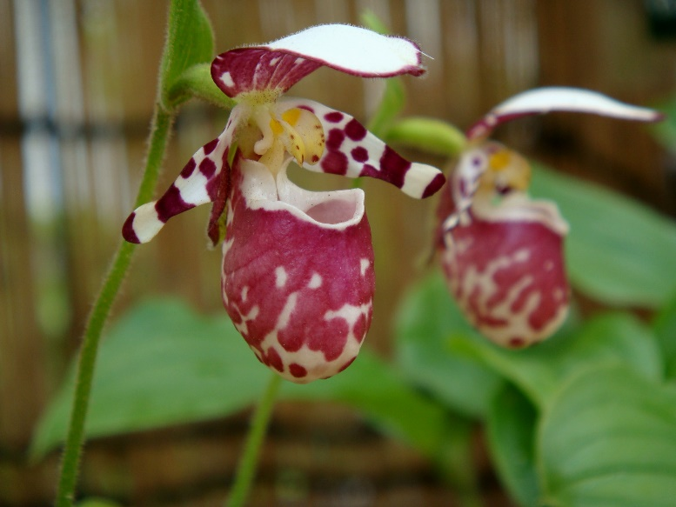
Cypripedium guttatum CHM
Three charming flowers on three erect, hirsute inflorescences grown in 10.5cm square plastic pot, leaves ovate, plicate (folded like a fan) 8cm long by 5cm wide; dorsal sepal and petals white, heavily overlaid, blotched magenta; dorsal sepal hooded; petals blotched dark magenta; pouch heavily blotched magenta; synsepal green blotched light magenta; staminode yellow, spotted magenta along margins; ovary green, 0.9cm, hirsute; substance firm; texture matte.

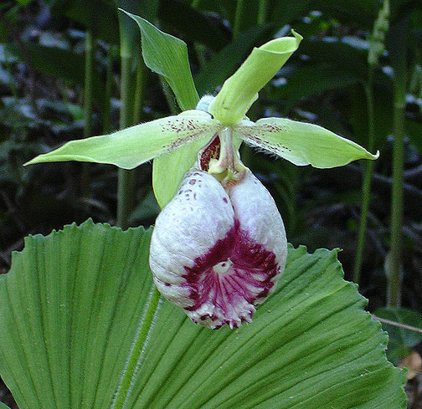
Cypripedium japonicum
One white flower on one inflorescence; inflorescence rises from two unusual rounded, plicate (folded like a fan) leaves margins dentate; sepals and petals light green, dorsal sepal rolled, petals finely spotted purple proximally; pouch white, full, suffused purple at upper rim, striped and veined purple at lower rim, pouch interior white; substance firm; texture matte.

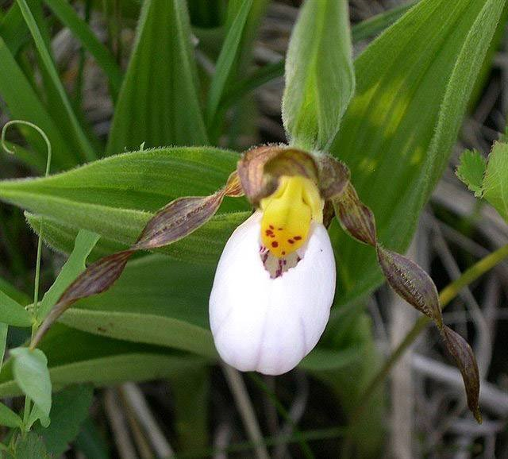
Cypripedium candidum
Three flowers nicely presented on three inflorescences; sepals light green overlaid mahogany stripes; petals light green, overlaid coalescing mahogany spots; pouch soft white veined pink; staminode bright yellow spotted red; substance medium; texture matte.

Barbara McNamee Page 1 of 2 2/9/19

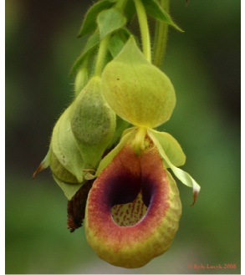
Selenpedium aequinoctiale

Two pendent flowers, four buds on three successively flowered inflorescences borne on a 1-m plant with alternate, lanceolate, pubescent leaves; sepals and petals yellow-green, finely pubescent on reverse; pouch ribbed, yellow-green, rim rolled, overlaid burnt-orange, interior lined dark maroon medially, yellow-green finely spotted maroon distally; column yellow; anthers maroon-brown; substance thin; texture matte.

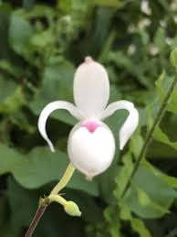
Mexipedium xerophyticum CCM
Twenty-two dainty flowers, 11 buds on 16 erect, successively flowering inflorescences borne on an exceptionally well-grown, rambling plant in a 31-cm pot, composed of 43 plantlets on wiry stolons with eight mature blooming growths; sepals white with light rose-pink apexes, petals white, porrect; pouch white, ovate; staminode rose-pink; substance delicate; texture crystalline.

Barbara McNamee Page 2 of 2 2/9/19

