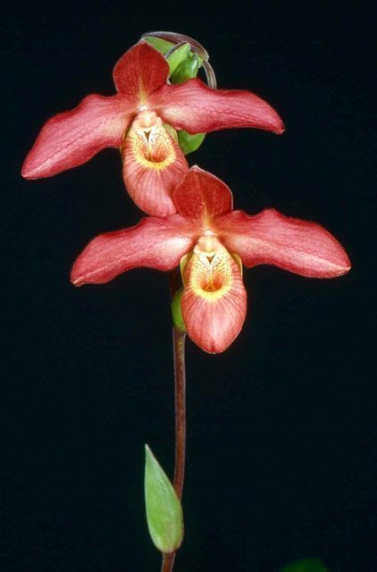
Phragmepedium Memoria Dick Clements
(P. sargentianum x P. besseae)

Two flowers, two buds well presented on one 48 cm, upright inflorescence; dorsal sepal recurved, dark red, lightly veined darker red; synsepal light yellow; petals down-swept, dark red, veined darker red, margins wavy, dark red; pouch red, veined and striped dark red, rim yellow, interior spotted red; staminode yellow, overlaid light red; substance firm; texture satin.

Phragmededium Eric Young
(P. besseae x P. longifolium)

Four well-formed flowers, five buds well arranged on two strong, branched, 61-cm inflorescences; sepals yellow green overlaid rose coral, veined dark maroon; petals yellow overlaid rose, spotted maroon proximally on inferior half, darker rose distally, veined maroon distal two-thirds, margins slightly undulate; pouch bright yellow, overlaid saturated deep red, interior spotted rose coral; staminode yellow brushed rose centrally; substance firm; texture matte.

Phragmepedium Wossen
(P. richteri x P. schlimii)

Fourteen charming violet flowers, 15 buds on 14 branched, upright inflorescences; sepals and petals overlaid ivory, dorsal sepal lightly striped and tessellated pale apple green, brushed lavender, petals down-swept, undulate, margin dilute lavender on superior half, reverse striped rose-pink; pouch blushed violet, rim red-violet, interior ivory, spotted red-violet coalescing to stripes; staminode ivory; substance firm; texture matte.

Barbara McNamee Page 1 of 2 3/9/19
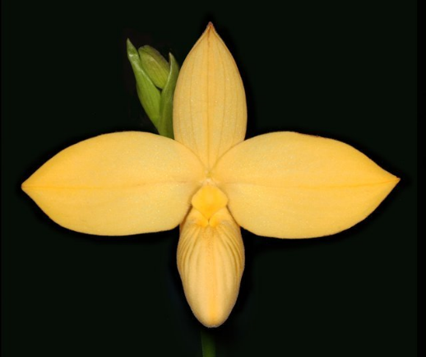
Phragmepedium besseae f. flavum
One exceptionally flat flower, one bud on one erect, staked 11-cm inflorescence; sepals and petals creamy yellow, dorsal sepal veined goldenrod, synsepal chartreuse; petals midrib goldenrod; pouch creamy yellow with transparent fenestration along sides, interior lemon yellow; staminode lemon yellow, diamond shaped; substance firm; texture crystalline.

Phragmipedium caudatum
Three flowers well-presented on one gently arched inflorescence; sepals pale yellow, boldy tessellated and striped olive green; petals pale yellow, striped rose longitudinally, coalescing to solid rose apically; pouch golden yellow, tessellated mahogany, rim olive green, interior white, spotted mahogany; staminode yellow, margins brick red; substance firm; texture glossy.

Barbara McNamee Page 2 of 2 3/9/19

