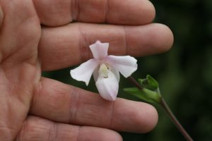
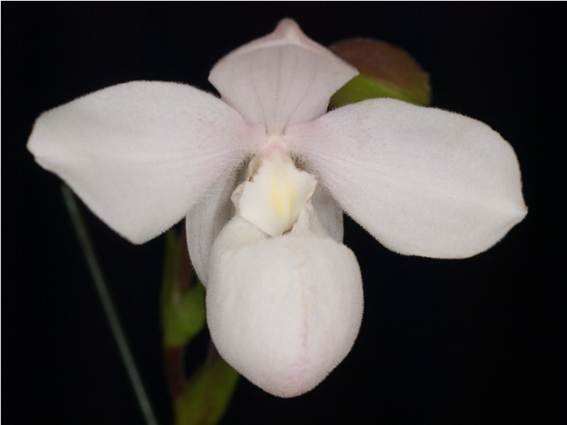
Phragmipedium andreettae CCM
One charming flower on an upright 5.5-cm inflorescence, one bud on an additional inflorescence, on a two-growth plant grown in a 9-cm plastic pot; leaves lanceolate, 15-cm long by 1.8-cm wide; sepals and petals pubescent, white flushed pale pink proximally; pouch white, central striped pink, hirsute; staminode white, flushed yellow proximally; substance firm; texture matte; species native to northwestern Ecuador.
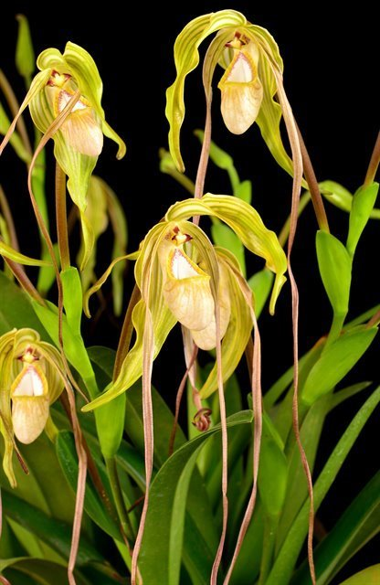

Phragmepedium wallisii

Four flowers held high on three inflorescences; dorsal sepal chartreuse veined and tessellated dark brown basally, fading to light green distally, synsepal chartreuse veined light green; petals ivory heavily veined dark red coalescing into solid brown-red distally; pouch chartreuse overlaid with dark brown tessellations, irregular bumps on upper lobes, interior dark mahogany speckles; substance firm; texture waxy.

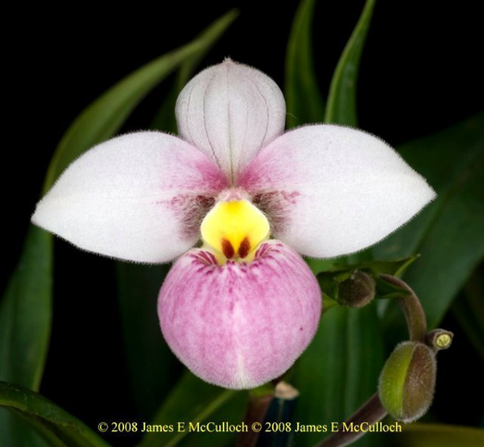

Phragmepedium schlimii AM
Two full, flat flowers, four buds on two upright inflorescences; sepals and petals white, dorsal finely spotted rose, veined rose, petals finely spotted rose on superior half, suffused rose basally; pouch white, overlaid rose, darker rose stripes around rim; staminode canary yellow, two rose spots on distal margin; substance firm; texture diamond-dusted.

Barbara McNamee Page 1 of 2 4/13/19
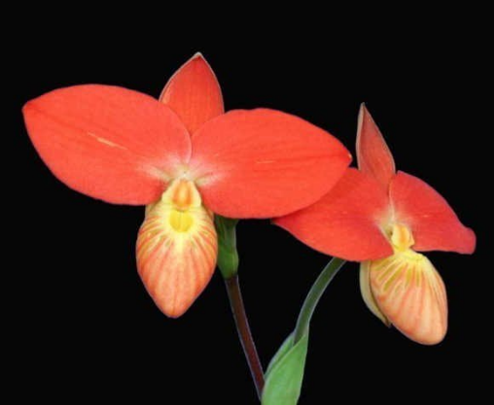
Phragmepedium besseae
Two flat flowers, two buds on two staked inflorescences; dorsal sepal orange, slightly cupped at apex; synsepal yellow; petals intense orange, cream-colored basally; pouch yellow striped tangerine orange, interior bright yellow; staminode yellow, orange centrally; substance firm; texture crystalline.

Phragmepedium kovachii

One large impressive flower on one upright inflorescence; sepals and petals white, dorsal sepal veined and suffused rose, cupped at apex, synsepal veined rose; petals heavily overlaid deep lavender, proximally white, margins wavy, apices flared deep purple; pouch white suffused dark lavender, rim deep purple, margins white, interior heavily spotted deep purple; staminode white, purple margins; substance firm; texture crystalline.

Terminology
Fenestration / windows
n. | 1. | (Arch.) The arrangement and proportioning of windows; - used by modern writers for the decorating of an architectural composition by means of the window (and door) openings, their ornaments, and proportions.

Windows or without (P. Andean Fire ‘Lisa Sauer’)
Twisted petals
Dorsal sepal convolute (P. richteri ‘Elizabeth Julia’) -
a. | 1. | (Bot.) Rolled or wound together, one part upon another; - said of the leaves of plants in æstivation.

Wings
Barbara McNamee Page 2 of 2 4/13/19

