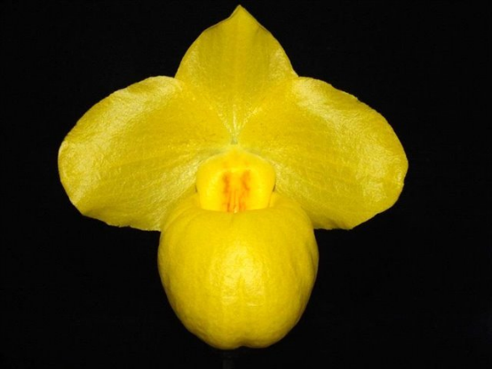
Paph. armeniacum
One bright yellow, round flower on one upright inflorescence; sepals and petals veined lemon yellow, finely hirsute, dorsal sepal margin apice slightly pinched; pouch beautifully bulbous, spotted magenta internally; staminode solid lemon yellow, tangerine centrally; substance good; texture waxy.

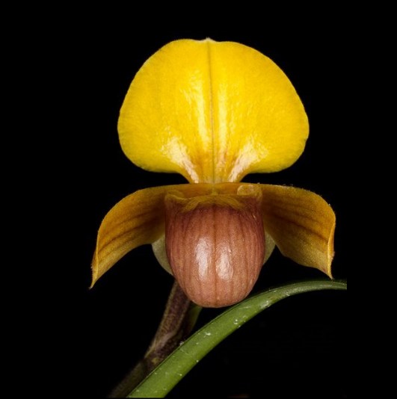
Paphiopedilum helenae CCM
Three charming flowers on three upright 7cm inflorescences grown in bark in an 8cm square pot; dorsal sepal vibrant yellow, dusty pink basally; petals porrect, yellow overlaid light chesnut, striped dark chestnut; synsepal cream lightly veined green; pouch dusty pink, side lobes translucent yellow; staminode translucent light green; substance firm; texture sepals and petals crystalline, pouch glossy.

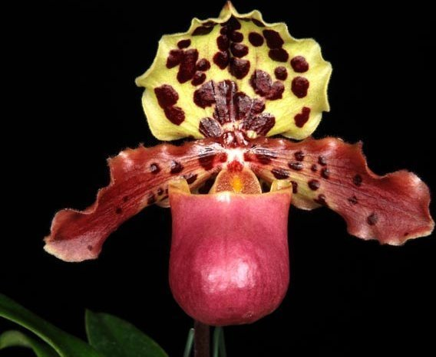
Paphiopedilum henryanum
One large, bold flower well displayed above the foliage on an upright, 15-cm inflorescence; sepals chartreuse irregularly spotted chestnut brown; petals chartreuse, undulate, heavily suffused purple and spotted chestnut brown on basal third; pouch rose, veined dark rose; staminode chartreuse heavily spotted maroon, orange centrally, red dot basally; substance firm; texture silky.

Barbara McNamee Page 1 of 2 5/11/19
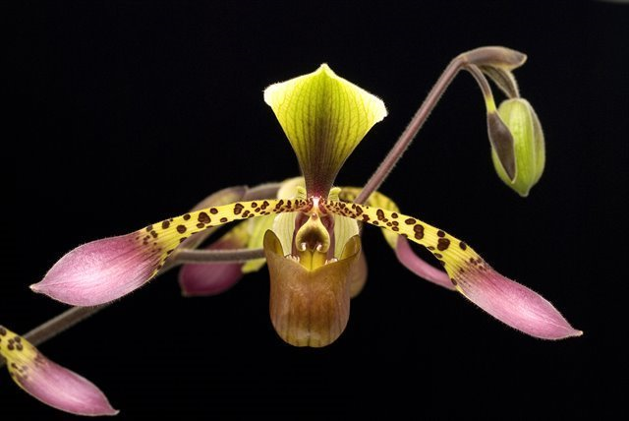
Paphiopedilum lowii AM
Eight flowers, 1 bud well presented on two staked, arched inflorescences; dorsal sepal cream color, overlaid chartreuse, striped mahogany centrally coalescing to solid mahogany basally; petals spatulate, chartreuse proximally, spotted mahogany, purple distally; sysnsepal cream color, striped dark green; pouch chartreuse overlaid mahogany, veined dark mahogany; staminode chartreuse overlaid mahogany, white apices; substance firm; texture matte.

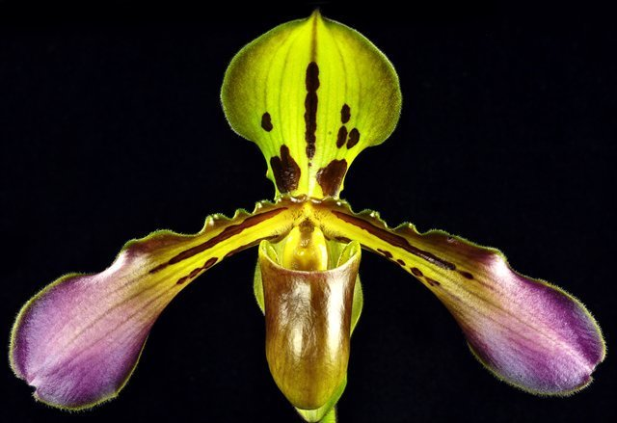
Paphiopedilum tigrinum
One well-presented, stately flower on one erect inflorescence; dorsal sepal lime green with one central chocolate stripe, blotched chocolate basally, synsepal lime green; petals spatulate, golden rod, margins undulate, hirsute, striped chocolate proximal two-thirds, apical third light plum; pouch green overlaid mahagony; staminode golden rod, mahogany centrally; substance firm; texture waxy, pouch glossy.

Terminology:
Spatulate petals

Barbara McNamee Page 2 of 2 5/11/19

