Paphiopedilum platyphyllum AM
Five elegant flowers, one bud well-arranged on one erect 42 cm long inflorescence; dorsal sepal hooded, white, striped chocolate brown, synsepal white striped chocolate brown, petals green, striped and finely spotted chocolate brown distally, larger brown spots basally, gently twisted apices; pouch yellow, reticulately veined dark red-brown; staminode bright yellow-green, margin hirsute, tesselated red-brown minute hairs; substance firm; texture satin, dorsal sepal matte.

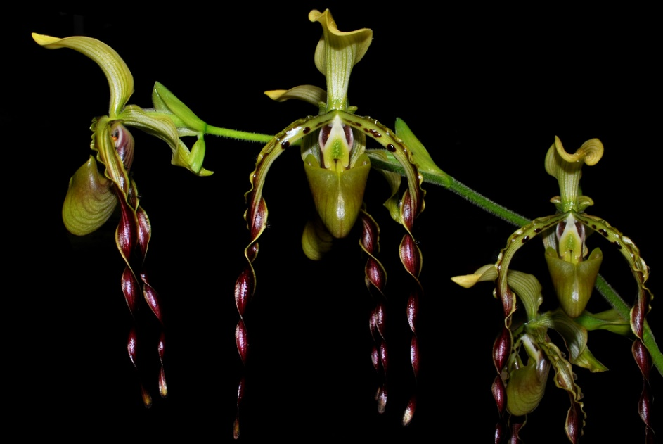
Paphiiopedilum parishii CCM
Forty-three flowers six buds proudly displayed on eight arching inflorescences on a well-groomed plant of 15 growths 54 cm tall by 54 cm wide presented in an 18-cm pot; leaves average 40 cm long; sepals chartreuse, dorsal sepal veined olive-green, gold on reverse, synsepal veined olive-green, petals olive-green, black warts basally, veined dark plum, saturated plum and evenly twisted on distal two-thirds; pouch olive-green, veined plum, bright plum veins at back of pouch; staminode cream-colored overlaid chartreuse centrally; substance firm; texture waxy.
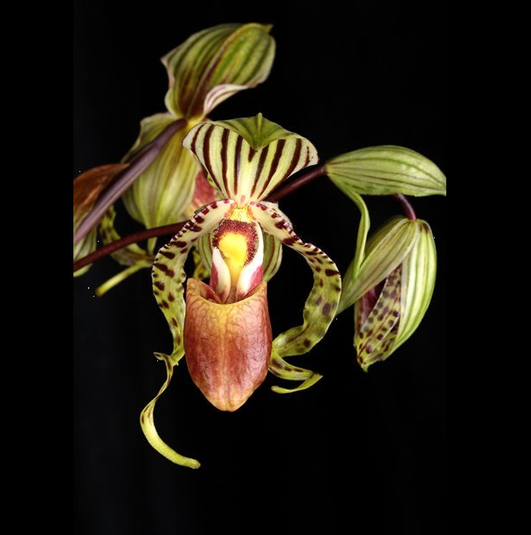
Paphiopedilum supardii
Eight flowers three buds on two gracefully arching inflorescences; sepals and petals light chartreuse, dorsal sepal cream-color interior, hooded, prominently striped dark brown, synsepal finely striped brown, petals cream color basally, irregularly twisted, curled distally, spotted dark brown; pouch light brown veined maroon coalescing to solid rich maroon centrally; staminode bright yellow, margin dark maroon, hirsute, side lobes maroon, margins cream; substance firm; texture matte, pouch satin.

Barbara McNamee Page 1 of 2 6/8/19
Paphiopedilum wilhelminae HCC
Four striking flowers one bud on two staked inflorescences; sepals white, boldly striped mahogany; petals mahogany striped darker mahogany, tightly twisted; pouch yellow, overlaid mahogany2, veined darker mahogany; staminode yellow, overlaid mahogany centrally, hirsute; substance firm; texture waxy.

Paphiopedilum Armeni White
One dainty white flower, one bud well-presented on one upright, self-supporting 42-cm inflorescence; petals full, round with minute purple spots basally, sepals and petals slightly wavy; pouch full, round, purple spots on interior; staminode white, overlaid brilliant red-orange centrally, yellow distally, one vertical yellow bar centrally; substance firm; texture crystalline.

Barbara McNamee Page 1 of 2 6/8/19

