Paphiopedilum Terminology

Stippled hirsute tufts reticulated
Coalesced linearly
Undulate Irregularly tessellated
Elliptical Linear lines
Synsepal flat staminode
staminode finely spotted burgundy, light green ventrally
Stippled maroon on basal two-thirds, distal third spotted
Pouch white, stippled maroon distally, interior heavily stippled maroon
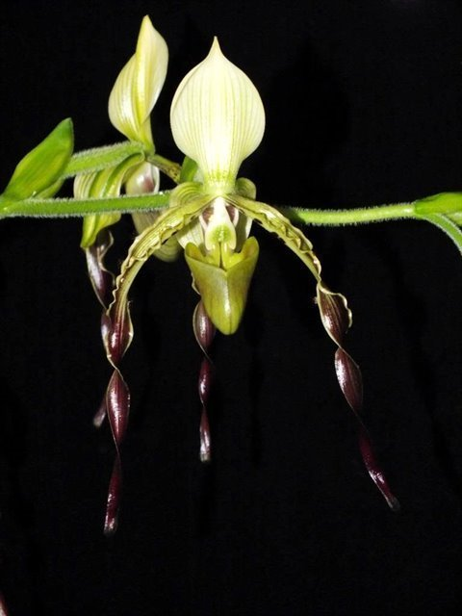

Paphiopedilum parishii CCM

Twenty-seven flowers, 15 buds well arranged on six, 65 cm arching inflorescences with flowers proudly presented on an 11 growth plant in a 17 cm pot; dorsal sepal ivory, striped pale green, synsepal chartreuse, veined green; petals chartreuse, hirsute, striped mahogany on proximal half margin, twisted and overlaid purple on distal half; pouch olive green overlaid maroon; staminode ivory overlaid green distally; substance firm; texture waxy.

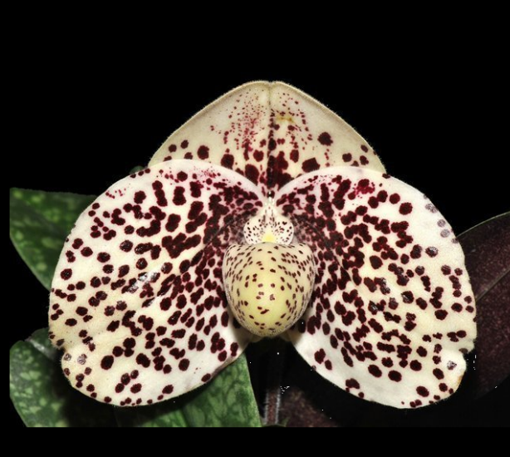

Paphiopedilum bellatulum ‘Barbara’ HCC
(German award photo from 1985)

One large, triangle-shaped, slightly cupped flower and two buds on three short inflorescences; sepals and petals milk-white with large vivid burgundy spots and blotches; pouch milk-white overlaid light yellow, small burgundy spots; staminode ivory, yellow centrally; substance firm; texture waxy.

Barbara McNamee Page 1 of 2 7/13/19
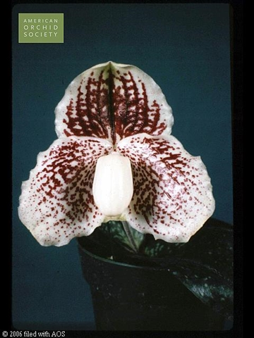
Paphiopeduilum godefroyae AM

One full, slightly cupped flower, one bud on two short inflorescences; sepals and petals cream color, dorsal sepal heavily tessellated dark maroon, petals uniformly spotted maroon, linearly spotted distal third, segments undulate; pouch clear cream color; staminode cream, spotted maroon; substance firm; texture waxy.

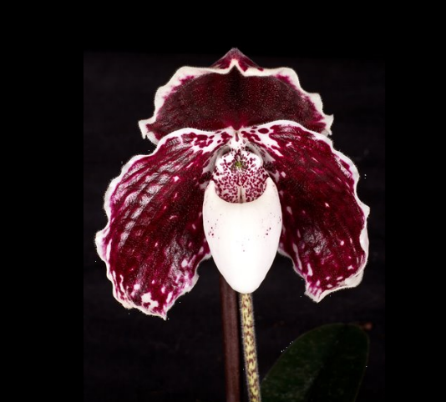

Paphiopedilum leucochilum ‘Andreas’ AM

One graceful ivory flower on one short, upright inflorescence; dorsal sepal hooded, saturated maroon, proximal margin ivory; petals downswept, heavily tessellated maroon, picatee ivory, segments undulate; pouch obovoid, clear ivory, finely spotted maroon centrally, interior spotted maroon; staminode ivory; substance heavy; texture waxy.

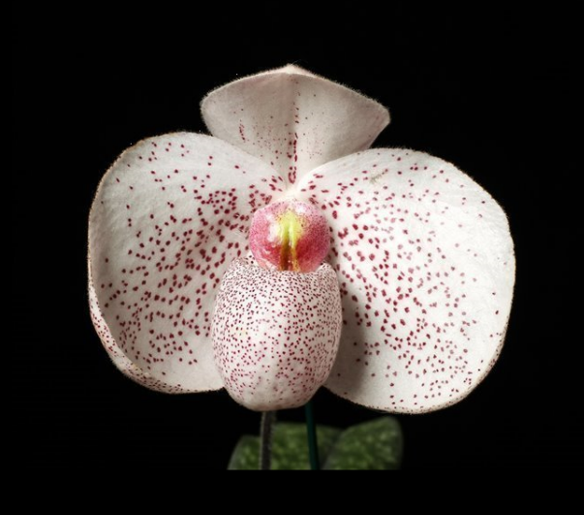

Paphiopedilum Vanda N. Pearman ‘Elke’ HCC

One charming flower, one bud well presented on two upright 18 cm inflorescences; sepals and petals white, dorsal sepal hooded, finely stippled burgundy; petals round, spotted burgundy, slightly recurved; pouch white, finely spotted burgundy; staminode white, burgundy distally, yellow centrally; substance medium firm; texture matte.

Barbara McNamee Page 2 of 2 7/13/19

