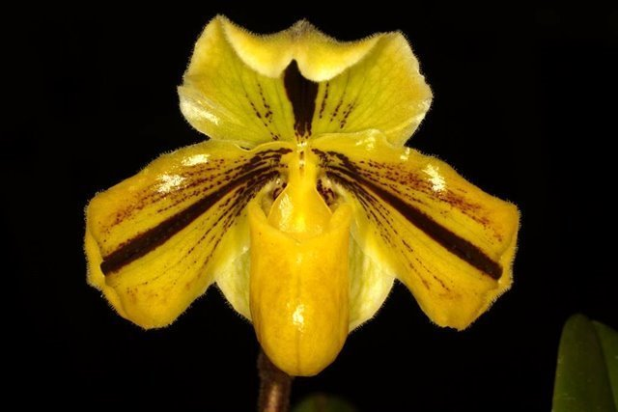
Paphiopedilum druryi ‘Jo Mammen’ AM
One stately flower elegantly presented on one upright 17 cm inflorescence; dorsal sepal, yellow-green, hooded, prominent dark maroon stripe centrally with maroon striations on either side, synsepal yellow; petals golden yellow, recurved apically, dark maroon stripe centrally, striped and spotted maroon on superior and inferior sides; pouch golden yellow, veined red-brown; staminode golden yellow; substance heavy; texture glossy.

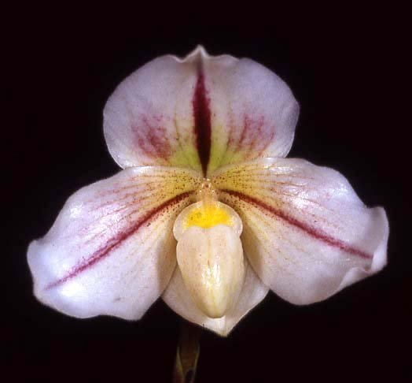
Paphiopedilum Microchilum ‘Blush’ HCC
(P. druryi x P. niveum)

One charming lavender flower on one upright 19 cm inflorescence; dorsal sepal pinched apically, prominent maroon stripe centrally, striped and spotted maroon on proximal two-thirds, chartreuse blush basally; petals striped maroon centrally, striped and spotted maroon on superior side, finely spotted maroon on inferior side, blushed yellow basally, margins wavy, recurved apically; pouch small, finely spotted maroon, staminode lavender, yellow distally; substance medium firm; texture satin.

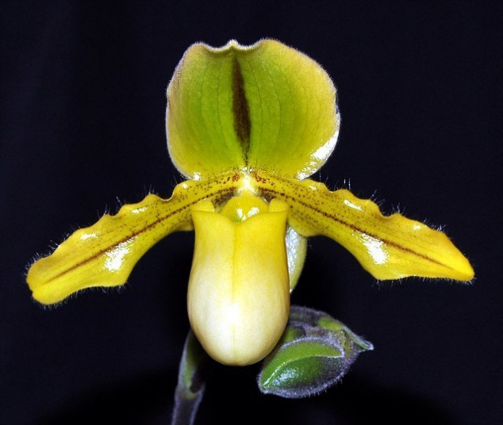
Paphiopedilum Druid Spring HCC
(P. druryi x P. primulinum)

One open flower, two buds on one upright inflorescence; dorsal sepal cream-color, suffused yellow, overlaid light green centrally, prominent brown stripe on midvein; synsepal cream-color; petals golden yellow, hirsute, brown stripe on midvein, finely spotted brown on superior half; pouch yellow, cream-color distally; staminode round, yellow, green distally; substance firm; texture waxy.

Barbara McNamee Page 1 of 2 8/10/19

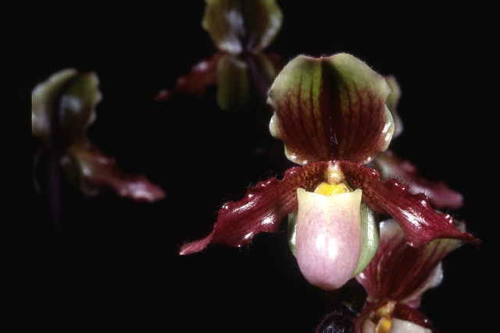
Paphiopedilum Mrs. Coburn AM
(P. glaucophyllum x P. druryi)

Six flowers, one bud on four upright inflorescences, dorsal sepal cream-color, overlaid lime green centrally, veined mahogany, dark mahogany stripe on midvein, picotee cream-color, synsepal cream-color; petals red-brown, hirsute, lime green overlay basally, spotted and striped mahogany; pouch cream, blushed pink distally; staminode golden yellow; substance heavy; texture waxy.

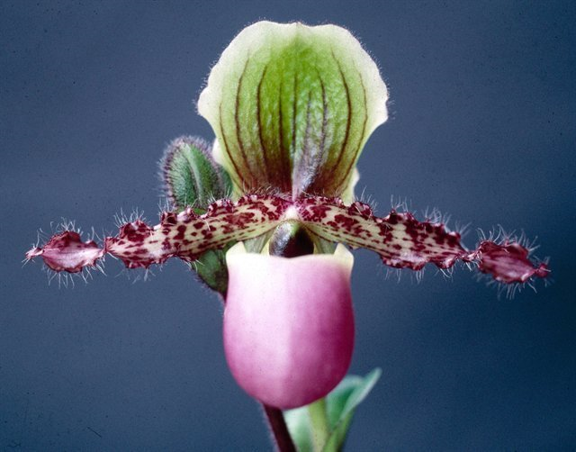
Paphiopedilum glaucophyllum HCC

Four colorful flowers, two buds on two 24 cm inflorescences; dorsal sepal white, overlaid lime green centrally, striped and veined dark burgundy, suffused dark burgundy basally, synsepal white; petals white, hirsute, spotted bright burgundy, margins undulate, twisted distally; pouch white suffused rose distally; staminode round, olive green; substance firm; texture glossy.

Barbara McNamee Page 2 of 2 8/10/19

