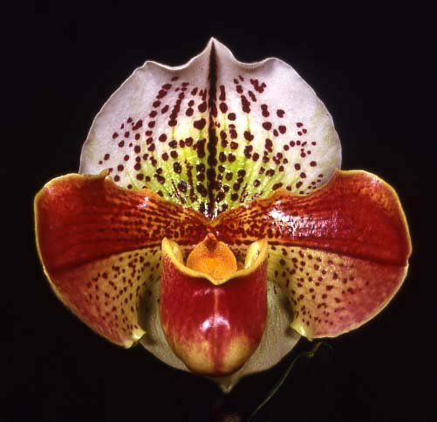
Paphiopedilum Acclamation ‘Cajun Queen’ AM 85 pts.

One large, round flower on one erect 22 cm inflorescence, dorsal sepal white, chartreuse centrally, boldly spotted maroon, synsepal green; petals chartreuse, saturated burgundy superior half, spotted and veined dark burgundy centrally, spotted dark burgundy inferior half; pouch burgundy, chartreuse basally; staminode peach; substance heavy; texture waxy.

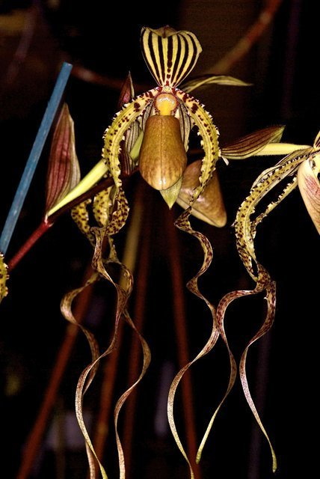
Paphiopedilum Dragontale (P. supardii x P. anderianum) AM
Six shapely, well presented flowers, two buds on two upright inflorescences; dorsal sepal chartreuse, boldly striped maroon, synsepal chartreuse, striped maroon; petals chartreuse, long, downswept, gently twisted, spotted maroon to medial half, transitioning to veins on distal half; pouch green overlaid light brown; staminode chartreuse; substance hard; texture matte.

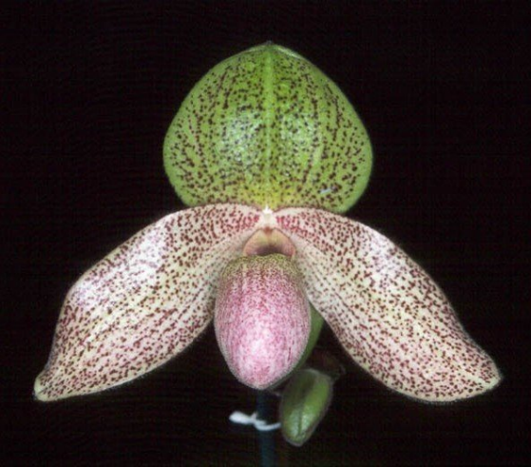
Paphiopedilum Charles Sladden (P. bellatulum x P. glaucochilum) HCC
Three well-presented, well-balanced cream colored flowers, one bud on one inflorescence; sepals overlaid light chartreuse, tessellated raspberry; petals veined deep rose; pouch white heavily peppered deep rose; staminode rose, green centrally; substance heavy; texture velvet.

Barbara McNamee Page 1 of 2 9/14/19
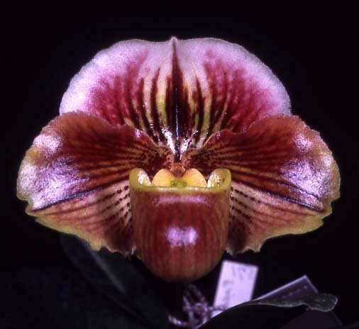
Paphiopedilum Ali Taba ‘Rosepoint’ (P. Paeony x P. fairrieanum) HCC
One flower on one 5.5 cm upright inflorescence; dorsal sepal white overlaid burgundy, striped dark burgundy; petals chartreuse, overlaid burgundy on superior half, striped dark burgundy on inferior half; pouch chartreuse overlaid burgundy; staminode peach, chartreuse centrally; substance heavy; texture waxy.

Paphiopedilum Ambiente ‘Rotspiel’ SM/DOG
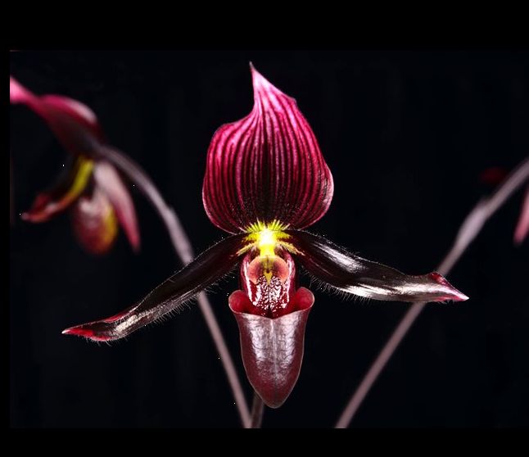
Six well-presented flowers, five buds on 11 inflorescences; dorsal sepal white, overlaid burgundy, striped dark burgundy, synsepal white striped burgundy; petals dark burgundy, gently twisted, bright yellow starburst basally; pouch dark burgundy; staminode rose, dark burgundy centrally; substance firm; texture glossy.

Barbara McNamee Page 1 of 2 9/14/19

