SPECIES DATA REPORT
Paphiopedilum glaucophyllum J.J.Smith 1900
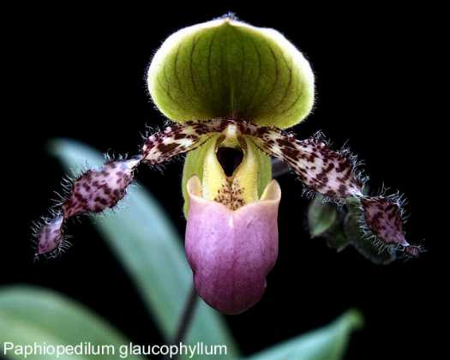
Common Name The Shiny Blue Green Leaf Paphiopedilum
Pronounce: glaw-ko-FILL-um
Flower Size 3" or more [8 cm]
Characteristics:
[to 20] successively opening flowers with never more than 2 open at a time and occurs over months.
Blue-green leaves
Keeled midvein on dorsal
Petals angled downward, strongly undulate, twisted, stiff hairs along margins

ORIGIN/HABITAT: Java. Plants are found near the southeast coast at 650-2300 ft. (200-700 m). They usually grow on cliffs of soft, crumbling limestone, where their roots extend into moss and leafy humus near a water seepage. Comber (1990) reported, "Formerly very common in the low hills south of G. Semeru in East Java at from 450-770 m, where it grew both in the soil and on rocks on steep hillsides. Unfortunately in the years 1965-1980 it was extensively collected for sale locally and abroad until it is now very difficult to find. Luckily there are still a few flowering plants on almost inaccessible cliffs in this area."

PLANT SIZE AND TYPE: A rather large lithophytic herb with a leaf span of 16-24 in. (40-60 cm). Each plant is made up of 1-3 rather closely spaced growths.

PSEUDOBULB/STEM: The short, erect stem is completely enclosed by overlapping, longitudinally folded leaf bases.

LEAVES: 8-12 in. (20-30 cm) long by 1.8-2.1 in. (4.5-5.3 cm) wide. 4-6 broadly strap-shaped to narrowly oblong-elliptic leaves are carried on each growth. They are hairy on the margins toward the base and bluntly tipped to rounded at the apex, which is unequally bilobed with a small tooth between the lobes. The leaves narrow below where they become increasingly folded along the midvein to form a rather long, narrow, longitudinally folded stem-like base. The glossy upper surface is deep bluish green with slightly darker veins and is longitudinally channeled along the midvein. The lower surface is somewhat lighter in color, has a distinct keel along the midvein, and is faintly washed with purplish red at the base.

INFLORESCENCE: Up to 12 in. (30 cm) long. The erect, terete peduncle is green, but is heavily mottled with purple and is fairly densely covered with short hairs. Flowers are carried on a green pedicellate ovary that is flushed with dull maroon, is 1.8-2.4 in. (4.5-6.0 cm) long, and is covered with short hairs.

FLOWERS: 20 or more per inflorescence. Blossoms open in succession, however, with 2 open at the same time only briefly if at all. The spreading flowers are up to 3.3 in. (8.5 cm) across the petals and 2.6 in. (6.5 cm) tall from the tip of the dorsal sepal to the apex of the lip. The erect, broadly egg-shaped to somewhat circular dorsal sepal is slightly concave, has somewhat undulate margins, is up to 1.2 in. (3 cm) long by 1.3 in. (3.2 cm) wide, has a shallow longitudinal groove in the center on the inside surface with a rather blunt longitudinal keel along the midvein on the back.

Barbara McNamee Page 1 of 3 6/8/19

It is white or cream with a yellow-green center and is marked with about 12 curving, narrow, longitudinal stripes that are dark gray to brown or maroon, that converge toward the base, and do not extend to the margins.

The outer surface of the dorsal sepal is covered with short, fuzzy hairs. The lateral sepals are joined to form an egg-shaped synsepalum that is concave, bluntly pointed at the tip, and about 1 in. (2.6 cm) long by 0.7 in. (1.8 cm) wide. It is similar in color the dorsal sepal, has a glossy inner surface, is marked with prominent longitudinal veins, and has margins and an outer surface that are covered with spreading, deep violet hairs. The linear, spreading petals, which are held at an angle of 10 to 20 below horizontal, are up to 1.8 in. (4.5 cm) long by 0.4 in. (1 cm) wide, have strongly undulate margins, and may be twisted on the apical half. They are whitish, but may be somewhat green toward the base, and are marked with numerous small- to medium-sized reddish brown spots on the margins and along the approximately 9 longitudinal veins. They are hairy along the margins with rather closely spaced, stiffly spreading hairs that are about 0.1 in. (0.3 cm) long. The deep, sack-like lip, which is longer than broad, is about 1.7 in. (4.3 cm) long by about 0.8 in. (2 cm) wide. It is white to greenish white at the base, shading fairly quickly to pink or lavender where it is densely marked or stippled with numerous small darker spots. The large, rounded side-lobes of the lip are folded inward and are covered with small bright purple spots. The inside of the lip, except for the rim, is covered with rather short, dark violet hairs. The large staminodal shield is egg-shaped, bluntly pointed, and up to 0.5 in. (1.2 cm) high by 0.4 in. (0.9 cm) wide. Over most of its surface, the staminode is a glossy blackish purple, but toward the base it is green and covered with short deep purple hairs.

Botanical Varieties: none
Synonyms:
Cordula glaucophylla Rolfe 1912
Cypripedium glaucophyllum Mast. 1903
Paphiopedilum glaucophyllum f. flavoviride Braem 2001
Paphiopedilum moquetteanum f. flavoviride (Braem) Braem & Chiron 2003
Paphiopedilum victoria-regina subsp. glaucophyllum (J.J.Sm.) M.W.Wood 1976

Awards:
ORIGIN | AM | CBM | CCM | FCC | HCC | TOTAL
AOS | 29 | 1 | 2 | 1 | 14 | 46

Hybrids:
Paphiopedilum Pinocchio (P. glaucophyllum x P. primulinum) 50% each, 10 AM, 15 HCC and 1 JC, used 148 times in hybridizing, has the most offspring of 60 with 116 progeny of its own. Registered 1977.
Paphiopedilum Vanguard (P. glaucophyllum x P. rothschildianum) 21 AM, CCE, CCM, 2 FCC, 16 HCC, most awarded of the offspring, used 19 times in hybridizing, only three have offspring and very few awards to any of the other progeny. Registered in 1921, one of the oldest crosses; most hybridizing was done in the 2000’s.

Barbara McNamee Page 2 of 3 6/8/19

Paphiopedilum Utgard (P. glaucophyllum x P/ chamberlainianum) 50% each) 2 AM, 3 HCC, used 24 times in hybridizing in Germany, has 28 total progeny registered from 1988 to 2017, few awards or offspring.
Paphiopedilum Charles Sladen (P. glaucophyllum x P. bellatulum) 50% each, 10 AM, 19 HCC the first hybrid registered in 1910, there was 1 other that year, P. May (P. glaucophyllum x P. Hera [1892] no awards or offspring. P. Charles Sladen was only used seven times, 10 total progeny, one was awarded an HCC, P. Good ‘N’ Plenty ‘Raspberries’.
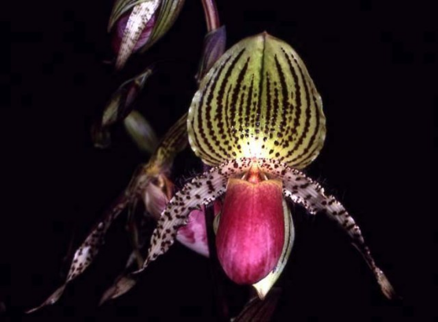
P. Pinocchio ’Chrysalis Elba Morales’ P. Vanguard ‘Muriel’ CSA Award
HCC/AOS 78 points 8 flowers on 2 inflorescences
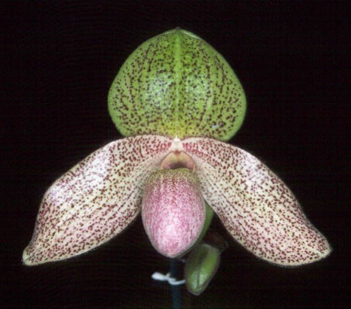
P. Utgard, ‘Adrienne’ AM/AOS P. Charles Sladden

References:
Orchidspecies.com
Orchidculture.com
OrchidWiz X5.2 Database

Barbara McNamee Page 3 of 3 6/8/19

