SPECIES DATA REPORT
Paphiopedilum henryanum Braem 1987
SUBGENUS Paphiopedilum SECTION Paphiopedilum Karasawa & Saito 1982
Common Name Henry's Paphiopedilum [Irish Plant Collector in China] - In China Heng Li Dou Lan
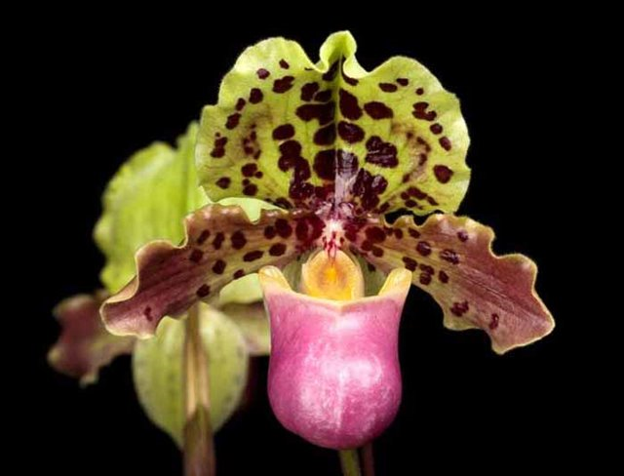
Flower Size 1 3/5" to 2 1/2" [4 to 6 cm]
Characteristics:

Distinctive color pattern – pink pouch, green, spotted dorsal sepal. Pouch coloration is dominant in its hybrids.
Paph. chaoi is now considered to be an albinistic forma called P. henryanum christae Braem.
P. henryanum is a diminutive species used for the breeding of smaller complex slipper orchids.

Barbara McNamee Page 1 of 4 8/10/19

ORIGIN/HABITAT: Southwest China. Plants are found near the village of Napo, which is in western Guangxi (Kwangsi) Province near the borders with Yunnan Province and northern Vietnam. Plants usually grow at 2000-3000 ft. (610-910 m), but have been reported from as high as 3950 ft. (1200 m). Little else
has been reported about the habitat, but Paphiopedilum henryanum has been reported as being found growing on the opposite creek bank from a colony of Paphiopedilum emersonii.

PLANT SIZE AND TYPE: A herbaceous humus epiphyte that may be up to 14 in. (35 cm) tall, including the inflorescence, and reach an overall width of about 14 in. (35 cm) when measured leaf tip to leaf tip.

PSEUDOBULB/STEM: The short stem is enclosed by the overlapping, longitudinally folded leaf bases.

LEAVES: Up to 6.7 in. (17 cm) long by 0.5-0.6 in. (1.2-1.6 cm) wide. Three to five spreading, linear to strap-shaped leaves with more or less rounded tips are carried on each growth. They are uniformly dark green on the upper surface, bright green on the lower side but may have a light purple hue at the base, and there is a distinct keel on the lower side.

INFLORESCENCE: Up to 6.3 in. (16 cm) long. The terete, green peduncle, which is thickly covered by brown to purple hairs, emerges from the center of the growth and usually bears a single blossom at the apex. The floral bract is bright green with purple at the base, is sharply pointed at the tip, and measures 0.8 in. (2 cm) long by 0.2 in. (0.6 cm) wide. The blossom is carried on an ovary that is yellowish green, densely covered with hairs, and is up to 1.6 in. (4 cm) long by 0.3 in. (0.8 cm) wide.

FLOWERS: 1 per inflorescence. The flower is up to 1.7 in. (4.3 cm) long by 2 in. (5 cm) wide when measured across the petals on a live blossom. The dorsal sepal is cream-yellow and is covered with large, irregularly shaped brown-purple spots. The synsepal is whitish to yellowish and is sometimes indistinctly spotted. The petals are deep rose-colored with a narrow cream-colored margin and bases that are more or less spotted with brown-purple. The main lobe of the lip is deep rose-colored and is brightest along the rim. It is smooth on the outside, but the rear and bottom parts of the inside wall of the main lobe are densely covered with stiff bristles. The staminode shield is bright yellowish green with a blunt yellow tooth at the center. The somewhat rounded dorsal sepal is about 1.4 in. (3.4 cm) long and almost as wide. The margins are slightly undulate, the basal margins often bend backward, there is a small, sharply pointed tip at the otherwise rounded apex, and the entire dorsal sepal curves forward somewhat to cover the opening of the lip. The inside surface is smooth, but the outer surface is densely hairy, and the margins are ciliate. The central part of the dorsal sepal is concave, and there is a prominent keel on the back side. The lateral sepals are united to form a synsepal that is about 1.1 in. (2.7 cm) long by 0.6 in. (1.6 cm) wide. It is 2-toothed at the apex and has 2 keels on the back side, is densely hairy on the back, and has ciliate margins. The narrowly ovate to broadly elliptic petals are more or less spreading but may curve inward somewhat. They are more or less rounded at the apex, have margins that are distinctly undulate and hairy, are smooth on both the front and back. The 3-lobed lip has an overall measurement of about 1.7 in. (4.2 cm) long by 0.8 in. (2 cm) wide by up to 1 in. (2.5 cm) deep. The lateral lobes are folded inward, forming an almost closed tube. The main lobe is shaped like an inverted helmet with well-developed lateral ears at the opening. The main lobe is about 1.2 in. (3 cm) long by 0.8 in. (2 cm) wide with a rounded apex and an opening that is about 0.8 in. (2 cm) wide with borders that are distinctly directed outward. The staminodal shield is obcordate, about 0.28 in. (0.7 cm) high, and is slightly wider at the lower margin.

In Taiwan, line bred species now have a flush of pigment overlaying a heavily spotted dorsal sepal, and the pouch is a darker reddish color.

Botanical Varieties:
Paphiopedilum henryanum var. christae Braem 1991

Barbara McNamee Page 2 of 4 8/10/19

Synonyms:
Paphiopedilum chaoi Hua 1999
Paphiopedilum dollii Luckel 1987
Paphiopedilum henryanum f. album O.Gruss 2002
Paphiopedilum henryanum f. chaoi (H.S.Hua) O.Gruss & M.Wolff 2007
Paphiopedilum henryanum f. christae (Braem) O.Gruss & Roeth 1999
Paphiopedilum henryanum var. christae Braem 1991

Awards:
ORIGIN | AM | HCC | CCM | CHM | CBR | AQ | TOTAL
AOS | 29 | 21 | 2 | 2 | 1 | 1 | 56

Hybrids: 149 registered to the 4th generation
With 149 progeny, 99 are first generation, only 23 have offspring and only 21 are awarded.
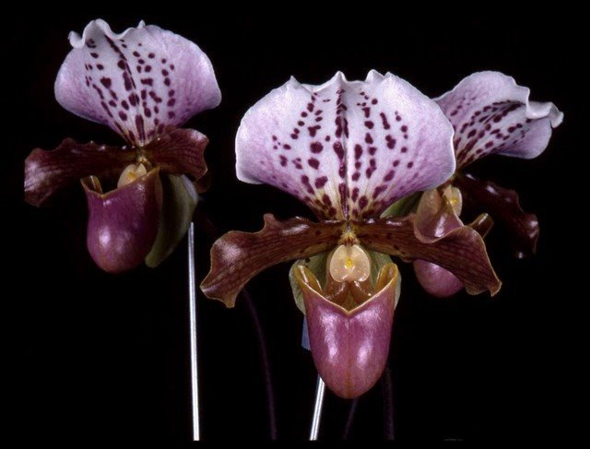
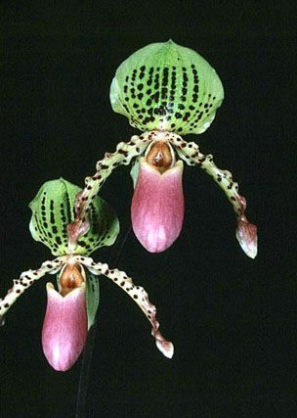
Paph. Pebblepack ‘The Rocks’ Paph. Doll’s Kobold ‘Hart’s Reward’ HCC/AOS
HCC/AOS (Transvaal x henryanum) (henryanum x charlesworthii)
5 HCC, no offspring 2CCM, 4 AM, 2 HCC
Barbara McNamee Page 3 of 4 8/10/19
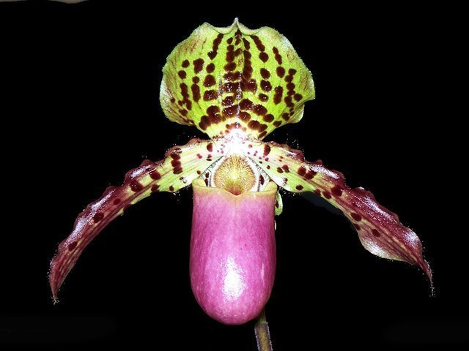

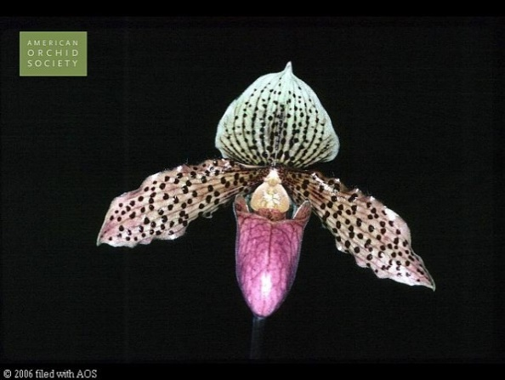
Paph. Graham Robertson ‘Jamboree Joy’ Paph. Princess Biianka (P. Bianka x henryanum)
HCC (sukhakulii x henryanum) 4 AM, 5 HCC, no offsrng
AM, HCC 2 offspring

References:
Orchiidspecies.com
Koopowitz, Harold 2018 Orchid Digest “An Annotated Checklist of Paphiopedilum Species” Vol. 82-4 P202
OrchidWiz Database
OrchidsPlus

Barbara McNamee Page 4 of 4 8/10/19

