SPECIES DATA REPORT
Paphiopedilum papuanum (Ridl. ex Rendle) L.O. Williams 1946
SUBGENUS Sigmatopetalum SECTION Blepharopetalum
Common Name The Papua Paphiopetalum
Pronounce –
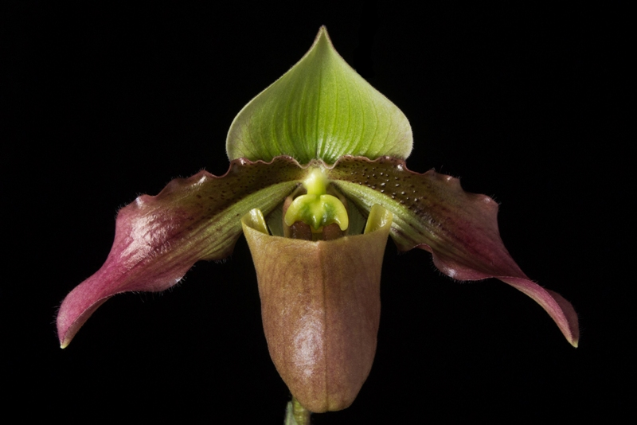
Characteristics:
Flower Size 2.4 to 4.6" [6 to 9 cm]

ORIGIN/HABITAT: This small sized, warm to cool growing epiphytic species is found in Papua and New Guinea at elevations of 800 to 1700 meters.

DESCRIPTION: Jay Pfahl describes this orchid species as "This small sized, warm to cool growing epiphytic species is found in Papua and New Guinea at elevations of 800 to 1700 meters with 4 to 6, oblong to oblong-elliptic, tesselated dark and light green, obtuse and tridenticulate apically leaves that blooms in the summer and fall on a single flowered, erect, to 10 3/4 [28 cm] long, reddish pubescent inflorescence with an ovate, pubescent floral bract and holding the flower well above the leaves

Barbara McNamee Page 1 of 2 11/9/19

Botanical Varieties:
none
Synonyms:
*Cypripedium papuanum Ridl. ex Rendle 1915
Paphiopediulm zieckianum Schoser 1967
Awards:
ORIGIN | AM | HCC | CCM | CHM | CBR | JC | TOTAL
AOS |  | 2 |  |  |  | 1 | 3

Hybrids: 3 total progeny registered to the 1st generation
There are 3 F1’s, none are awarded

References:
Orchiidspecies.com
OrchidWiz X6.0 Database
OrchidsPro
Barbara McNamee Page 2 of 2 11/9/19

