SPECIES DATA REPORT
Paphiopedilum parishii [Rchb.f] Stein 1894
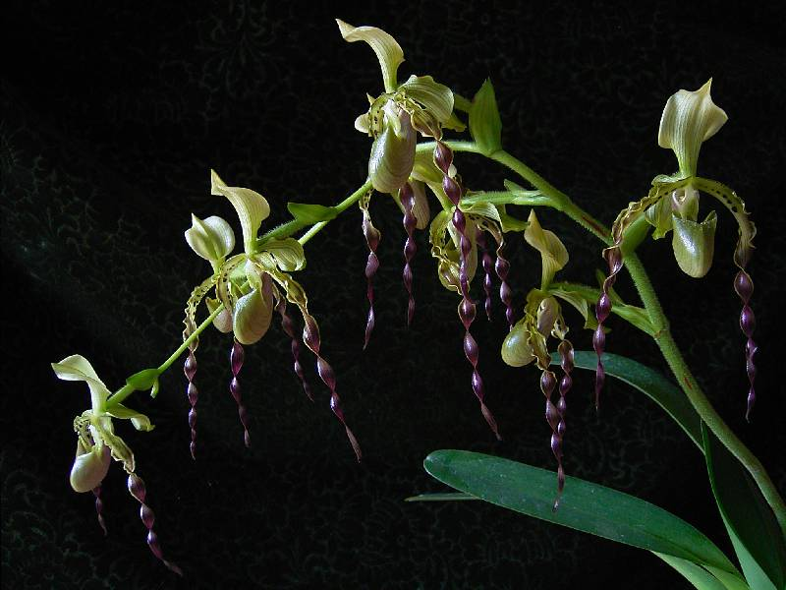
Common Name Parish's Paphiopedilum [English Orchid Collector 1800's] - in Thailand Rangthao nari mu'ang kan, Rangthao nari nuat ruesi - In China Piao Dai Dou Lan

Pronounce: par-ish-ee-eye
Flower Size 3" or more [8 cm]
Characteristics:

ORIGIN/HABITAT: Burma and Thailand. Plants are found in the Shan Plateau region of Burma at 4100-4500 ft. (1250-1370 m), and in the mountains of western and northern Thailand. Paphiopedilum parishii usually grows on east-facing slopes in shaded, low light conditions. It grows epiphytically on the middle or lower branches of trees between 5-15 ft. (3-5 m) above the ground, but it also grows in thick mosses on boulders or fern roots.

Barbara McNamee Page 1 of 3 6/8/19

PLANT SIZE AND TYPE: A large epiphytic or lithophytic plant with growths that may be clustered or spaced some distance apart along the rhizome.

PSEUDOBULB/STEM: The relatively long stem is enclosed by the distichous, overlapping, longitudinally folded bases of the leaves.

LEAVES: Up to 18 in. (45 cm) long by 1.6-3.0 in. (4.0-7.5 cm) wide. Each growth carries 5-8 spreading to arching leaves that are oblong to strap-shaped, 2-lobed at the apex, and bright green. They are channeled along the midvein and become increasingly V-shaped in cross section toward the base.

INFLORESCENCE: Up to 24 in. (60 cm) long. The stout, erect inflorescence is bright green and covered with downy hairs. Bracts are egg-shaped, sharply pointed, inflated, about 1.6 in. (4 cm) long, and cover the hairy ovaries for about three-quarters of their length

FLOWERS: 4-8 per inflorescence. The flowers, which are up to 7 in. (17 cm) tall by 5 in. (12 cm) across, have a pale yellow dorsal sepal that is marked with longitudinal green veins, and a synsepalum that is similar in color to the dorsal sepal. The petals are green at the base with a few scattered blackish spots, but they grade to blackish purple with a pale margin on the apical half. The lip is deep green suffused with brownish purple. It has deep green lateral lobes that often are stained with brownish purple. The staminodal shield is yellow with green mottling. The erect dorsal sepal is 1.2-2.0 in. (3-5 cm) long and up to 1 in. (2.5 cm) wide. It is elliptic-oblong, has a narrow base, a sharply pointed tip, is keeled on the back, the lateral margins curl backward at the base, and the upper half of the blade bends forward. The synsepalum is similar but smaller than the dorsal sepal and has 2 keels on the back side. The long, linear petals are about 5 in. (12 cm) long by 0.5 in. (1.2 cm) wide and twist several times along their length. The spread horizontally at the base but curve quickly downward and become quite pendulous. The lip, which tapers to a fairly narrow apex, is shaped like an inverted helmet and has a large mouth. It is up to 1.8 in. (4.5 cm) long by up to 0.9 in. (2.3 cm) wide and has narrow lateral lobes that fold inward. The staminodal shield is up to 0.6 in. (1.4 cm) long by 0.3-0.4 in. (0.7-0.9 cm) wide. It is obovate-oblong with a sinus in the broader front edge and a prominent tooth at the base.

Botanical Varieties: none
Synonyms:
Cordula parishii [Rchb.f] Rolfe 1912
*Cypripedium parishii Rchb.f 1869
Selenipedium parishii (Rchb. f.) Andre 1875

Awards:
ORIGIN | AM | CBM | CCM | CHM | HCC | TOTAL
AOS | 24 | 1 | 13 | 1 | 18 | 57

Hybrids:
Paphiopedilum Robinianum (P. lowii x P. parishii) 50% each 27 AM, CCE. 2 CCM, 3 FCC, 14 HCC, P. Robiniaum ‘Alisa Male’ FCC/AOS 92 pts., had 17 flowers, 2 buds on four inflorescences, NS 16.2 cm, P. Robinianum ‘Crystelle’ CCM, AM had 16 flowers, 12 buds on six inflorescences measuring 19 cm; used 5 times in hybridizing, only 1 award, an HCC awarded to P. Rob Mint ‘Twister Party’.
Barbara McNamee Page 2 of 3 6/8/19

Paphiopedilum Bengal Lancers (P. haynaldianum P. parishii) 50% each, 7 AM, CCM, 8 HCC, JC, used 16 times in hybridizing, significant progeny P. Memoria Galen Fox the most awarded with a CCM, 2 AM, 2 HCC’s but no offspring.
P. Frank Booth (P. stonei x P. parishii) 50% each, used 10 times in hybridizing, 5 AM, 7 HCC, P. Frank Booth ‘Ovid’s Mark’ was the largest measuring 18 cm, 3 flowers, 1 bud on 1 inflorescence, no awards or offspring to progeny.
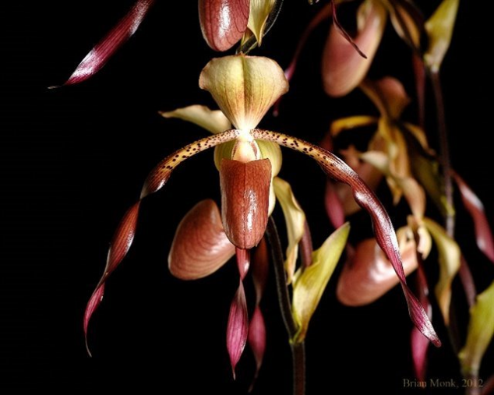
P. Umatilla (P. parishii x P. philippinense) owner W. W. Wilson, 5 AM, CCM, 2 HCC, P. Umatilla ‘Tower Grove’ CCM,AM, the 1992 AM measured 16.0 cm, had 7 flowers on one inflorescence, the 2010 CCM had 14 flowers, 12 buds on four inflorescences, measured 13.0 cm, only one progeny, no offspring or awards.
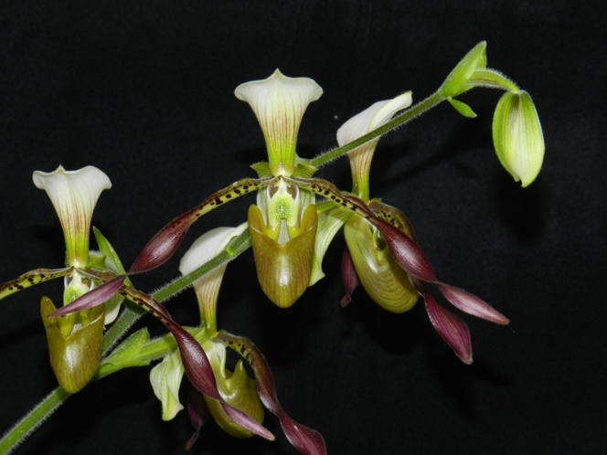

Paphiopedilum Robinianum ‘Crystelle’ AM/AOS Paphiopedilum Huntington’s Cavalry AM/AOS
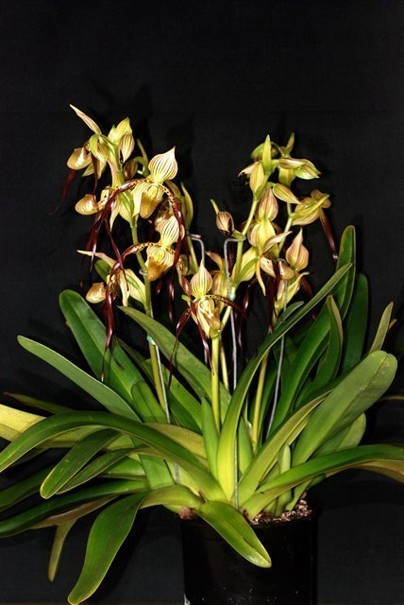
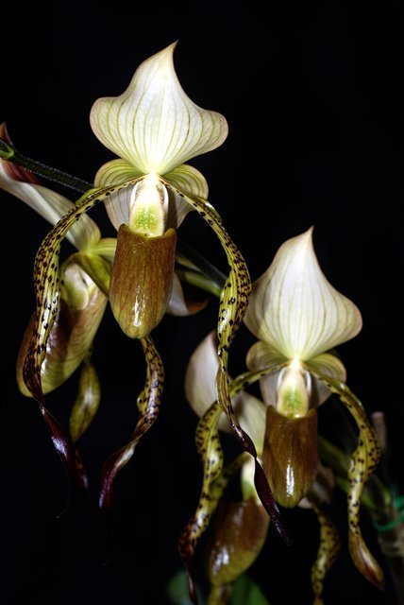
Paphiopedilum Frank Booth ‘Hilltop’s Zack’ Paphiopediilum Umatilla ‘Tower Grove’
AM/AOS CCM,AM/AOS
References:
Orchidspecies.com
OrchidWiz X5.2 Database
Barbara McNamee Page 3 of 3 6/8/19

