SPECIES DATA REPORT
Paphiopedilum purpuratum [Lindley] Stein 1894
SUBGENUS Sigmatopetalum SECTION Planipetalum
Common Name The Purple Paphiopedilum - In China Zi Wen Dou Lan
Pronounce – per-per-AY-tum
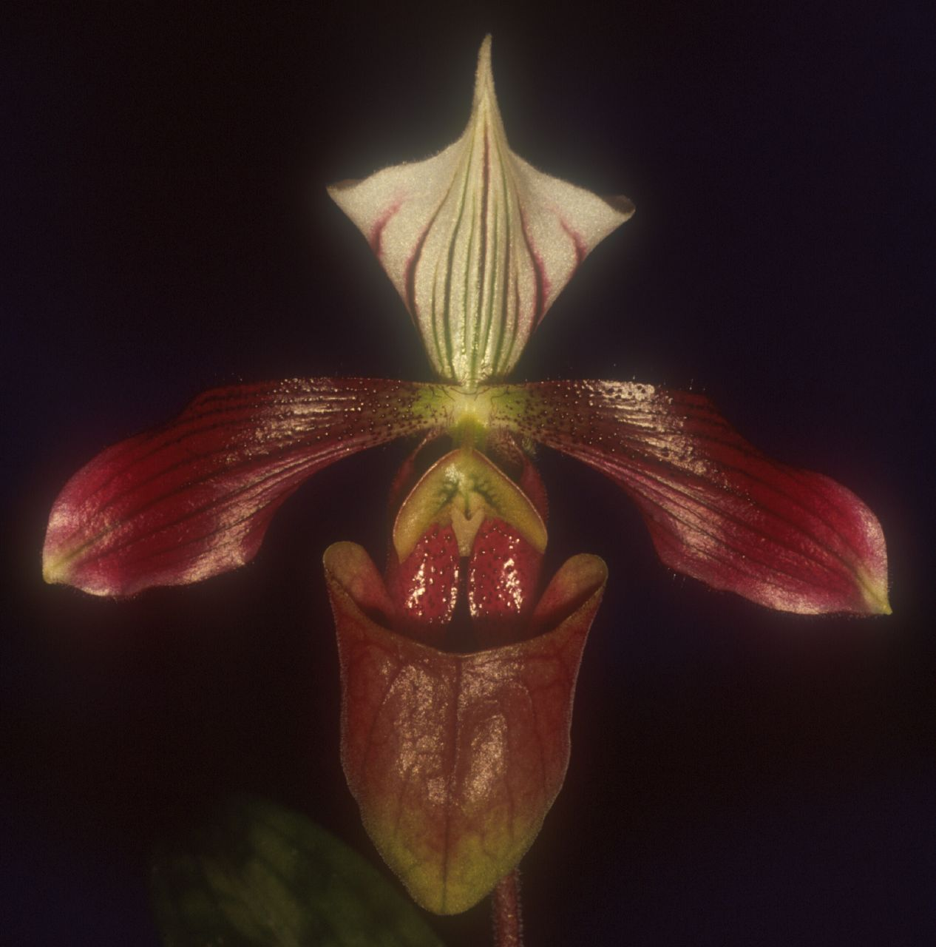
Characteristics:
The dorsal sepal has strongly reflexed lateral margins, is white and is marked with unequal longitudinal veins of purple that extend almost to the margins
The petals are marked with darker purple longitudinal veins, have blackish maroon spots liberally scattered over the basal one-third to one-half, have hairy margins
Flower size – 3 to 4" [7.5 to 10 cm]

Barbara McNamee Page 1 of 4 9/7/19
ORIGIN/HABITAT: Hong Kong and in the provinces of Guangdong, Guangxi, and southeast Yunnan in southeast China, as well as in northeastern Vietnam. There have been recent reports of collections on Hainan Island. Plants grow at 100-2300 ft. (30-700 m) on north and northwest facing wooded slopes near streams. They also grow with their roots embedded in thick, leafy humus at the base of tall trees, in bamboo thickets along stream banks, and on rock faces covered in moss. In addition, they have been reported on steep, rocky slopes growing in light shade beneath low scrub. In Vietnam, collections have been reported near Nguyen Bin in Cao Bang Province where plants were growing as lithophytes or terrestrials in shady areas in primary forests of semi deciduous, broad-leaved trees growing in rocky, weathered limestone at 4250-4600 ft. (1300-1400 m).

PLANT SIZE AND TYPE: A terrestrial plant with a leaf span up to about 10 in. (26 cm) across.

PSEUDOBULB/STEM: The short stem is enclosed by overlapping leaf bases.

LEAVES: 3-7 in. (7-17 cm) long by 1.0-1.6 in. (2.5-4.0 cm) wide. Three to eight narrowly oblong-elliptic leaves with sharply pointed tips and channeled mid-veins are carried on each growth. Leaves vary in color from yellow-green to bluish green with varying degrees of lighter colored tessellations. The lower side of the leaves is pale green with no purple pigmentation. Longitudinal striations occur in the leaves of these plants in the wild.

INFLORESCENCE: 6-8 in. (14-20 cm) long. The erect, purple inflorescence is produced from the center of the growth and is covered with purple hairs. Flowers are carried on a green pedicellate ovary that is covered with purple hairs and is 1.0-1.6 in. (2.5-4.0 cm) long.

FLOWERS: 1 per inflorescence. The flower is up to 3 in (8 cm) across the spreading petals. The dorsal sepal is white and is marked with unequal longitudinal veins of purple that extend almost to the margins. The synsepalum is green with dark green veins. Petals are dark purple except for a small area of white or greenish white toward the apex. They are held in more or less horizontally spreading positions, are marked with darker purple longitudinal veins, have blackish maroon spots liberally scattered over the basal one-third to one-half, have hairy margins, and may be somewhat recurved near the apex. The lip is purple-maroon to mahogany. The dorsal sepal is broadly egg-shaped, has strongly reflexed lateral margins, and is 1.0-1.4 in. (2.5-3.5 cm) long. The synsepalum is egg-shaped to oblong and is much smaller than the dorsal sepal. The narrowly oblong petals are 1.4-1.8 in. (3.5-4.5 cm) long. The helmet-shaped lip is 1.4-1.8 in. (3.5-4.5 cm) long by 0.8-1.0 in. (2.0-2.6 cm) wide, and the staminode is broadly egg- to crescent-shaped, measuring 0.3 in. (0.8 cm) long by 0.4 in. (1 cm) wide.

Botanical Varieties:
Paphiopedilum purpuratum var hainanense Liu & Perner 2001
Synonyms:
Cordula purpurata [Lindley] Rolfe 1912
*Cypripedium purpuratum Lindley 1837
Cypripedium sinicum Hance ex Rchb.f 1853
Menephora bicolor Raf. 1836
Paphiopedilum aestivum Liu & Zhang 2001
Paphiopedilum purpuratum f. album O.Gruss & Koop. 2008
Paphiopedilum purpuratum var hainanense Liu & Perner 2001
Paphiopedilum sinicum [Hance ex Rchb.f] Stein 1892
Awards:
ORIGIN | AM | HCC | CCM | CHM | CBR | JC | TOTAL
AOS | 6 | 13 | 2 |  | 1 | 1 | 23
Barbara McNamee Page 2 of 4 9/7/19
Hybrids: 1,513 progeny registered to the 8th generation
There are 65 F1’s, only 9 are awarded
The most highly awarded progeny:
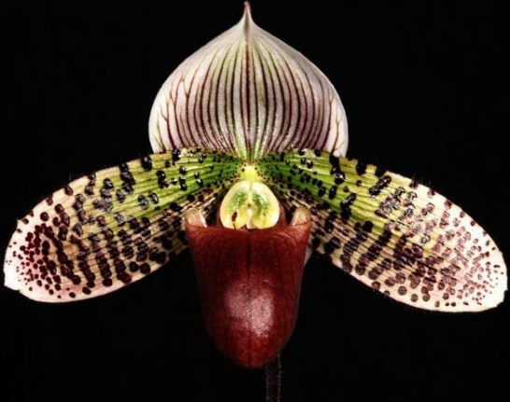
P. Macabre (P. sukhakulii x P. Voodoo magic) used 125 times in hybridizing, 133 awards: 57 AM, 6 FCC, 2 AQ, 68 HCC, most highly awarded offspring P. Hsinying Maru (P. Macabre x P. Ruby Mist) 15 offspring, 9 awards – 6 AM, 3 HCC.

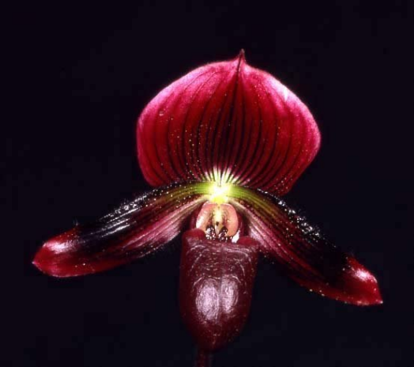
P. Macabre ‘Dot to Dot’ HCC/AOS

P. Vintner’s Treasure (P. Kowloon x P. callosum) used 74 times in hybridizing, 1,411 total progeny, 30 awards – 12 AM, 16 HCC, 1 AQ, 1 JC. Most awarded offspring P. Voodoo Magic (P. Vintner’s Treasure x P. Goultenianum) 83 offspring, 19 awards – 7 AM, 12 HCC.

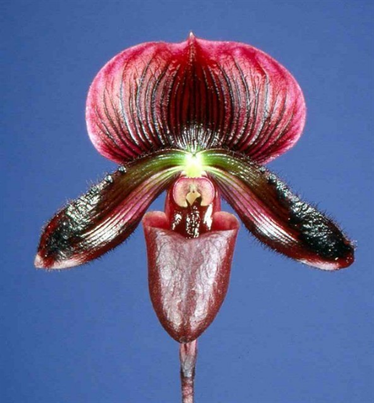
P. Vintner’s Treasure ‘Black Ruby’ CSA award photo

P. Pacific Magic (P. Maudiae x P. Voodoo Magic) used 13 times in hybridizing, 25 total progeny, 25 awards – 10 AM, 1 FCC, 14 HCC, most awarded offspring P. Stardust Flight (P. Pacific Magic x P. Tuxedo Junction) 4 awards – 2 AM, 2 HCC, 4 offspring.

P. Pacific Magic ‘Red Nova’ HCC/AOS
Barbara McNamee Page 3 of 4 9/7/19

P. Voodoo Magic (P. Goultenianum x P. Vintner’s Treasure) used 83 times in hybridizing, 1,045 total progeny, 19 awards – 7 AM, 12 HCC, most awarded offspring is P. Macabre (P. Voodoo Magic x P. sukhakulii) 125 offspring, 133 awards: 57 AM, 6 FCC, 2 AQ, 68 HCC.
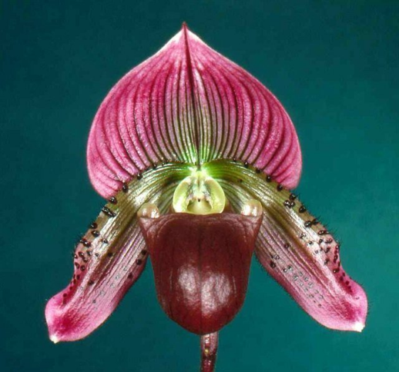

P. Voodoo Magic ‘Dark Brew’ HCC/AOS

P. fairieanum unexpectedly toned down the coloration of some hybrids to such an extent that they look pale and faded, evident in the primary hybrid between the species and purpuratum called P. H. Ballentine; a disappointment that has no awards or offspring as purpuratum and many of its hybrids have richly colored petals and pouch.

References:
Orchiidspecies.com
Koopowitz and Hasegawa 1989 “Novelty Slipper Orchids”
OrchidWiz X5.3 Database
OrchidsPlus

Barbara McNamee Page 4 of 4 8/10/19

