SPECIES DATA REPORT
Paphiopedilum sangii Braem 1987
SUBGENUS Sigmatopetalum SECTION blepharopetalum
Common Name Sang's Paphiopedilum [German Orchid Enthusiast]
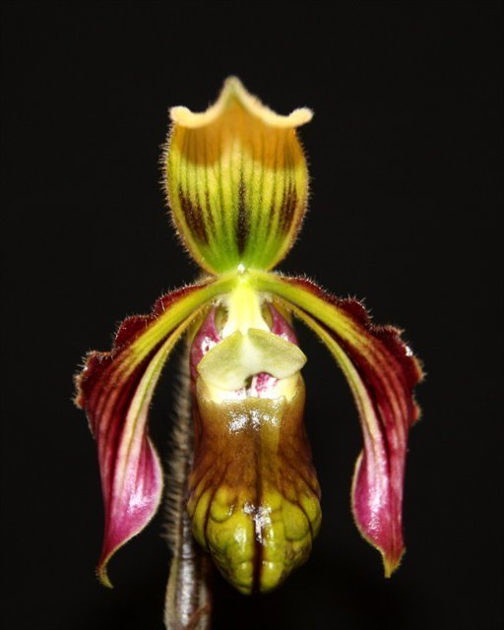

Characteristics:
Urceolate pouch - urceolatus, -a, -um (er-see-oh-LAY-tus) Hollow and cylindrical or ovoid, and contracted at or below the mouth like an urn; urn-shaped; urceolate.

Downswept petals

Flower size – median NS 5.4 cm

ORIGIN/HABITAT: Found in the Celebes [Sulawesi].

DESCRIPTION: Jay Pfahl describes this orchid species as "Cool to warm growing, humus epiphyte that blooms in the mid-fall through mid-spring on an erect, terette, very dark brown, intensly pubescent, 10 [22.5 cm] long,
single flowered inflorescence with a distinct basal sheath.

Barbara McNamee Page 1 of 2 9/7/19

Botanical Varieties:
Paphiopedilum sangii var. ayubianum O.Gruss & Roeth 2006
Synonyms:
Paphiopedilum sangii var. ayubianum O.Gruss & Roeth 2006

Awards:
ORIGIN | AM | HCC | CCM | CHM | CBR | AQ | TOTAL
AOS | 8 | 12 | 1 |  | 1 |  | 22

Hybrids: 10 registered to the 1st generation
There are 10 progeny registered, none have offspring or awards, only one photo is available.
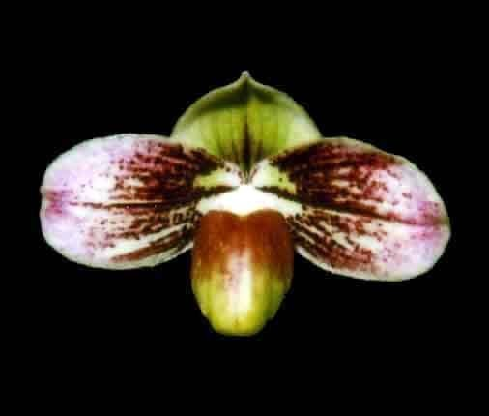
Paphiopedilum Wössner Godesang (P. sangii x P. godefroyae)

References:
Orchiidspecies.com
Koopowitz, Harold 2018 Orchid Digest “An Annotated Checklist of Paphiopedilum Species” Vol. 82-4 P202
OrchidWiz Database
OrchidsPlus

Barbara McNamee Page 4 of 4 8/10/19

