SPECIES DATA SHEET
Paphiopedilum supardii Braem & Lob 1985
Common Name Supard's Paphiopedilum [Indonesian Orchid Collector current]
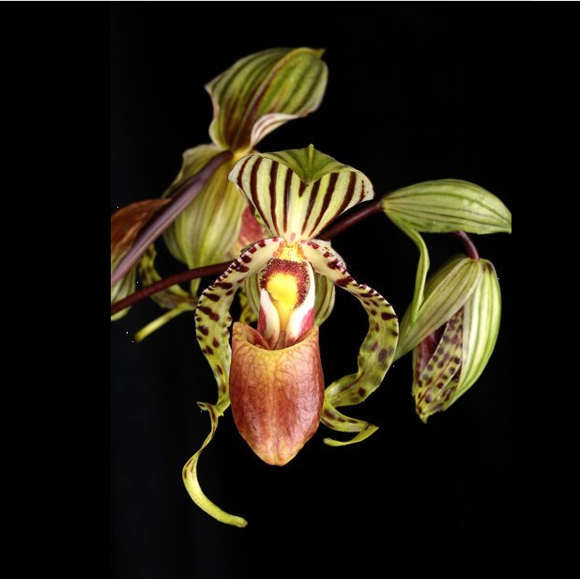
Flower Size 4" [10 cm]
Characteristics:
Drooping, ribbon-shaped petals are twisted on the apical part, taper to sharply pointed tips, and are 3.1
Egg-shaped, sharply pointed dorsal sepal is somewhat concave, keeled on the back
The staminode is knee-shaped
Saccate lip
ORIGIN/HABITAT: Borneo. This species is found only in southeast Kalimantan, where it grows along the Kapuas River at 1950-3150 ft. (600-960 m). It is usually found on limestone rocks in hollows filled with leaf-mold in locations exposed to morning sun but in shade the rest of the day.

PLANT SIZE AND TYPE: An erect lithophytic plant.

PSEUDOBULB/STEM: The short stem is enclosed by the closely spaced, distichous, overlapping, longitudinally folded leaf bases.

LEAVES: 9-22 in. (22-55 cm) long by 1.4-2.2 in. (3.5-5.5 cm) wide. Seven to nine strap-shaped leaves are distichously arranged into a fanlike growth. They are leathery, suberect, rounded to unequally bilobed at the apex, channeled on the upper surface with a corresponding keel on the lower side, and become increasingly folded longitudinally toward the base.

INFLORESCENCE: 12-18 in. (30-45 cm) long, including the 8-12 in (20-30 cm) long peduncle. The erect to arching peduncle emerges from the center of the growth. Flowers are carried in a raceme toward the apex of the spike, each one with an elliptic floral bract that is sharply pointed, is pale yellow-green with purple longitudinal lines, and measures up to 2.1 in. (5.2 cm) long, which is about the same length or slightly longer than the ovary.

FLOWERS: 3-7 per inflorescence. The dorsal sepal and the synsepal are white with pale green margins and are distinctly striped with numerous longitudinal dark brown lines. The stripes on the synsepal are considerably narrower, however. Petals have the same pale color as the sepals but are marked with dark brown-maroon spots, bars and wart-like structures. The lip is pale to dark brown with darker brown reticulations, and the inwardly folded lateral lobes have white margins. The staminode has a yellow shield and has dark brown hairs covering the margins of the platform. The egg-shaped, sharply pointed dorsal, and 1.0-2.2 in. (2.5-5.5 cm) long by 0.9-1.0 in. (2.4-2.6 cm) wide. The synsepal is similar to the dorsal sepal but narrower.

Barbara McNamee Page 1 of 2 6/8/19
The drooping, ribbon-shaped petals are twisted on the apical part, taper to sharply pointed tips, and are 3.1-3.5 in. (8-9 cm) long by 0.3-0.4 in. (0.7-0.9 cm) wide. The clearly saccate lip is about 1.8 in. (4.5 cm) long by 0.6-0.7 in. (1.5-1.8 cm) wide. The staminode is knee-shaped and is about 0.3 in. (0.8 cm) long by 0.3-0.4 in. (0.8-0.9 cm) wide.

Botanical Varieties: none
Synonyms:
Paphiopedilum "victoria" devogeli Schoser & Van Deed 1978
Paphiopedilum praestans sensu Van Vloten 1933
Paphiopedilum praestans Van Hell 1938
Paphiopedilum "victoria' de Vogel 1975

Awards:
ORIGIN | AM | CCM | CHM | HCC | TOTAL
AOS | 1 | 1 | 1 | 5 | 8

Hybrids:
There are 28 hybrids registered to Paph. supardii in only two generations from 1991 - 2017, 3 have offspring of their own and six have a total of 12 awards. Paph. David Ott would be the most successful progeny with 3 AM’s and one HCC
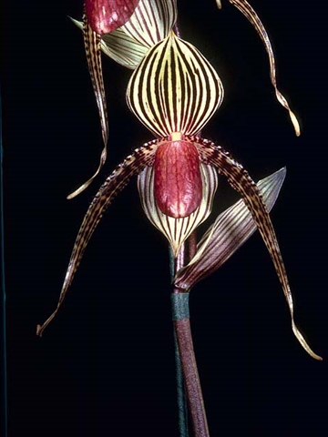
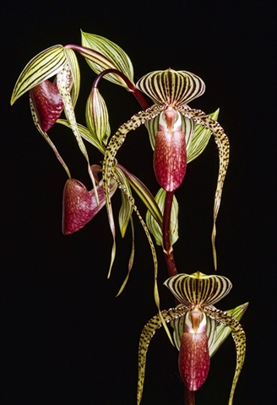

Paph. David Ott ‘Elektra’ AM/AOS 88 pts. Paph. David Ott ‘Candor Talon’ AM/AOS 87 pts
5 flowers, 1 bud on 1 inflorescence, NS 11 cm 4 flowers, 1 bud on 1 inflorescence, NS 15.5 c

References:
AOS.org
OrchidWiz Database X5.2
Orchidspecies.com

Barbara McNamee Page 2 of 2 6/8/19

