SPECIES DATA REPORT
Paphiopedilum urbanianum Fowlie 1981
SUBGENUS Sigmatopetalum SECTION Barbata SUBSECTION Chloroneura
Common Name Urban's Paphiopedilum [Mrs. Jacinta Urban Tecson - Philippine Orchid Nurserywoman]
Pronounce – ur-ban-ee-AY-num (metropolitan, in town)
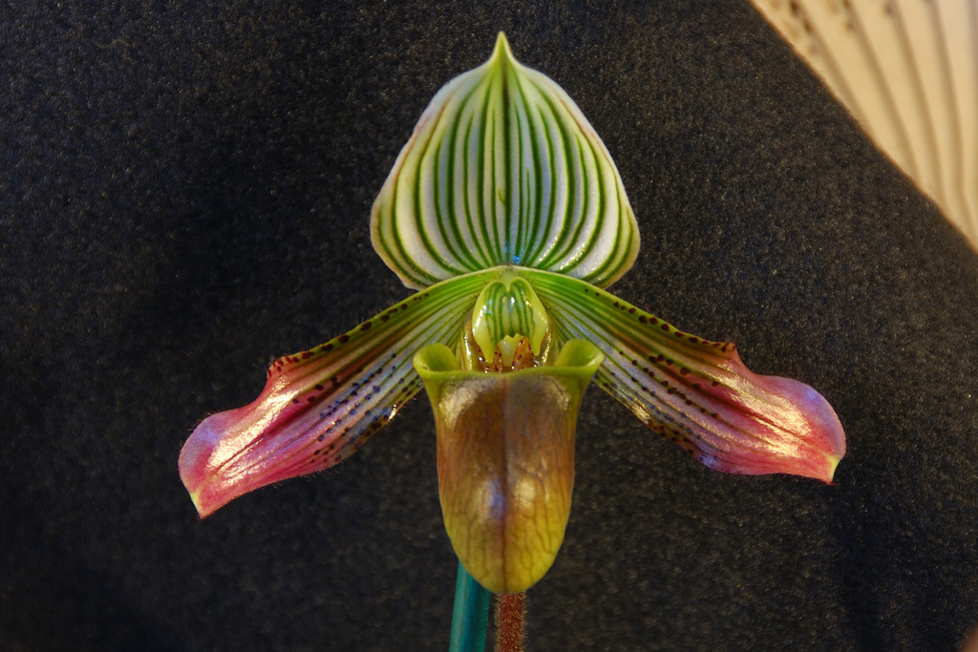
Characteristics:
Flower Size 4 1/5" [10.5 cm]
Somewhat drooping petals.
The dorsal sepal is broadly egg-shaped to almost circular and sharply pointed tip at the apex
The staminode is distinctly notched above and below and the lower margin has a small tooth in the middle of the sinus

ORIGIN/HABITAT: The Philippine Islands. Found only on Mindoro Island at 1300-2600 ft. (400-800 m). Plants grow on northeast-facing slopes, usually among rocks in fairly shaded locations on the jungle floor. The roots generally are embedded in thick pads of humus and leaf litter.

PLANT SIZE AND TYPE: A moderately large, herbaceous perennial which grows as a semi-epiphyte or semi-terrestrial in leaf-mold on the forest floor. Plants have a leaf span of up to 16 in. (40 cm), and the growths are closely spaced on a short rhizome.

Barbara McNamee Page 1 of 3 11/9/19

PSEUDOBULB/STEM: The short stem is enclosed by distichous arranged, overlapping, longitudinally folded leaf bases.

LEAVES: 5-8 in. (12-20 cm) long by 1.2-1.6 in. (3-4 cm) wide. 5-6 narrowly elliptic or oblong-elliptic leaves with bluntly pointed and minutely 3-toothed tips are carried on each growth. The leaves are channeled along the mid-vein on the top surface, keeled on the lower side, and narrow toward the base, tapering to a fairly long, narrow, longitudinally folded base. They are pale green with faint tessellations of somewhat darker green on the upper surface and have hairy margins toward the base. The pale green lower side is free of any purple pigmentation.

INFLORESCENCE: 8-10 in. (20-25 cm) long. The erect peduncle emerges from the apex of the stem along the axil of the apical leaf. It is purple and densely covered with short, fuzzy hairs and has a floral bract that is 0.8-1.2 in. (2-3 cm) long by 0.4-0.8 in. (1-2 cm) wide, is green with maroon veins, and is covered with short, fuzzy hairs. Flowers are carried on a pedicellate ovary that is 2.0-2.4 in. (5.0-6.5 cm) long, is green with maroon ribs, and is also covered with short, fuzzy hairs.

FLOWERS: 1-2 per inflorescence. Usually only a single blossom is produced, but occasionally a second bloom may develop before the first one falls. The flowers are 3.3-4.1 in. (8.5-10.5 cm) across the spreading, somewhat drooping petals. The broadly egg-shaped to almost circular dorsal sepal is 1.2-1.4 in. (3.3-3.6 cm) long by 1.4-1.7 in. (3.6-4.2 cm) wide and has an abrupt, fairly short, sharply pointed tip at the apex. It is greenish white marked with 11-13 curving, parallel, longitudinal veins of alternating longer and shorter length. These veins usually are green, but they may sometimes be partially rose-lilac. The concave, narrowly elliptic to egg-shaped, sharply pointed synsepalum is 1.0-1.2 in. (2.6-3.2 cm) long by 0.6-0.7 in. (1.6-1.9 cm) wide and is greenish white with up to 9 green longitudinal veins. The oblanceolate petals are more or less rounded at the slightly recurved at the apex and are held at a descending angle of approximately a 45. They are 2.2-2.4 in. (5.5-6.0 cm) long by 0.5-0.6 in. (1.2-1.5 cm) wide and are green over the basal half marked with 7-8 dark green longitudinal veins. The apical half is purple, and the central third is fairly densely covered with dark maroon, sparsely hairy warts. The deeply pouched lip is up to 2 in. (5 cm) long by 0.9-1.0 in. (2.2-2.6 cm) wide. It is slightly constricted below the aperture and is colored a glossy green, suffused with bright leather-like brown, has dark greenish brown veins toward the lower end of the pouch, and may be suffused with rose-purple over the area just below the opening. The staminodal shield is up to 0.5 in. (1.2 cm) high and 0.4 in. (1 cm) wide. It is somewhat rounded, distinctly notched above and below, and the lower margin has a small tooth in the middle of the sinus. The staminode is yellowish brown with a distinct green pattern and is covered with short, fuzzy hairs.

Botanical Varieties:
none
Synonyms:
Paphiopedilum urbanianum f. alboviride Braem 1998
Awards:
ORIGIN | AM | HCC | CCM | CHM | CBR | JC | TOTAL
AOS | 4 | 17 | 6 | 2 | 1 | 1 | 31

Barbara McNamee Page 2 of 3 11/9/19
Hybrids: 48 total progeny registered to the 2nd generation
There are 38 F1’s, only 6 are awarded
The most highly awarded progeny:
P. Erica Potent (P. urbanianum x P. hookerae) 1 AM, 1 CCM, 2 HCC, no offspring, not used for hybridizing, very tall inflorescences possibly.
P. Karen Muir (P. godefroyae x P. urbanianum) hybridized only one time, has 1 AM, 2 HCC, 1996 is the lastest award.P. Duane Erdmann (P. urbanianum x P. bellatulum) not used for hybridizing, has 2 awards, 1 AM, 1 HCC, latest award was in 1997.

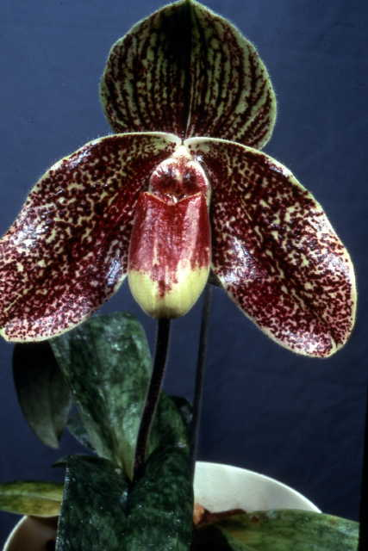

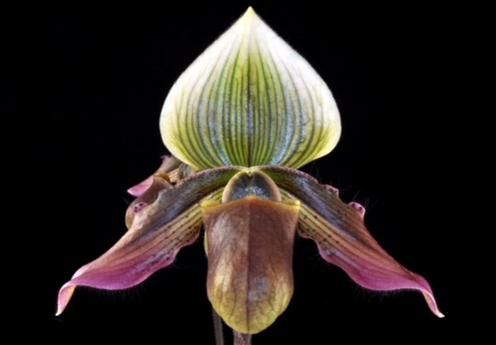
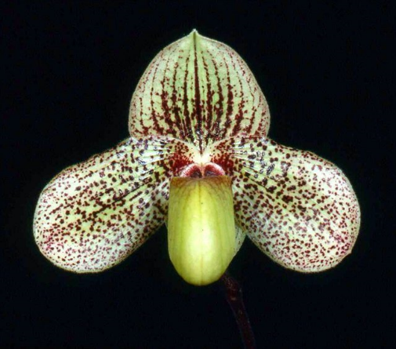

P. Erica Potent AM/AOS P. Karen Muir HCC/AOS P. Duane Erdmann AM/AOS

References:
Orchiidspecies.com
OrchidWiz X6.0 Database
OrchidsPro
Barbara McNamee Page 3 of 3 11/9/19

