SPECIES DATA SHEET
Paphiopedilum wilhelminae L.O.Williams 1942
Common Name Wilhelminha's Paphiopedium [Queen of the Netherlands 1900's]
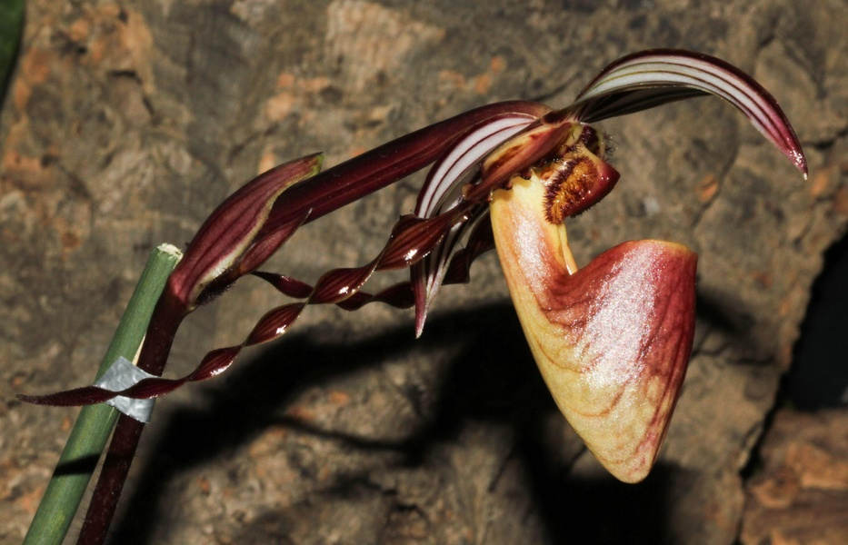
Flower Size 5-6 in. (12-16 cm)
Characteristics:
Often cited as a synonym of P praestans but there are diferences in the shape of the staminode
ORIGIN/HABITAT: New Guinea. This terrestrial orchid is distributed in a narrow east-west band at 5600-5900 ft. (1700-1800 m) through the highlands of central New Guinea from near the Wissel Lakes region in western New Guinea (Irian Jaya) eastward to Southern Highlands Province in Papua New Guinea. Plants are found grassy slopes that have been long deforested, growing in heavy clay-like soil over limestone, and on limestone rubble in full sunlight. They grow in the open in bright light among grasses or near rhododendrons.

PLANT SIZE AND TYPE: A clump-forming terrestrial with clustered growths that form large clumps that in nature have been observed at 24 in. (60 cm) or more in diameter.

PSEUDOBULB/STEM: The short stems are completely concealed by the closely spaced, distichous, overlapping, longitudinally folded leaf bases.

LEAVES: 2.4-11.0 in. (6-27 cm) long by 0.8-1.4 in. (2.0-3.5 cm) wide. Four to six linear-oblong leaves with bluntly pointed, 3-toothed apices are distichously arranged on each growth. They are dark green, smooth, and sparsely hairy on the basal margins.
Barbara McNamee Page 1 of 3 6/8/19
INFLORESCENCE: 12-20 in. (30-50 cm) long. The erect peduncle is purple to greenish brown and is covered with short hairs. The floral bracts are egg-shaped, sharply pointed, smooth, pale yellow with purple longitudinal stripes, hairy, and up to 1.8 in. (4.5 cm) long. Each blossom is carried on a pedicellate ovary that is 2.0-2.8 in. (5-7 cm) long.

FLOWERS: 1-3 per inflorescence. The large blossoms are 5-6 in. (12-16 cm) across and have sepals that are pale whitish yellow with maroon longitudinal veins. The petals are yellow with dark maroon veins at the base but shade into maroon toward their tips. They may be lacking marginal warts or have only a few. The yellow lip is veined and more or less flushed with purple-brown. The staminode is reddish with a yellow base, and the pedicel and ovary is sparsely hairy and maroon. The egg-shaped dorsal sepal tapers to a sharply pointed tip, is concave, measures 1.9-2.2 in. (4.9-5.5 cm) long by 1.0-1.1 in. (2.5-2.9 cm) wide, and curves forward to be held hood-like over the opening of the lip. The synsepal is similar to the dorsal sepal but measures 2.1-2.2 in. (5.3-5.5 cm) long by 1.1 in. (2.8-2.9 cm) wide. The deflexed petals are linear-tapering, somewhat twisted, 2.0-2.8 in. (5-7 cm) long by 0.4 in. (1 cm) wide, have small pimple-like projections toward the apex, and are sparsely hairy on the basal margins. The lip, which extends forward almost horizontally, is 1.4-1.8 in. (3.5-4.5 cm) long by 0.7 in. (1.8-1.9 cm) wide with narrow, sharply pointed, inwardly curved side lobes. The staminode is convex, somewhat 4-sided, bluntly pointed, and 0.5 in. (1.2 cm) long by 0.4-0.5 in. (1.0-1.2 cm) wide and has brownish hairs on the sides.

Botanical Varieties:
Paphiopedilum glanduliferum var. wilhelminae (L.O.Williams) P.J.Cribb 1986
Paphiopedilum praestans var. wilhelminae (L.O.Williams) Braem 1998

Synonyms:
Paphiopedilum glanduliferum var. wilhelminae (L.O.Williams) P.J.Cribb 1986
Paphiopedilum praestans subsp. wilhelminae (L.O.Williams) M.W.Wood 1977
Paphiopedilum praestans var. wilhelminae (L.O.Williams) Braem 1998

Awards:
ORIGIN | AM | FCC | CHM | HCC | TOTAL
AOS | 3 | 1 | 2 | 11 | 17

Hybrids: 32 registered to the 2nd generation
Of the 32 progeny, only two stand out as having awards and or offspring:
P. William Ambler (P. rothschildianum x P. wilhelminae) 50% each, used 15 times in hybridizing, 18 total progeny, 32 awards: 20 AM, CCM, FCC, 10 HCC, largest flowers on P. William Ambler ‘Brown Fuzzies’ AM/AOS 83 pts., five flowers on 1 inflorescence, NS 19.8 cm., two progeny P. Lefty Kei ‘Brazos’, FCC, CCM, AM, no offspring and P. Shin-Yi-Williams ‘Golden Wings’, FCC, five flowers on one inflorescence, NS 26.1 cm, no offspring.

Barbara McNamee Page 2 of 3 6/8/19

Hybrids cont’d

P. Lyro Blackhawk (P. Saint Swithen x P. wilhelminae) 6 AM, AQ, 4 HCC, only one progeny P. Raingreen’s Sandi Hawk’ (P. Lyro Blackhawk x P. sanderianum) 25% P. wilhelminae, AM/AOS 85 pts., no offspring.
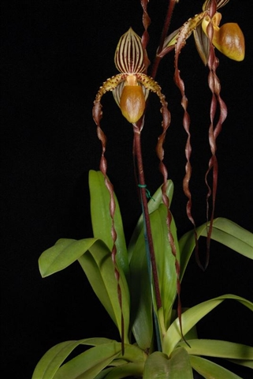

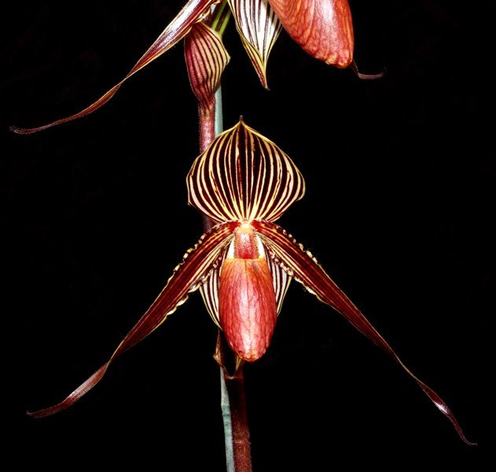

Paphiopedilum William Ambler ‘Springwater Paphiopedilum Raingreen’s Sandi Hawk
Brown Fuzzies’ AM/AOS ‘Springwater’ AM/AOS

References:

AOS Orchids Plus
OrchidWiz Database X5.2
orchidspecies.com

Barbara McNamee Page 3 of 3 6/8/19

