SPECIES DATA REPORT
Paphiopedilum platyphyllum T.Yukawa 2001
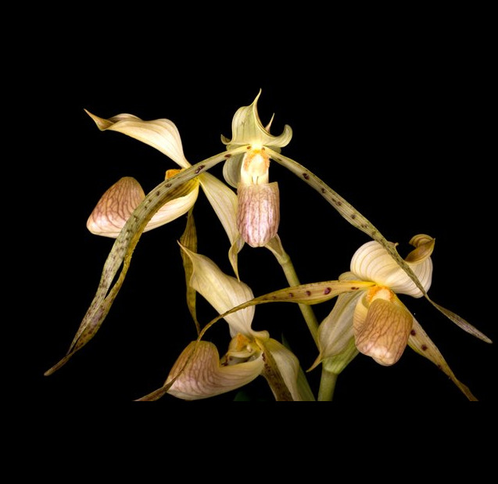
Common Name or Meaning The Broad-Leaf Paphiopedilum
Flower Size 4" [10 cm]
ORIGIN/HABITAT: Sarawak at elevations around 800 meters near the summit of Bukit Kana.

DESCRIPTION: Jay Pfahl describes this orchid species as "Found in Sarawak at elevations around 800 meters near the summit of Bukit Kana. It may still be just a variety of Paphiopediulum stonei."

FLOWER SIZE: 4 inches [10 cm]

Botanical Varieties:
Cordula stonei [Hkr] Rolfe var platytaenia [Rchb.f] Ames 1921
Cypripedium stonei var platytaenium Rchb.f 1867
Paphiopedilum stonei var. latifolium hort
Paphiopedilum stonei ( Hook. ) Stein. var. platyphyllum ( T.Yukawa ) J.M.H.Shaw 2002

Synonyms:
Cordula stonei [Hkr] Rolfe var platytaenia [Rchb.f] Ames 1921
Cypripedium platytaenium Rchb.f. 1880
Cypripedium stonei var platytaenium Rchb.f 1867
Paphiopedilum stonei var. latifolium hort
Paphiopedilum stonei ( Hook. ) Stein. var. platyphyllum ( T.Yukawa ) J.M.H.Shaw 2002

Barbara McNamee Page 1 of 2 6/8/19
Awards:
No AOS awards, 7 international

Hybrids:
P. Yellow Tiger (P. platyphyllum x P. glanduliferum) 50% each, 9 AM, 3 CCM, 9 HCC, used six times in hybridizing, P. Yellow tiger ‘Krull Smith’ had 18 flowers, 18 buds on two inflorescences, 11.5 NS

P. Taiwan (P. rothschildianum x P. platyphyllum) 50% each, 2 AM, 2 CCM, 5 HCC, used seven times in hybridizing, 10 progeny, P. Chow-Yi Diamond (P. Taiwan x P. Prince Edward of York) two AM

P. Fumimasa Sugiyama (P. platyphyllum x P. sanderianum) 50% each, 4 AM, HCC, JC, used seven times in hybridizing, no hybrid awards or progeny.

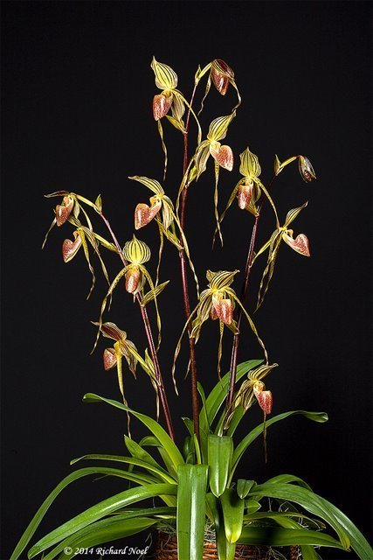
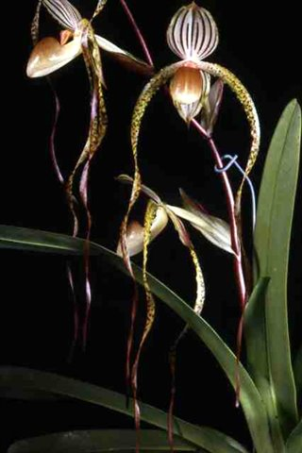
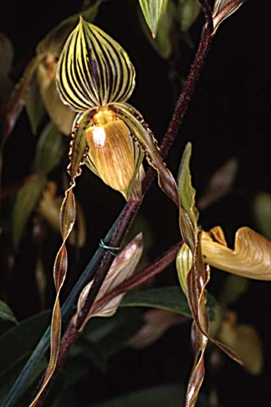

P. Yellow Tiger P. Taiwan’Orchid Inn’ CCM P. Fumimasa Sugiyama
‘Krull Smith’ CCM, AM ‘Crystelle’ AM/AOS

References:
OrchidWiz Database X5.2
Orchids Plus Online
Orchidspecies.com

Barbara McNamee Page 2 of 2 6/8/19

