SPECIES DATA REPORT
Phalaenopsis philippinensis Golamco ex Fowlie & C.Z.Tang 1987
SUBGENUS Phalaenopsis SECTION Phalaenopsis
Common Name The Philippine Phalaenopsis

Characteristics:
Dark green, mottled with silver leaves
Erect to semi-pendulous, freely branching inflorescence
Found only in the Philippines on the island of Luzon
Shield shaped callus

Flower Size 2 3/4" [7 cm]

ORIGIN/HABITAT: Philippine Islands. Found on northeastern Luzon in Nueva Vizcaya Province as well as the provinces of Quirino, Isabela, and northern Aurora. It is found in the Sierra Madre rainforests, where it grows in the shade on tall trees, usually near streams, at about 3950 ft. (1200 m).

PLANT SIZE AND TYPE: A medium- to large-sized, pendent, monopodial epiphyte.

PSEUDOBULB/STEM: The rather short stem is enclosed by the distichous, overlapping, longitudinally folded leaf bases.

Barbara McNamee Page 1 of 3 2/8/2020

LEAVES: 10-14 in. (25-36 cm) long by up to 5 in. (13 cm) wide. 3-7 fleshy, oblong to oblanceolate leaves are carried on each stem. They are dark green with silvery-gray marmorations on the upper surface and are dark purple on the lower side.

INFLORESCENCE: 24-48 in (61-122 cm) long. The slender spikes are erect at the base but become arching to pendent toward the apex. They are zigzag with nicely spaced flowers, and the spikes branch freely on mature plants. After the flowers fade, a new spike may develop from a node below the lowest blossom and bloom within a few weeks. Each blossom is carried on a pedicellate ovary that is up to 2 in. (5 cm) long.

FLOWERS: 3-30 per inflorescence. Mature plants may produce more than 100 blossoms, which open simultaneously. The flowers, which are 2.5-3.5 in. (6-9 cm) across, are full, flat, delicately textured, and broad-petaled. The sepals and petals are white with a pale pink suffusion whey newly opened, but they become bluish white with age. The lateral sepals are dotted with dark red spots at the base. The lip is white with dark yellow lateral lobes which are marked with dark red stripes at their bases. The column is white. The erect, elliptic or elliptic to egg-shaped dorsal sepal are bluntly pointed to rounded at the apex and are up to 1.8 in. (4.5 cm) long by 0.9 in. (2.3 cm) wide. The obliquely egg-shaped lateral sepals have somewhat sharply pointed tips, are divergent, and are up to 1.8 in. (4.5 cm) long by 0.9 in. (2.4 cm) wide. The rhomboid petals are wedge-shaped to clawed at the base, broadly rounded toward the apex with bluntly pointed tips, and are up to 1.8 in. (4.5 cm) long by 1.8 in. (4.5 cm) wide. The 3-lobed lip is up to 1 in. (2.5 cm) long and up to 1.6 in. (4 cm) wide across the expanded lateral lobes. In their natural position, however, the elliptic to egg-shaped lateral lobes are erect to incurved and have bluntly pointed to rounded tips. The lip midlobe is oblong to egg-shaped with a spear-shaped base and a notched apex with a narrow, elongate, sharply pointed, recurved lobule projecting laterally from each side of the apex. The shield-shaped callus is channeled and has a posterior edge that is extended in a pair of wing-like teeth. The stout, straight column is up to 0.3 in. (0.8 cm) long.

Botanical Varieties:
None found
Synonyms:
None found
Awards:
ORIGIN | AM | HCC | CCE | CCM |  | JC | TOTAL
AOS | 4 | 5 | 1 | 1 |  | 1 | 12

Hybrids
There are 180 progeny registered to the 4th generation

Barbara McNamee Page 2 of 3 2/8/2020
Phal. Mini Mark (P. Micro Nova x P. philippinensis) 50% philippinenis, 25% each lobbii and maculata, used 6 times in hybridizing, is the most successful progeny with 14 awards: 7AM, 4HCC, CCM, JC, AQ but only six offspring. Registered in 1992.
Phal. King’s Amar Philip (P. philippinensis x P. amabilis) 50% each, used 18 times in hybridizing, has a total of 36 progeny, no awards, registered in 1997.
P. Louisiana Pixie (P. philippinensis x P. stuartiana) 50% each, used 4 times in hybridizing, has 1 AM of 85 pts. with 175 flowers measuring 5.5 cm., and 4 total progeny. Registered in 1991.

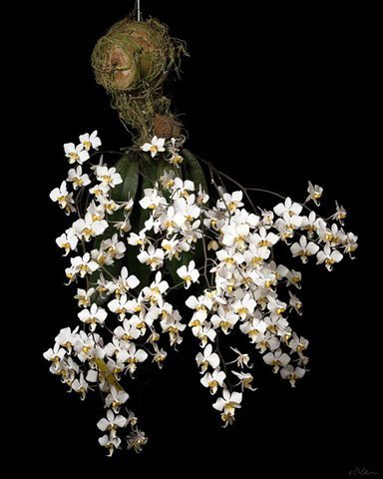

P. Mini Mark ‘Rage’ HCC/AOS

P. Louisiana Pixie ‘Aloysius’ CCM/AOS

References:
Orchiidspecies.com
OrchidWiz X6.0 Database, Baker’s
OrchidPro

Barbara McNamee Page 3 of 3 2/8/2020

