BUILDING BLOCK REPORT
Phalaenopsis amabilis [L.] Blume 1825 SUBGENUS Phalaenopsis SECTION Phalaenopsis Benth 1883
Type Species – Phalaenopsis amabilis
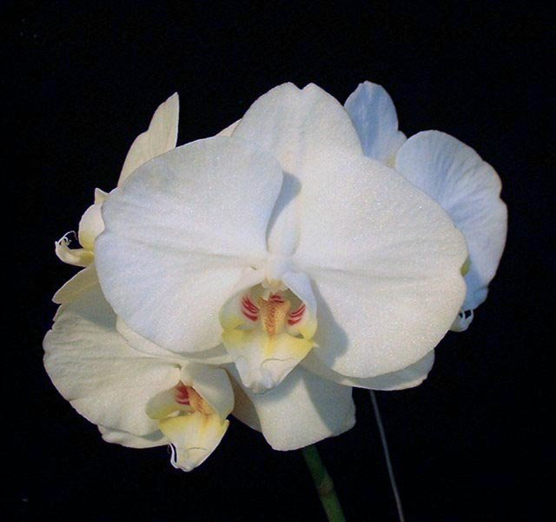
Pronounced a-MA-bill-iss (lovely, enchanting)
Abbreviation:
Common Name The Lovely Phalaenopsis [it is the national Flower of Indonesia]

Flower size: 4" [10 cm] often 15 per branch, mature 70-80
*Largest flowers of the genus

Characteristics:

Long, arched inflorescences, often branched, 24-36” (61-91cm)
Many flowers, shingled presentation

It is one of two white species (amabilis & aphrodite) which are the backbone of the large standard modern white Phalaenopsis of today.

They are broad-petaled, showy, milky-white, can be variable, and often flushed with pink on the back. Lip margins are spotted with yellow and red, fragrant, opens simultaneously

Slender, crumpled, recurved antennae about 1 in. (3 cm) long project from the apex of the lip.

The midlobe is rather cross-shaped, extends down to a pair of long, thin, thread-like tendrils, lip is tri-lobed

Two teeth on the shield-shaped callus

Leaf undersides are green (aphrodite – purple)

Description:

ORIGIN/HABITAT: ORIGIN/HABITAT: Widespread from Malaya through Sumatra, Java, and the rest of Indonesia. Distribution extends to Borneo, the Philippines, New Guinea, and Australia. In Java, plants were once common in the southern half of West and Central Java, especially near the coast, but populations are now greatly diminished. Plants have been found in East Java growing between sea level and 2000 ft. (610 m). Plants may still be found in small, isolated pockets near the West Java/Central Java border where they grow on trees overhanging the sea. In this extended range, plants may grow high in tall trees in dense forests or on tree branches sometimes so close to the ocean that the plants are washed by salt spray. In Borneo, plants are found in Sabah on Mt. Kinabalu, and in Kalimantan and Sarawak at undisclosed locations. Plants grow in lower mountain forests from near sea level to about 4900 ft. (1500 m) and seem to grow mostly in regions that experience a distinct but short dry season. in the Philippines, plants are found in the southern islands of Balabac, Bancalan, Lambugan, Palawan and Sulu and Tawitawi in the Sulu Archipelago. In this region, plants are found at elevations up to 1650 ft. (500 m).

PLANT SIZE AND TYPE: A monopodial epiphyte that is wider than it is tall and produces extensive roots that are fleshy, often branched, smooth, flexuous, and may be 92 in. (300 cm) or more long.

Barbara McNamee Page 1 of 5 2/8/2020

PSEUDOBULB/STEM: The short stem is completely enclosed by distichous, overlapping, longitudinally folded leaf bases.

LEAVES: 4-20 in. (10-50 cm) long by 4 in. (10 cm) wide. 3-5 elliptic, egg-shaped to elliptic, obovate-oblong, or oblong-lanceolate leaves are carried on each stem. The arching to pendent leaves are and glossy dark green with purplish tones on the underside, bluntly pointed at the tip with an obliquely bilobed apex, and taper to a narrow, longitudinally folded base. Leaves are sometimes deciduous, in habitats with an extended dry season, but in cultivation, plants are healthiest when foliage is evergreen.

INFLORESCENCE: 24-36 in. (61-91 cm) long. Plants often produce 2 purple-tinged spikes, which are arching to pendent, branching, and often produce secondary branches from nodes on the peduncle. Each blossom is carried on a pedicellate ovary that is up to 2 in. (5 cm) long.

FLOWERS: Many, often 15 per branch. Mature plants can have 70-80 fragrant blossoms. Plants often produce 2 inflorescences, and the flowers on each spike open simultaneously and may last 6 months. The blossoms are 3.0-3.5 in. (8-9 cm) across, and on rare plants they may be as large as 5 in. (13 cm). They are broad-petaled, showy, milky-white, and often flushed with pink on the back. Lip margins are spotted with yellow and red. Slender, crumpled, recurved antennae about 1 in. (3 cm) long project from the apex of the lip. Flower size and color are variable. The erect, elliptic to egg-shaped dorsal sepal has a rounded to bluntly pointed tip and is 1.2-1.8 in. (3.0-4.5 cm) long by 0.6-1.1 in. (1.5-2.7 cm) wide. The somewhat oblique, egg-shaped, egg-shaped to elliptic, or egg-shaped to lanceolate lateral sepals have sharply pointed tips and are 1.2-2.0 in. (3-5 cm) long by 0.4-1.0 in. (1.0-2.5 cm) wide. The broadly egg-shaped to elliptic petals have a broadly rounded tip, contract below into a wedge-shaped base, and are 1.2-1.8 in. (3.0-4.5 cm) long by 1.0-2.0 in. by (2.5-5.0 cm) wide. The fleshy, 3-lobed lip has erect lateral lobes that are 0.4-0.5 in. (1.0-1.2 cm) long by 0.5-0.6 in. (1.3-1.5 cm) wide and are egg-shaped to oblanceolate with rounded tips. The midlobe is rather cross-shaped, extending from a wedge-shaped base expanding into a pair of triangular, laterally extended projections, and then extending into a narrow, tapering apical portion which terminates in a pair of long, thin, threadlike tendrils. The shield-shaped callus is located at the junction of the midlobe and the lateral lobes and has a lower edge that has a shallow notch in its center while the apical edge is bluntly rounded. The straight, stout column is about 0.3 in. (0.8 cm) long.

Botanical Varieties:
Phalaenopsis amabilis var aphrodite subvar gloriosa [Rchb.f] Ames 1908
Phalaenopsis amabilis var. aurea (auct.) Rolfe 1886
Phalaenopsis amabilis var. cinerascens J.J.Sm. 1917
Phalaenopsis amabilis var fournieri Cogn. 1898
Phalaenopsis amabilis var. fuscata Rchb.f. 1862
Phalaenopsis amabilis var. gloriosa (Rchb.f.) Brero 1937
Phalaenopsis amabilis var gracillima Burb. 1882
Phalaenopsis amabilis var grandiflora [Lindl.] Batem 1867
Phalaenopsis amabilis var. moluccana Schltr. 1911
Phalaenopsis amabilis var. papuana Schltr. 1913
Phalaenopsis amabilis var ramosa van Deventer 1935
Phalaenopsis amabilis var rimestadiana Linden 1901
Phalaenopsis amabilis var rimestadiana alba Hort 1906
Phalaenopsis aphrodite var gloriosa [Rchb.f] Veitch 1891
Phalaenopsis grandiflora var. aurea auct. 1864
Phalaenopsis grandiflora var. borneensis Corning 1881
Phalaenopsis grandiflora var. fuscata (Rchb.f.) Burb.1882
Phalaenopsis grandiflora var. gracillima Burb. 1882
Phalaenopsis grandiflora var. ruckeri Burb. 1876

Barbara McNamee Page 2 of 5 2/8/2020

Synonyms:
Angraecum album majus Rumph 1750
Cymbidium amabile [L.]Roxb. 1832
*Epidendrum amabile L. 1855
Phalaenopsis amabilis f. concolor Baume & Christenson 2006
Phalaenopsis amabilis f. fuscata (Rchb.f.) O.Gruss & M.Wolff 2007
Phalaenopsis amabilis f. marmorata (Rchb.f.) Ames 1908
Phalaenopsis amabilis subsp. moluccana (Schltr.) Christenson 2001
Phalaenopsis amabilis subvar. gloriosa (Rchb.f.) Ames 1908
Phalaenopsis celebica Vlooten 1932
Phalaenopsis gloriosa Rchb.f 1888
Phalaenopsis grandiflora Lindley 1848
Phalaenopsis rimestadiana [Linden] Rolfe 1905
Phalaenopsis rosenstromii F.M. Bailey 1906
Phalaenopsis xelisabethae Hort. 1927
Synadena amabilis [L.]Raf. 1836

AOS Awards:
Origin | CCE | CCM | AM | CHM | HCC | JC | AQ | Total
AOS |  | 8 | 21 | 1 | 12 | 3 | 1 | 46

Other Awards and when given:
Herbert Hager Award 2016 – amabilis hybrid - P. Taisuco Snowflake ‘B96047’ (P. Taisuco Bridian x P. amabilis) CCM/AOS 84 pts.
Outstanding Clones:
P. amabilis ‘Cheng-Fan’, 2 CCM, 252 and 217 flowers
P. amabilis var. formosana ‘Hwang’, CCM, 332 flowers
P. amabilis ‘Creole’s White Cloud’, AM 85 pts., 70 flowers, NS 9.8 cm

Hybrids: Total of 32,529 registered, to the 12th generation

Before |  |  |  |  |  |  | After
1940 | 1940-49 | 1950-59 | 1960-69 | 1970-79 | 1980-89 | 1990-99 | 1999
41 | 87 | 340 | 1,241 | 3,177 | 5,750 | 8,838 | 13,096
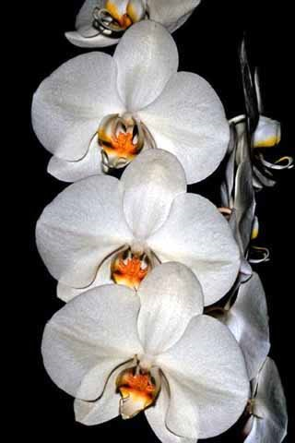
Hybrids:
P. Doris (P. Elisabethae x P. Kathleen Siegwart) 50% amabilis, 29 awards: 14 AM, 1 CCM, 2 FCC, 12 HCC – no awards after 1967, hybridized 262 times, has 31,392 total progeny, is an old cross and is in the background of many of hybrids, notable and familiar is P. Leopard Prince. Modern day white and pink hybrids owe their origins to P. Doris, registered in 1940.

P. Doris ‘Mae Emma’ AM/AOS 82 pts., 1962

Barbara McNamee Page 3 of 5 2/8/2020

P. Grace Palm (P. Doris x P. Winged Victory) 38% amabilis, used 138 times in hybridizing, has 25,732 total progeny, 27 awards: 9 AM, 2 CCM, 16 HCC, instrumental in white hybridizing, registered in 1950.

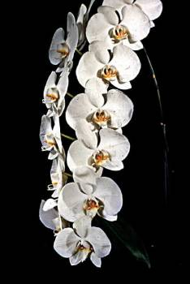
P. Grace Palm ‘Lucinda’ CCM//AOS 83 pts. 1965

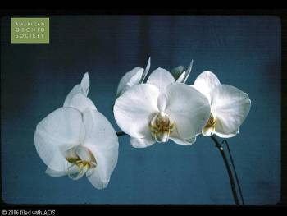

P. Joseph Hampton (P. Monarch Gem x P. Doris) 48% amabilis, used 178 times in hybridizing, has 1867 total progeny but only 9 awards: 5 AM, 3 HCC, JC, no awards after 1981, another instrumental in hybridizing the white color form, registered 1966
P. Joseph Hampton ‘Diane’ AM/AOS 84 pts.

P. Leopard Prince (P. Sun Prince x P. Ho’s French Fantasia) 28% amabilis, 12 awards: 4 AM, CCM, FCC, 6 HCC, hybridized 237 times, has 753 total progeny. Registered 1997.

P. Sogo Yukiden (P. Yukimai x P. Taisuco Kochdian) 40% amabilis, 12 awards: 4 AM, 6 CCE, CCM, HCC, hybridized 161 times, 468 total progeny, registered 1998. Most successful progeny is P. Yu Pin Easter Island, with 78 offspring and 9 awards: 5 AM, 3 HCC, JC.

P. Orchid World (P. Malibu Imp x P. Deventeriana) 25% amabilis, 103 awards: 54 AM, 3 CCN, 1 FCC, 44 HCC, one of the most highly awarded of the offspring, used 22 times in hybridizing, 24 total progeny, only 1 is awarded P. Green Earth, AM 81 pt. Registered in 1984.

P. Alice Gloria (P. Ramona x P. Grace Palm) 47% amabilis, 19 awards, 9 AM, AQ, 9 HCC, hybridized 156 times, has 3,467 total progeny, registered 1961.

P. Brother Lawrence (P. Taipei Gold x P. Deventeriana) 34% amabilis, 27 awards: 10 AM, AQ, CCM, 14 HCC, JC, hybridized 108 times, has 850 total progeny, registered 1995.

P. Deventeriana (P. amabilis x P. amboinensis) 50% used 230 times in hybridizing, but only 3 awards: AM, 2 HCC, has 2,056 total progeny, registered in 1927.

P. Sweet Memory (P. Deventeriana x P. violacea) 25% amabilis, used 38 times in hybridizing, has 52 total progeny, 40 awards: 18AM, 4 CCM, 17 HCC, JC, registered in 1982.

Barbara McNamee Page 4 of 5 2/8/2020

Desirable characteristics which can be passed to progeny:
Vigorous growth
Amounts of red and yellow pigment on the lip
Presence and density of red spots on the lateral lobes of the lip
Overall flower shape – round and full
Light fragrance
Good substance
Undesirable characteristics which can be passed to progeny:
Large plant size
Long leaves
Light substance

Other Information

References:
OrchidPro
OrchidWiz Database X5.3
Orchidspecies.com
Harper, Tom, AOS Orchids supplemental magazine October 2017, pg. 25
Alrich, P & Higgins, W, 2014 Phalaenopsis Journal of the IPA, 4th qtr, pgs 18-21
Christenson, Eric. 2001. Phalaenopsis: A Monograph, Pp. 186-193

Barbara McNamee Page 5 of 4 2/8/2020

