BUILDING BLOCK REPORT
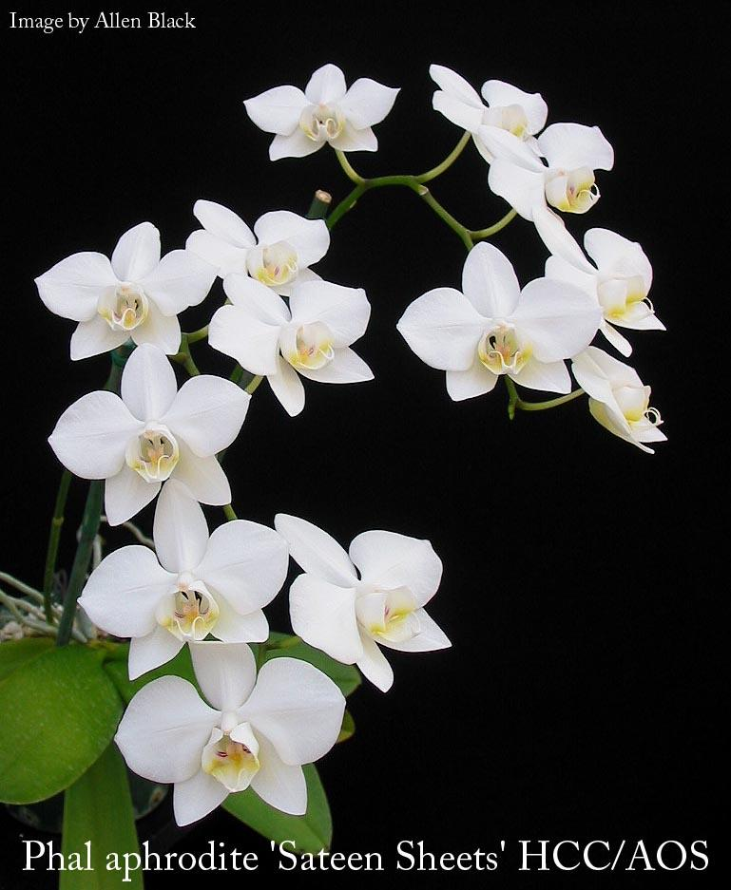
Phalaenopsis aphrodite Rchb.f 1862
SUBGENUS Phalaenopsis SECTION Phalaenopsis Benth 1883
Type Species – Phalaenopsis amabilis
Abbreviation:
Common Name Aphrodite's Phalaenopsis [Goddess of Fertility] - In China Hu Die Lan

Flower size: 3" or less [7.5 cm or less]

Characteristics:

It is one of two white species (amabilis & aphrodite) which are the backbone of the large standard modern white Phalaenopsis of today.

closely resembles P. amablis but differs in the red lip disc
triangular midlobe
very floriferous
four teeth on the callus
leaf undersides are purple (amabilis is green)

Description

ORIGIN/HABITAT: Taiwan and the Philippines north of Mindanao. Found in primary and secondary forests, between sea level and 1650 ft. (500 m). The forms found in Taiwan have been found at elevations up to 4900 ft. (1500 m).

PLANT SIZE AND TYPE: A moderate-to-large monopodial epiphyte.

PSEUDOBULB/STEM: The short stem is enclosed by the overlapping, longitudinally folded bases of the leaves.

LEAVES: 8-15 in. (20-38 cm) long by 2.4 in. (6 cm) wide. 3-5 elliptic to oblong or egg-shaped leaves are carried on each stem. They are sharply-to-bluntly pointed at the tip and taper to a rather narrow, longitudinally folded base. The top surface is uniformly dark green, while the underside is more or less tinged with reddish to purple suffusion.

INFLORESCENCE: Much longer than the leaves. The arching to pendent flower spikes emerge from the stem at the base of the leaves. Flowers are carried in racemes or few-branched panicles on a rachis that is somewhat zigzag. Each blossom is carried on a pedicellate ovary that is up to 1.4 in. (3.5 cm) long.

FLOWERS: Many. The blossoms are 2.5-3.5 in. (6-9 cm) across. They are delicately textured with a showy, broad-petaled form. The widely spread sepals and petals are white with a creamy or greenish suffusion. The lip is also white but is variably marked with red and yellow. The column is white. The erect dorsal sepal is elliptic to egg-shaped, bluntly pointed to rounded at the apex, and up to 1.6 in. (4 cm) long by 0.8 in. (2 cm) wide. The obliquely spreading lateral sepals are somewhat egg-shaped and slightly sickle-shaped, curving upward along the upper margin. They are rather sharply pointed and are about 1.6 in. (4 cm) long by 0.8 in. (2 cm) wide. The horizontally spreading, broadly spoon-shaped to somewhat rhomboid petals are up to 1.6 in. (4 cm) long and wide. They have a very narrow base and then spread into a broadly rounded blade that is bluntly pointed or rounded at the tip. The 3-lobed lip is 1.2 in. (3 cm) long by 1.6 in. (4 cm)

Barbara McNamee Page 1 of 4 2/8/2020

Description con’t.
wide across the expanded lateral lobes. In their natural position, however, the obliquely egg-shaped, clawed, broadly rounded lateral lobes are held in erect or incurved positions. The triangular midlobe is bluntly pointed at the tip where it extends into a pair of long, crumpled, tendril- or filament-like appendages. The callus has a posterior edge that is notched to form 4 erect teeth and an anterior edge that is bluntly pointed to rounded. The column is short and fleshy

Botanical Varieties:
Phalaenopsis amabilis subvar. dayana (Warner & B.S.Williams) Ames 1908
Phalaenopsis amabilis subvar. erubescens (Burb.) Ames 1908
Phalaenopsis amabilis [L. & Rchb.f] Blume var ambigua [Rchb.f] Burb 1882
Phalaenopsis amabilis [L. & Rchb.f] Blume var aphrodite [Rchb.f] Ames 1908
Phalaenopsis amabilis [L. & Rchb.f] Blume var aphrodite subvar erubescens [Burb] Ames 1908
Phalaenopsis amabilis [L. & Rchb.f] Blume var dayana Hort ex Warn 1881
Phalaenopsis amabilis [L. & Rchb.f] Blume var erubescens [Burb] Burb 1882
Phalaenopsis amabilis [L. & Rchb.f] Blume var formosana Shim 1921
Phalaenopsis amabilis [L. & Rchb.f] Blume var longifolia Don 1845
Phalaenopsis amabilis [L. & Rchb.f] Blume var rotundifolia Don 1845
Phalaenopsis aphrodite subsp. formosana Christenson 2001
Phalaenopsis aphrodite var dayana Veitch 1891

Synonyms:
Phalaenopsis amabilis Lindl. 1838
Phalaenopsis ambigua Rchb.f 1862
Phalaenopsis babuyana Miwa 1941
Phalaenopsis erubescens Burb 1876
Phalaenopsis formosana Miwa 1941

AOS Awards:
Origin | CCE | CCM | AM | CHM | HCC | CBR | AQ | Total
AOS | 2 | 12 | 13 | 1 | 7 | 1 | 1 | 37
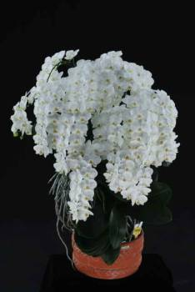
Other Awards and when given:
Butterworth Prize 2009 – P. aphrodite subsp. formosana ‘Showy Mountain’ CCE/AOS 93 pts.
Outstanding Clones:
P. aphrodite ‘CP3127’ massive # of flowers – 315 on 15 inflorescences
P. aphrodite ssp. formosana ‘Yen Lin’ AM & CCM, 261 flowers, 26 buds on 18 inflorescences
P. aphrodite ‘Tropic 1’ CCM & CHM - judges recognized as an excellent clone
P. aphrodite ‘Leucadia’ 2 CCM’s in different years, flower counts 210 & 158 (NS 8.1)
P. aphrodite ‘Jordan Winter’ CCM, 32 flowers on 1 inflorescence, NS 9.0
P. aphrodite ‘Zuma Canyon’ HCC NS 10 cm, largest flowers awarded in 1987, but only 6 flowers on 1 inflorescence, it was also the first award.

Hybrids: Total of 32,616 registered, to the 12th generation

Before |  |  |  |  |  |  | After
1940 | 1940-49 | 1950-59 | 1960-69 | 1970-79 | 1980-89 | 1990-99 | 1999
42 | 86 | 351 | 1,258 | 3,271 | 5,815 | 8,793 | 12,992
Barbara McNamee Page 2 of 4 2/8/2020

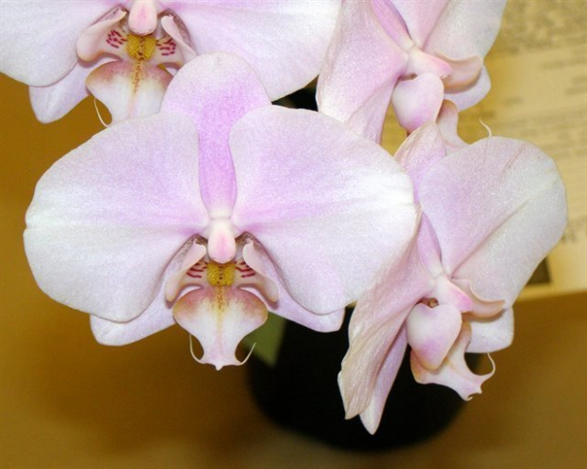
Hybrids:

P. Leucorrhoda (P. aphrodite x P. schilleriana) 50%, 5AM, CCM, 3 HCC, JC, used 62 times in hybridizing. Significant progeny P. Tokyo ‘MAJ’ CCM, HCC, 103 flowers, 13 buds on 2 inflorescences, has 5 total progeny.

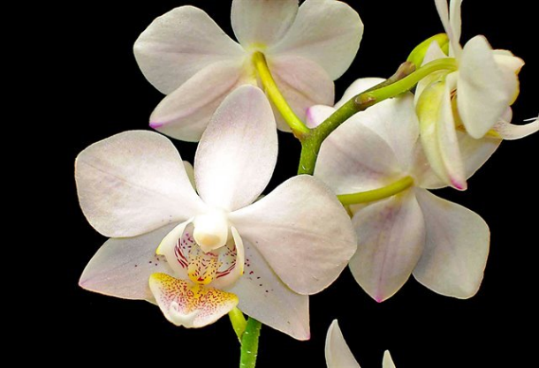

P. Timothy Christopher (P. Cassandra x P. aphrodite) 50%, used 201 times in hybridizing, 2AM, CCM, 3HCC, AQ. 690 total progeny, significant progeny P. Liu’s Fantasy, 31% aphrodite, 8 awards, used 23 times in hybridizing, has 33 total progeny.

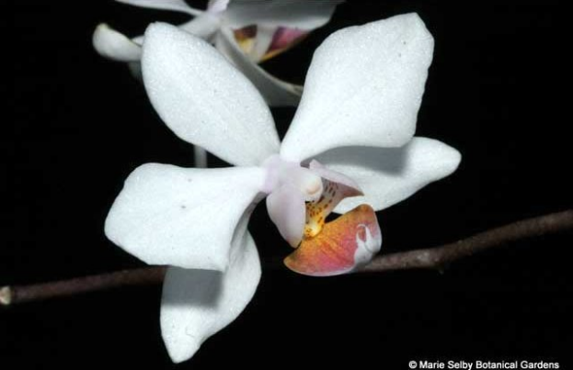

P. intermedia (P. aphrodite x P. equestris) 50% Aphrodite, 2AM, CCM, used 63 times, has 102 total progeny.

P. Leopard Prince (P. Sun Prince x P. Ho’s French Fantasia) 16% aphrodite, 12 awards: 4AM, CCM, FCC, 6HCCC, hybridized 237 times, has 753 total progeny. Significant progeny P. I-Hsin Black Jack, hybridized 28 times, 187 total progeny, 3AM, 7HCC, JC.

P. Sogo Yukidian (P. Yukimai x P. Taisuco Kochdian) 15% aphrodite, 4AM, 6CCE, CCM, HCC, hybridized 161 times, 468 total progeny. Significant progeny P. Yu Pin Easter Island (P. Sogo Yukidian x P. World Class) 13% aphrodite, 5AM, 3HCC, JC, increased flower size, median NS 10.6 cm.

Barbara McNamee Page 3 of 4 2/8/2020

Desirable characteristics which can be passed to progeny:
Vigorous growth
Long, arched inflorescences, presents flowers shingled
Fragrance – light, sweet
Floriferousnss
Branching abilities
Light Undesirable characteristics which can be passed to progeny:
Petals not full
Light substance
Other Information

References:
OrchidPro
OrchidWiz Database X5.3
Orchidspecies.com
Harper, Tom, AOS Orchids supplemental magazine October 2017, pg. 25
Christenson, Eric. 2001. Phalaenopsis: A Monograph, Pp. 194-198

Barbara McNamee Page 4 of 4 2/8/2020

