BUILDING BLOCK REPORT
Phalaenopsis schilleriana Rchb.f 1860 SUBGENUS Phalaenopsis SECTION Phalaenopsis Benth 1883
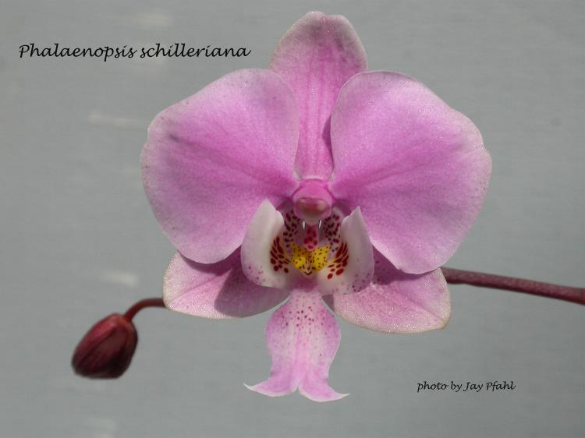
Type Species – Phalaenopsis amabilis
Common Name Schiller's Phalaenopsis [German Orchid Enthusiast 1800's]

Flower size: less than 3 1/2" [8 to 9 cm]

Characteristics:

Lip is anchor shaped
Magenta side lobes with carmine dots
Long, branched inflorescences
Numerous, well-displayed flowers 85+
Light to medium pink

Description:
ORIGIN/HABITAT: The Philippines, on Luzon Island south of Quezon City, and on the eastern shores of adjacent islands. It is found at 0-1500 ft. (0-457 m) growing high on tree trunks and on high branches.

LEAVES: 3-5 per plant. The leaves are 6-18 in. (15-46 cm) long, dull, dark green mottled with greyish white, and marked with purple on the underside.

INFLORESCENCE: 36 in. (91 cm) long. Plants produce 2-3 spikes per year. The inflorescences are erect, branching, and droop at the apex. Flowers are arranged in 2 rows along each branch.

FLOWERS: Many, 100 is not unusual, and one plant had 733 flowers, with 400 blossoms on a single spike. The blooms are 3.0-3.5 in. (8-9 cm) across, often smaller if very numerous. They are fragrant and last several weeks. Wide-petaled and delicately textured, the sepals and petals may be white, pale rose, lilac-pink, or deep rose-purple with white at the edges. The white lip is anchor-shaped, and the magenta side lobes have carmine dots. The flowers vary in color and form.

Botanical Varieties:
Phalaenopsis schilleriana var. advena Rchb.f. 1885
Phalaenopsis schilleriana var compacta nana Hort. 1890
Phalaenopsis schilleriana var delicata Dean 1877
Phalaenopsis schilleriana var grandiflora van Brero 1935
Phalaenopsis schilleriana var. immaculata Rchb.f. 1875
Phalaenopsis schilleriana var major J D Hook ex Rolfe 1886
Phalaenopsis schilleriana var odorata van Brero 1935
Phalaenopsis schilleriana var pallida Val & Tiu 1984
Phalaenopsis schilleriana var purpurea O'Brien 1892
Phalaenopsis schilleriana var splendens Warn. 1878
Phalaenopsis schilleriana var viridi-maculata Ducharte 1862

Barbara McNamee Page 2 of 5 2/8/2020

Synonyms:
Phalaenopsis schilleriana f. immaculata (Rchb.f.) Christenson 2001
Phalaenopsis schilleriana f. purpurea (O'Brien) O.Gruss & M.Wolff 2007
Phalaenopsis schilleriana f. splendens (R.Warner) O.Gruss & M.Wolff 2007

AOS Awards:
Origin | CCE | CCM | AM | CHM | HCC | CC | AQ | Total
AOS | 4 | 11 | 19 |  | 13 | 2? | 1 | 50

Other Awards and when given:
.
Outstanding Clones:
P. schilleriana ‘Classic’ CCM, HCC, 7.5 & 6.9 cm NS, 102 flowers, 23 buds on 2 inflorescences and 26 on 1
P. schilleriana ‘Brazos’ CCM, AM, NS 7.5 cm, 74 flowers on 2 inflorescences
P. schilleriana ‘JM – Sakura King’, CCE & AM, 360 flowers, 54 buds on 6 inflorescences, NS 7.7 cm
P. schilleriana ‘JM – Sakura Queen’ CCM, 278 flowers, 55 buds on 15 inflorescences. NS 7.4 cm, most recent, in 2015
P. schilleriana ‘Jardin botaniqe de Montreal, CCE, 91 pts. 126 flowers, 26 buds on 3 inflorescences
P. schilleriana var. purpurea ‘Lin’ CCE, 373 flowers, 159 buds on 21 inflorescences, NS 6.1 cm

Hybrids: Total of 29,107 registered, to the 16th generation

Before |  |  |  |  |  |  | After
1940 | 1940-49 | 1950-59 | 1960-69 | 1970-79 | 1980-89 | 1990-99 | 1999
51 | 77 | 245 | 767 | 2,225 | 4,862 | 8,288 | 12,583
Hybrids:
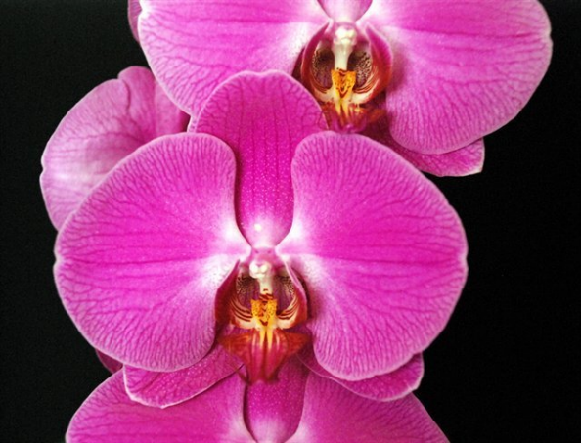
There are numerous hybrids with large percentages of P. schilleriana in the background, many have few to no awards and have no new hybridizing or awards activity since the 1960’s and earlier.

P. Abendrot (P. Lippezauber x P. Lippstadt) 23% schilleriana, 6AM, 1FCC, 9HCC, used 229 times in hybridizing, has 4,218 total progeny; significant progeny P. Lippegruss, 7 awards, 60 F1’s and 832 total progeny.

Photo P. Abendrot ‘Cheng’ HCC/AOS

Barbara McNamee Page 3 of 5 2/8/2020
P. Jiaho’s Pink Girl (P. schilleriana x P. Zuma’s Pixie) 50% schilleriana, 2AM, CCM – 116 flowers, 14 buds on 2 inflorescences, used 11 times in hybridizing, has 19 total progeny.
Photo P. Jiaho’s Pink Girl ‘Lucky Star’ TRO/TOGA (grower HSU, HSIN-MAN
Fu Sing Orchids)

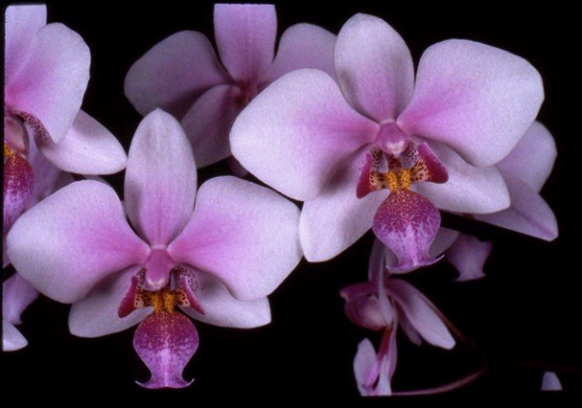

P. Veitchiana (P. equestris x P. schilleriana) 50% each, 6AM, 2 HCC, CCM had 325 flowers on eight inflorescences, used 47 times in hybridizing, 89 total progeny; significant
Photo P. Veitchiana ‘Cat’s Paw’ AM/AOS

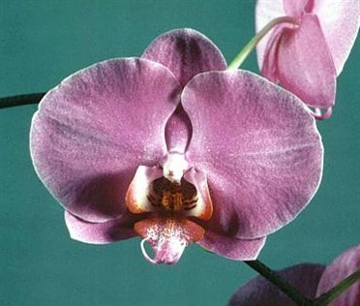
P. Herbert Hager (P. Dear Heart x P. Flor de Mato) 30% schilleriana, 3AM, 11HCC, used 56 times in hybridizing, has 2,687 total progeny; P. Nobby’s Pink Lady, used 51 times in hybridizing, has 1,021 total progeny, 6 awards.
Photo P. Herbert Hager ‘Thanks Herb’ AM/AOS

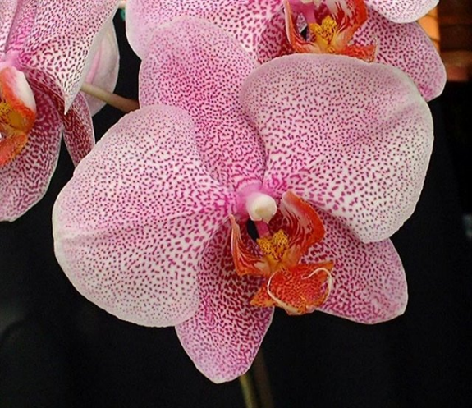

P. Carmela’s Spots (P. Jutta Brungor x P. Frisson) 34% schilleriana, only 2HCC, used 73 times in hybridizing, has 1,204 total progeny. Significant progeny P. Leopard Prince, 12 awards, hybridized 237 times and has 753 total progeny; another is P. Ho’s French Fantasia, no awards but used 41 times in hybridizing and has 979 total progeny; P. Carmela’s Wild Thing 26% schilleriana, 10 awards, hybridized 31 times and has 45 total progeny.

Barbara McNamee Page 4 of 5 2/8/2020

Desirable characteristics which can be passed to progeny:
Color – used for pink breeding
Floriferousness
Long, branching inflorescences

Undesirable characteristics which can be passed to progeny:
Petals not full
Light substance
Other Information

References:
OrchidPro
OrchidWiz Database X5.3
Orchidspecies.com
Harper, Tom, AOS Orchids supplemental magazine October 2017, pg. 24

Barbara McNamee Page 5 of 5 2/8/2020

