SPECIES DATA SHEET
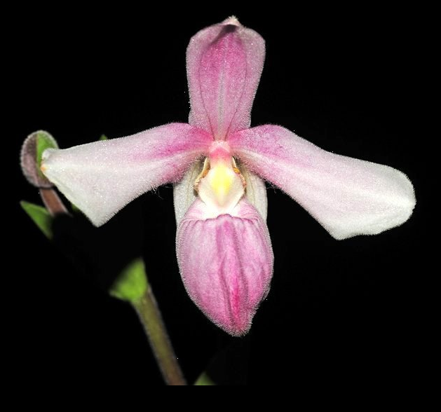
Phragmipedium andreetae P.J.Cribb & Pupulin 2006
Pronounced
Abbreviation:
Common Name Andreett’s Phragmipedium
Flower Size 2" [5 cm]

Distribution:

ORIGIN/HABITAT: Northwestern Ecuador at elevations of 500 to 1000 meters.

DESCRIPTION: Jay Pfahl describes this orchid species as "Small sized, hot to warm growing lithophyte with linear, acute, mid-green leaves that blooms in the fall on an erect to arching, unbranched or with a single branch, 5.2 to 6.4 inches [13 to 16 cm] long, finely white pubescent, successively single flowered inflorescence."

FLOWER SIZE: 2 inches [5 cm]

Synonyms:
none

AOS Awards:
AM | HCC | FCC | CCM | CBM | CHM |  |  | Total
 |  |  |  |  | 1 |  |  | 1

Hybrids: Total of 22 registered, to the 3rd generation
Of 22 hybrids only four have progeny, only one has an award.

Phrag. Petite Queillette (P. besseae x P. andreettae) 50% each, the first to have any offspring, registered in 2008, it has five progeny, only one has an offspring.

P. Alejandro Teson (P. pearcei x P. andreettae) 50% each, is the only hybrid to be awarded, an HCC 77 pts., has no offspring.
References:
OrchidWiz Database X5.1
Orchidspecies.com
Wikipedia

Barbara McNamee Page 1 2/9/201

