BUILDING BLOCK REPORT
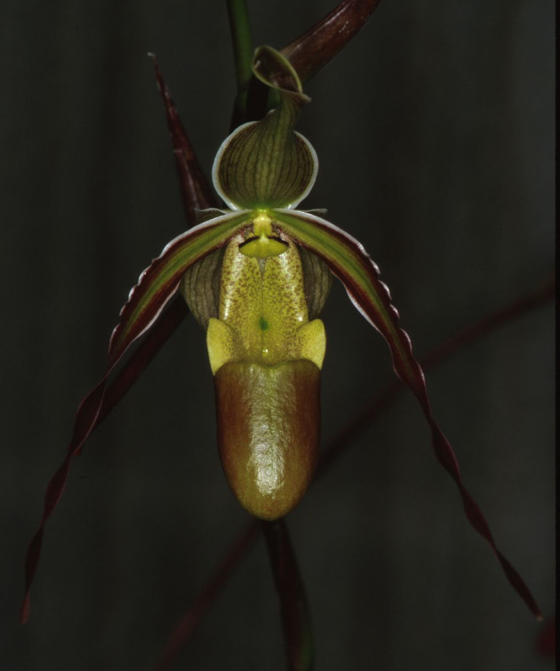
Phragmipedium longifolium [Warsc. & Rchb.f]Rolfe 1896
Section Lorifolia
Pronounced: lawn-ji-FOE-lee-um
Abbreviation:
Common Name The Long-Leaf Phragmipedium
Flower Size 2" [20 cm]

Distribution:

ORIGIN/HABITAT: Mexico to Peru. In Colombia it is found at 4920-5904 ft. (1500-1800 m), always in the shade and always in wet areas. Plants usually grow in grass just above stream-side gravel bars, where they are subject to seasonal flooding, along road banks where they receive runoff, or on steep cliffs in wet mountain forests.

PLANT SIZE AND TYPE: A 24-32 in. (61-81 cm) sympodial terrestrial or lithophyte. The plant often forms a large clump.

PSEUDOBULB: None.

LEAVES: Several per growth. The bright, dark green foliage is paler on the underside. The leaves are 24-32 in. (61-81 cm) long, pointed, linear, and arranged in a distichous fan.

INFLORESCENCE: 16-24 in. (41-61 cm) long. The erect spike is pubescent at the base and emerges from the center of the leaves, and may be deep purple or green.

FLOWERS: 6-10. The blossoms are 3-5 in. (8-13 cm) vertically and up to 8 in. (20 cm) across. The pale, yellowish green flowers have darker green veins and white margins. The petals are edged with purple and have brown-purple markings near the tips. The lip margin is distinctly V shaped. The long-lasting flowers open over an extended period.
Botanical Varieties:
Cypripedium longifolium var. gracile H.J.Veitch ex Rolfe in ?
Paphiopedilum longifolium var. hincksianum (Rchb.f.) Stein 1892
Phragmipedium longifolium var. chapadense (Campacci & R.Takase) O.Gruss 2003
Phragmipedium longifolium var. coloratum (Rchb.f.) Pfitzer 1903
Phragmipedium longifolium var. darienense (Rchb.f.) Hallier f. 1897
Phragmipedium longifolium var. gracile (H.J.Veitch) Pfitzer 1903
Phragmipedium longifolium var. hincksianum (Rchb.f.) Stein 1892
Phragmipedium longifolium var. splendidum (Pucci) Pfitzer 1903

Synonyms:
Cypripedium dariense Rchb. f. 1878
Cypripedium hincksianum Rchb.f 1878
*Cypripedium longifolium Warsc & Rchb.f 1852

Barbara McNamee Page 1 of 4 3/9/19

Cypripedium longifolium var. gracile H.J.Veitch ex Rolfe in ?
Cypripedium reichenbachianum hort. 1887
Cypripedium reichenbachii W. Bull 1869
Cypripedium roezlii Regel 1873
Paphiopedilum hinksianum Pfitz 1894
Paphiopedilum longifolium Pfitz 1888
Paphiopedilum longifolium var. hincksianum (Rchb.f.) Stein 1892
Phragmipedium dariense (Rchb.f.) Garay 1979
Phragmipedium hincksianum [Rchb.f] Garay 1979
Phragmipedium longifolium f. album O.Gruss & Koop. 2006
Phragmipedium longifolium f. gracile (H.J.Veitch ex Rolfe) O.Gruss 2001
Phragmipedium longifolium f. minutum O.Gruss 2001
Phragmipedium longifolium var. chapadense (Campacci & R.Takase) O.Gruss 2003
Phragmipedium longifolium var. coloratum (Rchb.f.) Pfitzer 1903
Phragmipedium longifolium var. darienense (Rchb.f.) Hallier f. 1897
Phragmipedium longifolium var. gracile (H.J.Veitch) Pfitzer 1903
Phragmipedium longifolium var. hincksianum (Rchb.f.) Stein 1892
Phragmipedium longifolium var. splendidum (Pucci) Pfitzer 1903
Phragmopedilum longifolium (Rchb. f. & Warsz.) Pfitzer 1898
Selenipedium dariense Rchb.f 1869
Selenipedium gracile (H.J.Veitch) Desbois 1889
Selenipedium hincksianum Rchb. f. 1878
Selenipedium longifolium Rchb.f 1854
Selenipedium reichenbachii Endres 1869

AOS Awards:
AM | HCC | CCE | CCM | CBM | CHM |  |  | Total
12 | 8 | 1 | 9 | 2 | 7 |  |  | 39

Other awards and when given: none found
Outstanding Clones:
Phrag. longifolium ‘Eloise’ CCE 93 pts. 33 flowers, 18 buds on 17 inflorescences, highest flower count, 14cm x 11.5 cm
Phrag. longifolium ‘Irma’ CCM 87 pts., 18 flowers, 11 buds on 15 inflorescences, 21 cm x 12.5 cm commended for robust plant with branched inflorescences
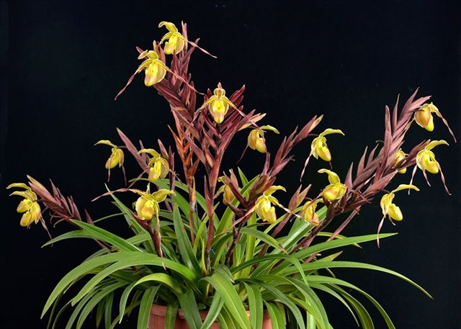
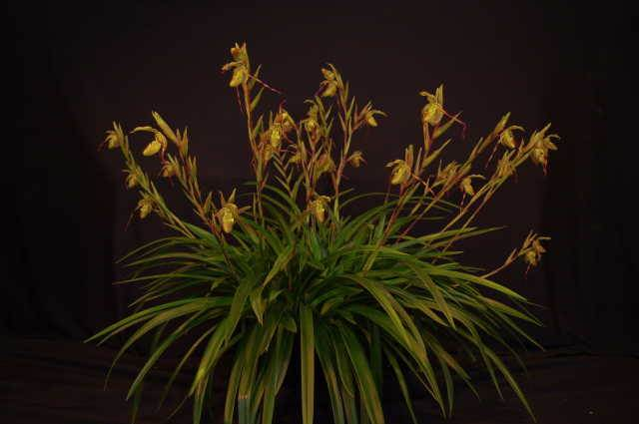

Phrag. longifolium ‘Eloise’ CCE 93 pts Phrag. longifolium ‘Irma’ CCM 87 pts.

Barbara McNamee Page 2 of 4 3/9/19

Hybrids: Total of 592 registered, to the 5th generation

Before 1940 | 1940-49 | 1950-59 | 1960-69 | 1970-79 | 1980-89 | 1990-99 | After 1999
46 | 0 | 0 | 1 | 2 | 2 | 72 | 587
There was 1 hybrid between 1906 and 1975: Phrag. Confusion (P. Grande x P. Memoria J H Walker), no awards or offspring.
Phrag. Eric young (P. besseae x P. longifolium) 50% each, used 46 times in hybridizing, 190 total progeny, 35 awards including 8 CCM’s, 15 AM’s, 11 HCC’s and a JC. Highest award went to Phrag. Eric Young ‘Jack’s Pamela’ CCM 89 points, had 21 flowers, 11 buds on 12 inflorescences, petals were 74 cm long (29.13”).
Phrag. Sorcerer’s Apprentice (P. longifolium x P. sargentianum) 50% each, used 43 times in hybridizing, 136 total progeny, 53 awards; 28 AM’s, 2 FCC’s, CCE, 5 CCM’s, 16 HCC’s and a JC. Most recent award in 2018 is Phrag. Sorcerer’s Apprentice ‘Willowcreek’, FCC 91 points, three flowers, four buds on two inflorescences. Highest award is Phrag. Sorcerer’s Apprentice ‘Ginormous’, FCC 92 points in 2010, only one ‘extraordinarily large’ flower and one bud on one inflorescence; flower NS measured 17 cm wide by 21 cm long.

Phrag. Grande (P. longifolium x P. humboldtii) 50% each, used 41 times in hybridizing, 61 total progeny, 88 awards; 33 AM’s. 2 CCE’s, 23 CCM’s, 2 FCC’s, 27 HCC’s and a JC. Highest award was Phrag. Grande ‘Macrochilum’ CCE 94 points, 26 flowers, 8 buds on 13 inflorescences, virtually unblemished, huge plant, 41 cm long, most floriferous Phrag. Grande seen to date – 2002. Most flowers awarded to Phrag. Grande ‘Main Street Orchids’ CCM 83 points, had 35 flowers, 1 bud on 12 inflorescences, 41cm length. Some of longest petals are Phrag. Grande ‘Long Legs’ HCC 77 points 2016, 61cm long; Phrag. Grande ‘Phil’s Pholly’ FCC 90 points 2010, 64.4cm long; Phrag. Grande ‘Lindsey’ CCE 91 points, AM 84 points, 12 flowers, 7 buds on 6 inflorescences, 62cm long; Phrag. Grande ‘Berke’,CCM 85 points, HCC 77 points, 2001, 16 flowers, 5 buds on 5 inflorescences, 68cm long; Phrag. Grande ‘Magnificum’ AM 85 points 1995, 3 flowers on one inflorescence, 65cm long. See below.
Phrag. Sedenii (P. longifolium x P. schlimii) 50% each, used 41 times in hybridizing, 112 total progeny, 23 awards; 5 AM’s, CCE, 12 CCM’s, 4 HCC’s and a JC. Highest and most recent award went to Phrag. Sedenii ‘Anne’s Blush’ CCE 90 points in 2018, 22 flowers, 14 buds on nine strong inflorescences; Phrag. Sedenii ‘Adie’ CCM 90 points was awarded in 1974, 16 flowers, “numerous buds” on 10 double or triple flowered inflorescences; most flowers were 29 on Phrag. Sedenii ‘Shirley’ CCM 83 points in 1976. See below.
Phrag. Don Wimber (P. Eric Young x P. besseae) 50% each, used 17 times in hybridizing, 23 total progeny, 98 awards; 59 AM’s, 2 CCE’s, 4 CCM’s, FCC, 32 HCC’s. Highest award and also most flowers Phrag. Don Wimber ‘Morright’ CCE 94 points, 27 flowers, 12 buds on nine inflorescences awarded in 2012.

Barbara McNamee Page 3 of 4 3/9/19

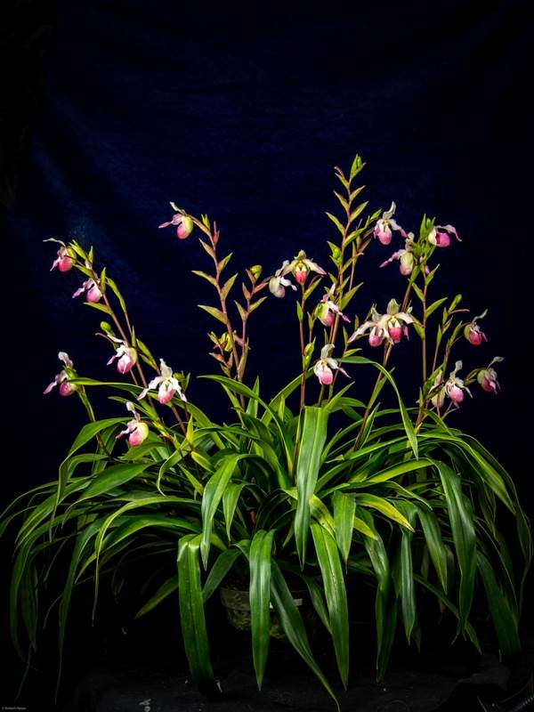
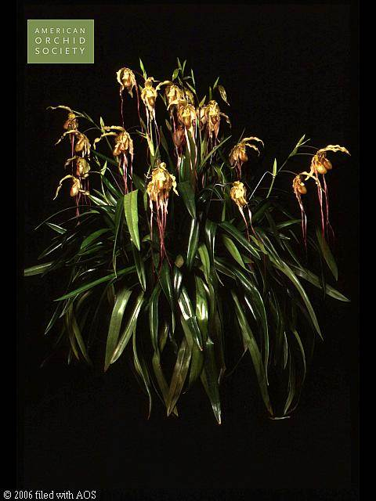

Phrag. Grande ‘Macrochilum’ CCE 94 pts Phrag. Sedenii ‘Anne’s Blush’ CCE 90 pts.
Desirable characteristics that can be passed to progeny:
Long-lasting, floriferous
Undesirable characteristics that can be passed to progeny:
Can be very tall/large plants

References:
OrchidWiz Database X5.1
Orchidspecies.com
Cash, Catherine 1991 “The Slipper Orchids” Timber Press

Barbara McNamee Page 4 of 4 3/9/19

