SPECIES DATA SHEET
Phragmipedium pearcei [Rchb.f.] Raugh & Senghas 1975
Pronounced
Abbreviation:
Common Name Pearce’s Phragmipedium
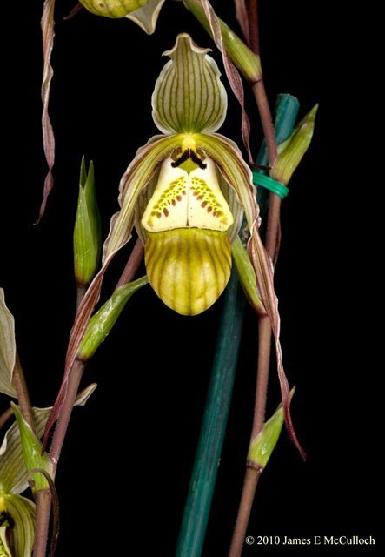
Flower Size 2" [5 cm]

Distribution:
ORIGIN/HABITAT: Ecuador and Peru, at high elevations on the eastern slopes of the Andes. It is usually found growing at water's edge or on cliffs above streams.

PLANT SIZE AND TYPE: A 10-12 in. (25-30 cm) sympodial terrestrial.

PSEUDOBULB: None.

LEAVES: Several per growth. The linear leaves are 9-11 in. (23-28 cm) long. They may be erect or recurved.

INFLORESCENCE: Length is variable. The purplish spikes, up to 4 per new growth, are erect.

FLOWERS: 1 per inflorescence. The blossoms are similar to those of P. longifolium, differing in technical details of flower structure. The strongly twisted petals are slightly contorted, pendent, and somewhat thickened at the apex. The green lip is marked with red spots and darker vertical lines. The sepals are white with greenish veins, pubescent on the edges, and pale pink at the margins.

Botanical Varieties:
Phragmipedium pearcei var. ecuadorense (Garay) C.Cash ex O.Gruss 1994

Synonyms:
Cypripedium caricinum Lindl. & Paxton 1850-1
Cypripedium pearcei Veitch ex J.Dix 1864
Cypripedium pearcei (Rchb. f.) hort. ex J.H. Veitch 1889
Paphiopedilum caricinum (Lindl. & Paxton) Pfitzer 1895
Paphiopedilum ecuadorense (Garay) V.A.Albert & Börge Pett. 1994
Paphiopedilum pearcei (Rchb.f.) V.A.Albert & Börge Pett. 1994
Phragmipedium caricinum (Lindl. & Paxton) Rolfe 1896
Phragmipedium ecuadorense Garay 1978
Phragmipedium pearcei var. ecuadorense (Garay) C.Cash ex O.Gruss 1994
Phragmopedilum caricinum Rolfe ex Pfitzer 1903
Selenipedium longifolium Rchb.f 1854
Selenipedium caricinum (Lindl. & Paxton) Rchb. f. 1854
Barbara McNamee Page 1 of 2 3/9/2019

AOS Awards:
AM | HCC | CCE | CCM | CBM | CHM |  | CBR | Total
4 | 12 | 1 | 7 | 1 | 1 |  | 1 | 27

Hybrids: Total of 122 registered, to the 4th generation

Phrag. Green Hornet (P. longifolium x P. pearcii) 50% each, only 1 award, HCC of 79 pts., used 17 times in hybridizing, Phrag. Red Flare (P. longifolium x P. Memoria Dick Clements) is the only awarded offspring with 3 AM’s.
Phrag. Taras (P. pearcii x P. boissierianum) 50% each, no awards, used 15 times in hybridizing, registered in 2003.
Phrag. Carol Kanzer (P. pearcii x P. schlimii) 50% each, 6 awards; 1 AM, 4 HCC’s and 1 CCM, used 8 times in hybridizing, highest award was P. Carol Kanzer ‘Michael’ CCM with 85 points, 24 flowers, 22 buds on 16 inflorescences in 2003, most recent award was in 2017 Phrag. Carol Kanzer ‘Beepaw’ HCC 77 points, 11 flowers, 7 buds on 10 inflorescences.
Phrag. Euca-Bess (P. ecuadorense x P. besseae) 50% each, 8 awards; 3 AM’s, 4 HCC’s, 1 AD, hybridized 5 times, no awards.
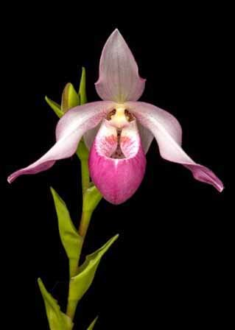
Phrag. Cape Gold Nugget (P. pearcii x P. Eric Young) 50% each, 2 awards, CCM and AM, used 5 times, none have any offspring, one has 3 awards, an AM and 2 HCC Phrag. Haroldeen Quintal (P. Cape Gold Nugget x P. schlimii).

References:
OrchidWiz Database X5.1 P. Carol Kanzer ‘Beepaw” HCC
Orchidspecies.com
Wikipedia

Barbara McNamee Page 2 of 2 2/9/2019

