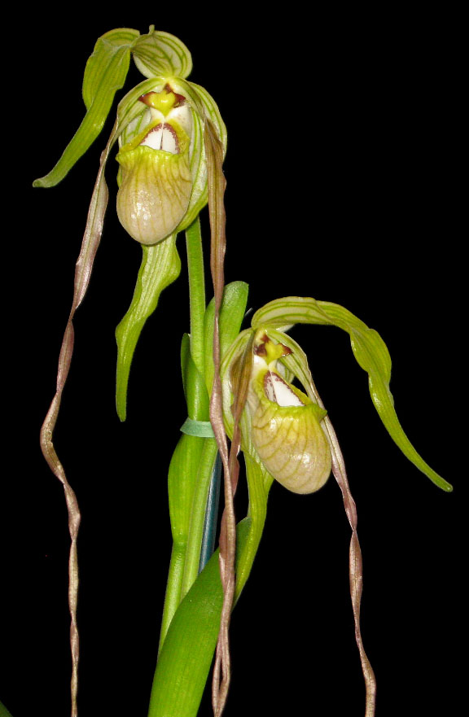
SPECIES DATA SHEET
Phragmipedium wallisii [Rchb.f] Garay 1978
Section: Phragmepedium
Abbreviation: Phrag.
Aka: warscewizianum (var-sheh-VICH-ee-AH-num
Common Name Wallis’ Phragmipedium
Flower Size to 24" in length (61cm)

Distribution:
ORIGIN/HABITAT: Colombia. It grows fully exposed, on granite rocks and cliff faces, at elevations ranging from 4000-7000 ft. (1219-2134 m).

PLANT SIZE AND TYPE: A 14-24 in. (36-61 cm) sympodial lithophyte.

PSEUDOBULB: None.

LEAVES: 10-12 per growth. The leaves are 6-12 in. (15-30 cm) long, distichous, stiff, and yellow-green.

INFLORESCENCE: 14-16 in. (36-40 cm) long. The erect spike emerges from the base of the leaf fan.

FLOWERS: 2-4. The large, showy, velvety blossoms open simultaneously. The pendent petals are greenish, flushed with red-brown near the apex. Continuing to elongate for several days after the flowers open, they may grow to 24 in. (61 cm) in length. The sepals are ivory-white to yellow-green with green to yellowish green veins. The lip is flushed with pale rose at the base of the pouch and yellow-green at the edges.
Botanical Varieties:
Cypripedium caudatum var. wallisii (Rchb. f.) J.H. Veitch 1894
Paphiopedilum caudatum var. wallisii (Rchb. f.) Stein 1892
Phragmipedium caudatum var. wallisii (Rchb. f.) Schltr. 1921
Phragmopedilum caudatum var. wallisii (Rchb. f.) Schltr. 1921
Selenipedium caudatum var. wallisii (Rchb. f.) Rolfe 1895

Barbara McNamee Page 1 of 3 2/9/2019

Synonyms:

Cypripedium caudatum var. wallisii (Rchb. f.) J.H. Veitch 1894
*Cypripedium wallisii Rchb.f. 1873
Cypripedium warscewizianum Rchb.f 1852
Paphiopedilum caudatum var. wallisii (Rchb. f.) Stein 1892
Paphiopedilum wallisii (Rchb. f.) Pfitzer 1894
Paphiopedilum warszewiczianum (Rchb.f.) Pfitzer 1894
Phragmipedium caudatum var. wallisii (Rchb. f.) Schltr. 1921
Phragmipedium wallisii [Rchb.f]Garay 1978
Phragmipedium warscewiczianum [Rchb.f] Schlechter 1922
Phragmopedilum caudatum var. wallisii (Rchb. f.) Schltr. 1921
Phragmopedilum warscewiczianum (Rchb. f.) Schltr. 1922
Selenipedium caudatum var. wallisii (Rchb. f.) Rolfe 1895
Selenipedium wallisii (Rchb.f.) Rchb.f. 1878
Selenipedium wallisii (Rchb.f.) Linden 1887
Selenipedium warszewiczianum Rchb. f. 1866

AOS Awards:
AM | HCC | FCC | CCM | CBM | CHM |  |  | Total
15 | 11 | 4 | 2 |  | 1 |  |  | 33

Hybrids: Total of 65 registered, to the 2nd generation

Phrag. Stairway To Heaven (P. wallisii x P. humboldtii), 50% each, 4 awards: AM, 4 HCC’s, used five times in hybridizing from 2013-2016, no awards, no offspring.

Phrag. Paul Eugene Conroy (P. wallisii x P. longifolium) 50% each, 13 awards: 2 CCM’s, 5 AM’s, 6 HCC’s, hybridized 4 times, no awards, no offspring.

Phrag. Tall Tails (P. caudatum x P. wallisii) 50% each, 15 awards: CCE, CCM, 13 AM’s, hybridized twice, P. Fiddlesticks (P. Tall Tails x P. humboldtii) 3 AM’s, 1 HCC; P. Red Tail Hawk (P. Tall Tails x P. Memoria Dick Clements) 2 AM’s, 1 HCC, neither have offspring

Phrag. Penns Creek Cascade (P. Grande x P. wallisii) 1/3rd wallisii, 18 awards: FCC, 10 AM’s, 6 HCC’s, CCM, long, twisting petals, only one offspring with no awards, registered in 2017. See below.
Phrag. Ruby Cascade (P. Andean Fire x P. wallisii) 1/3rd wallisii, no offspring but has 9 awards: 7 AM’s and 2HCC’s. See below.

Barbara McNamee Page 2 of 3 3/9/2019
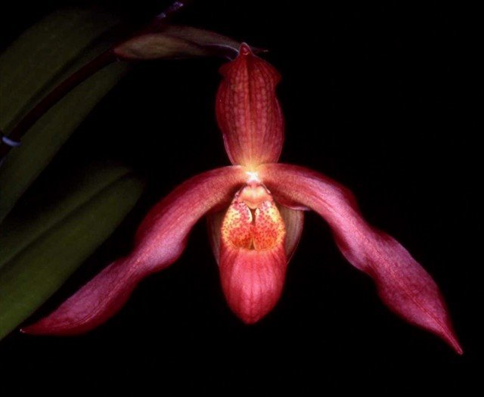
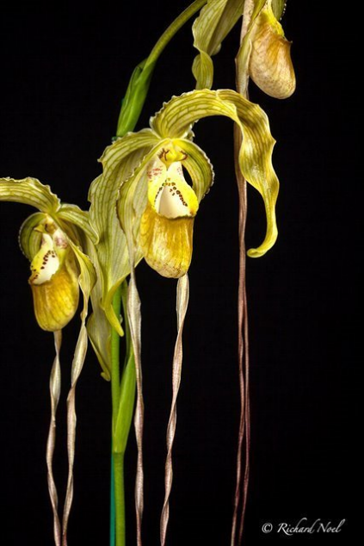

Phrag. Penns Creek Cascade Phrag. Ruby Cascade ‘Judy’s Easter Surprise’ AM/AOS
Drew Rohner’ HCC/AOS

References:
OrchidWiz Database X5.1
Orchidspecies.com

Barbara McNamee Page 3 of 3 3/9/2019

