Selenipedium aequinoctiale Garay, Opera Bot., B 9(225: 1): 13 (1978).
The Equatorial Ocurring Selenipidum
SECTION Cypripedium SUBSECTION Macrantha

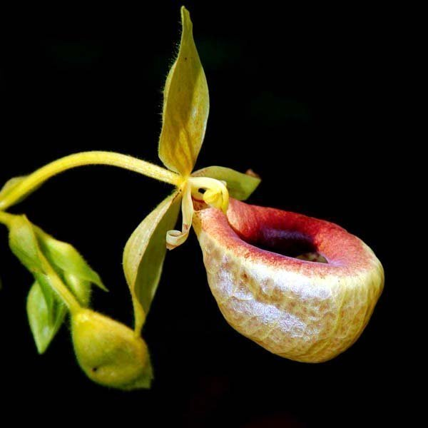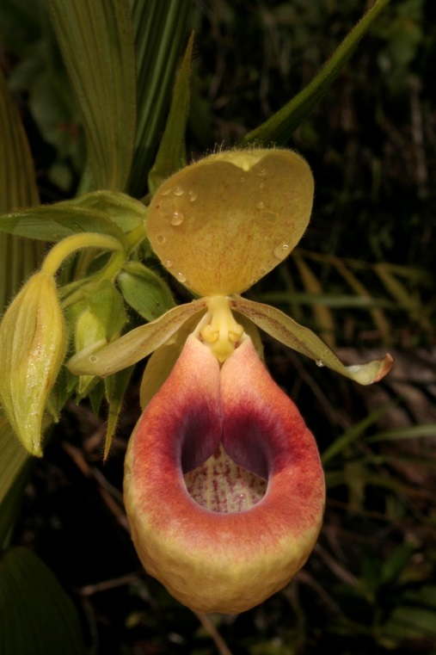
Synonyms
None
Description
A medium to large sized, hot to warm growing terrestrial with suberect to arcuate pendent, branched, elongated, slender cane-like stems carrying alternate, widely spaced, thin, lanceolate to ellipitc lanceolate, chartaceous, puberulent, plicate leaveswith basal sheathing stems and blooms in the spring and summer on a terminal or from axis of upper branches, arcuate, puberulent, short, bracteate, successively several [to 10] flowered inflorescence.³
A terrestrial herb with erect, terete, leafy stems up to 3 m tall, often sparsely branching above; stems dark green, covered by coarsely and densely glandular-villose leaf-bases. Leaves lanceolate to elliptic-lanceolate, acuminate, cuneate at base of lamina, 11–16 cm long, 2–3.5 cm wide, dark green, glabrous above, sparsely pilose beneath, about 8-nerved, sheathing at base; sheaths minutely puberulent. Inflorescence terminal or from

axils of upper branches, up to 20 cm long, densely many-flowered; bracts chartaceous, ovate, acute or subacuminate, 1–2 cm long, 0.6 cm broad, glandular ciliate. Flowers small, produced in succession; sepals and petals light straw yellow, lip yellow, finely spotted with purple within and with two large maroon marks on the basal margin of the rim; pedicel and ovary 5–7 cm long, pubescent. Dorsal sepal elliptic, acute, 2–3 cm long, 1.8 cm broad. Synsepal elliptic-ovate, bidentate at apex, 2–2.5 cm long, 1.6 cm broad. Petals obliquely linear-lanceolate, acute, up to 2.5 cm long, 0.4 cm broad. Lip calceolate, broadly elliptic in outline, up to 3 x 2.5 cm; inflexed basal margins rounded. Column 0.7 cm long; staminode stalked, rhombic, acute, up to 0.5 cm long, longer than the triangular, papillate stigma. Fruits triangular-cylindrical, slightly arcuate, up to 5 cm long, round in cross-section.⁵
Range and Habitat
Found in Ecuador in wet montane forests at elevations of 550 to 1000 meters.³
On steep banks on laterite with ferns, grasses and low shrubs; 690–700m. October–November. SW. Colombia to NW. Ecuador. ⁵

F-1 Hybrids and Progeny
The species has never been successfully hybridized.
Awards
The species has 1 AOS award, a CBR from 2003.
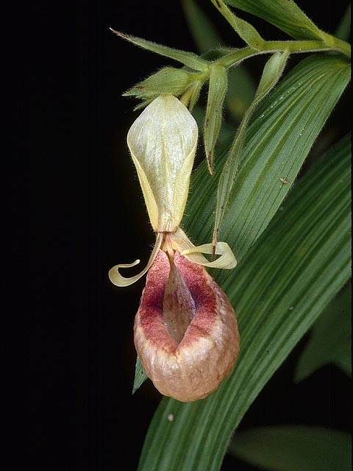
Selenipedium aequinoctiale 'Erich's Adventure' CBR/AOS

Culture
As with Cypripedium, all species of Selenipedium are terrestrial but are tropical, and all may prefer acid soils as none is documented in association with limestone or serpentine. Most attempts at transplantation have failed, suggesting a high reliance on mycorrhizae, but the single S. aequinoctiale has been successfully transplanted (C. H. Dodson, personal communication).⁶
Very little is known about the cultural requirements of this genus, and very few if any plants are currently grown. If one were to obtain material to grow, we suggest that a standard terrestrial mix such as that which has proved successful with either Paphiopedilum or Phragmipedium be attempted. It is probably easier to establish seedlings than divisions of adult jungle plants.⁶
References
Aldridge, Peggy. 2008. An Illustrated Dictionary of Orchid Genera. Selby Botanical Garden Press.
¹la Croix, Isobyl. 2008. The New Encyclopedia of Orchids. Timber Press
²Meisel, Kaufmann, Pupulin 2014. Orchids of Tropical America .Cornel University Press
³Jay Pfahl's IOSPE at www.orchidspecies.com
⁴OrchidWiz.Database X4.1
⁵ http://powo.science.kew.org/taxon/urn:lsid:ipni.org:names:232405-2
⁶Chase MW. 2006. Cypripedioideae. In: Pridgeon AM, Cribb PJ, Chase MW, Rasmussen F, eds. Genera Orchidacearum, Vol. 1. Oxford: Oxford University Press, 105-161.
http://apps.kew.org/wcsp/qsearch.do
https://secure.aos.org/aqplus/SearchAwards.aspx

