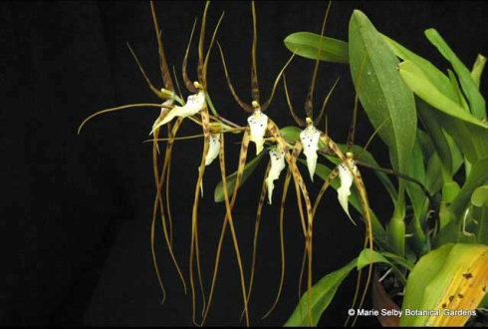
Brassia arcuigera
Seven flowers and one bud on one basally produced inflorescence; sepals and petals heavily spotted brown; lip lanceolate, white with small mahogany spots at base; substance good; texture matte.

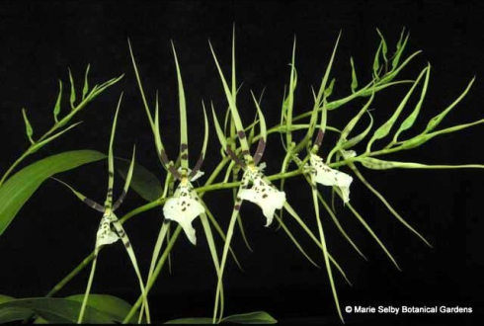
Brassia gireoudiana
Four flowers and twenty three buds on two inflorescences; sepals and petals with chestnut-brown blotches, basal third of lateral petals solid chestnut-brown; lip white with brown spots; substance firm; texture matte.

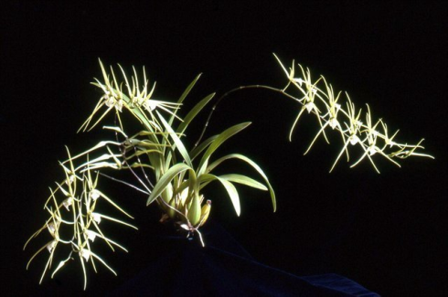
Brassia verrucosa
Twenty eight flowers and three buds on three spreading inflorescences; sepals and petals white with yellow-green spots; lip cream-white, sparsely spotted brown; substance firm; texture crystalline.

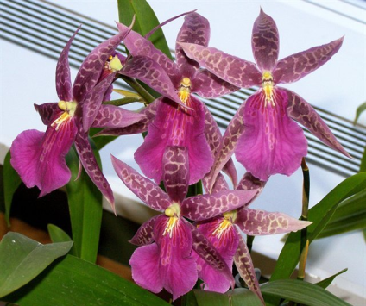
Bratonia Bright Star
Six flowers on two inflorescences; sepals and petals burgundy, blotched darker burgundy; lip dark magenta with a waterfall pattern proximally; column and anther cap yellow-green; substance firm; texture crystalline.

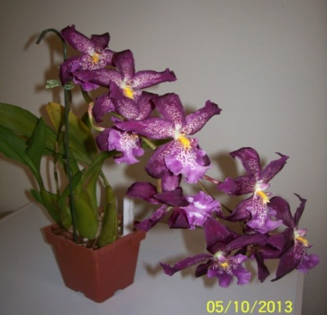
Aliceara Marfitch
Eight flowers on one basally produced inflorescence; sepals and petals garnet, overlaid with light garnet blotches; lip light garnet apically, yellow crest prominent with garnet spots laterally; substance firm; texture matte.

