BUILDING BLOCK DATA
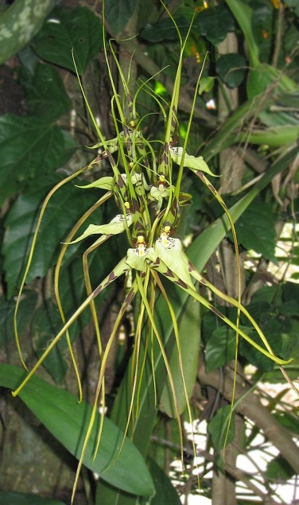
Species Brassia arcuigera
Pronounced: are-KWIH-ger-a

Botanical Varieties (if any):

Synonyms: Brassia longissima, B. gireoudiana
var. longissima

Awards:

Origin | HCC | AM | FCC | CCM | CBR | CHM | Total
 | 6 | 8 | 0 | 3 | 1 | 0 | 18
Years | 1987 -2007 | 1968-2003 |  | 1985-2015 | 1978
Other awards and when given: None

Outstanding clones of species and reason they are considered outstanding:
None

Hybrids:
Before  1940 | 1940-49 | 1950-59 | 1960-69 | 1970-79 | 1980-89 | 1990-99 | After 1999
 |  | 1 | 10 | 4 | 15 | 9 | 9

Outstanding progeny and reason they are considered outstanding:
Brassia Edvah Loo 1966 15 Awards 40 F1 Offspring 93 Progeny
This is a primary hybrid between Brassia arcuigera and B. gireoudiana. It has large flowers, great color and is very floweriferous.
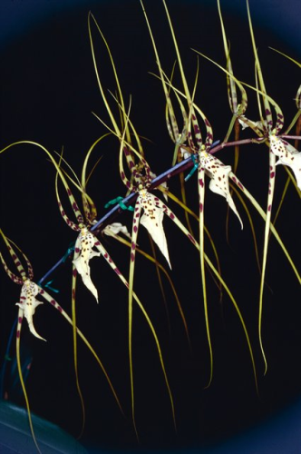

Brassidium Longlen 1966 11 Awards 4 F1 Offspring 6 Progeny
This is a Brassia/Oncidium hybrid that demonstrates good flower size and spacing. It has great patterns and colors.
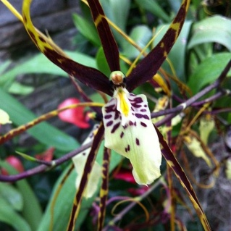

Bratonia Royal Robe 1986 6 Awards 17 F1 Offspring 17 Progeny
This Brassia/Miltonia hybrid has great color and a satiny texture.
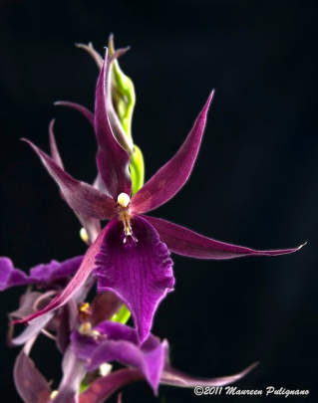

Desirable characteristics which can be passed to progeny:
Flower size and spacing, vigor, inflorescence initiation, color and pattern and heat tolerance.

Undesirable characteristics which can be passed to progeny:
First generation hybrids often pollen sterile, dilution genes affecting color, reduced fertility, star-like flower form and sometimes twisted lip.

Other information:

