BUILDING BLOCK DATA
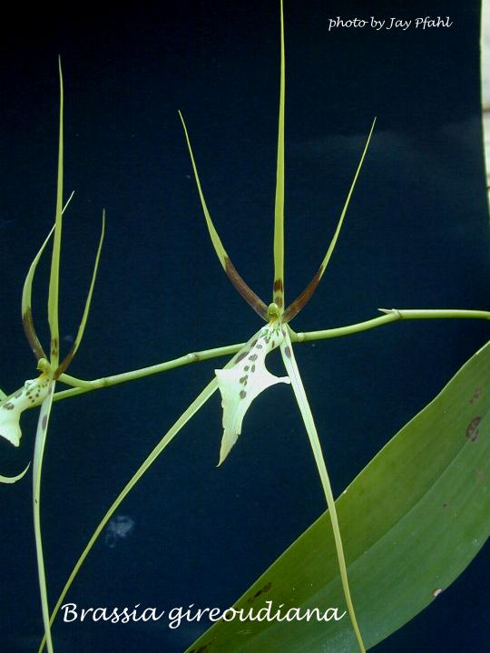
Species Brassia gireoudiana
Pronounced: gee-ree-ood-ee-AH-na

Botanical Varieties : alba, longissima

Synonyms: Brassia verrucosa ssp. gireoudiana

Awards:

Origin | HCC | AM | FCC | CCM | CBR | CHM | Total
 | 4 | 16 | 0 | 3 | 0 | 1 | 18
Years | 1981 -2005 | 1967-2007 |  | 1958-1989 |  | 1996
Other awards and when given: CCE 2007

Outstanding clones of species and reason they are considered outstanding:

F-1 Hybrids:
Before  1940 | 1940-49 | 1950-59 | 1960-69 | 1970-79 | 1980-89 | 1990-99 | After 1999
 |  | 1 | 10 | 3 | 10 | 13 | 5

Progeny:
Before  1940 | 1940-49 | 1950-59 | 1960-69 | 1970-79 | 1980-89 | 1990-99 | After 1999
 |  | 1 | 14 | 17 | 79 | 104 | 123

Outstanding progeny and reason they are considered outstanding:

Brassia Rex 1964 15 Awards 80 F-1 Offspring 182 Progeny
This primary hybrid between two building block species brings together some of the best traits of Brassia.
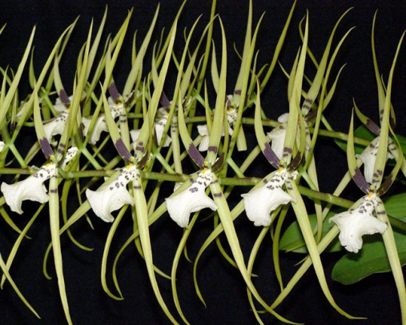

Brassia Edvah Loo 1966 15 Awards 40 F1 Offspring 93 Progeny
This is a primary hybrid between Brassia arcuigera and B. gireoudiana. It has large flowers, great color and is very floweriferous.
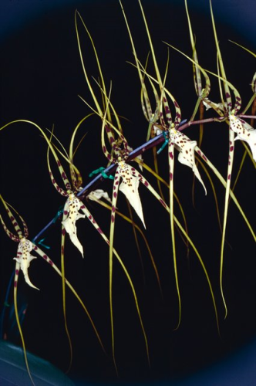

Bratonia Olmec 1975 5 Awards 24 F-1 Offspring 33 Progeny
This hybrid brings cool colors from Miltonia and great size, form and spacing fron Brassia.
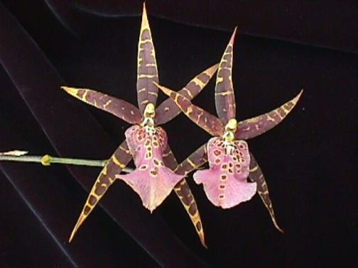

Desirable characteristics which can be passed to progeny:
Flower size and spacing, vigor, inflorescence initiation, color and pattern and heat tolerance.

Undesirable characteristics which can be passed to progeny:
First generation hybrids often pollen sterile, dilution genes affecting color, reduced fertility, star-like flower form and sometimes twisted lip.

Other information:

