BUILDING BLOCK DATA
Species Brassia verrucosa

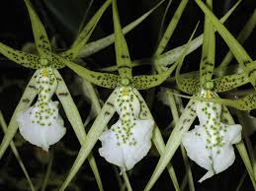
Botanical Varieties : majus, brachiata, gigantean, grandiflora, minor

Synonyms: Brassia brachiata, B. aristata, B. odontoglossoides, B. longiloba, B. coryandra, B. cowanii, Oncidium verrucosum, O. brachiatum

Awards:

Origin | HCC | AM | FCC | CCM | CBR | CHM | Total
 | 3 | 7 | 0 | 8 | 0 | 0 | 18
Years | 1986 -2006 | 1968-1996 |  | 1965-2009
Other awards and when given: 4 ACM (2005 – 2014) 3 ACC (1992) 4 CC (1988 – 2006) 1 JC (1972)

Outstanding clones of species and reason they are considered outstanding:

F-1 Hybrids:
Before  1940 | 1940-49 | 1950-59 | 1960-69 | 1970-79 | 1980-89 | 1990-99 | After 1999
 | 1 | 1 | 12 | 6 | 17 | 19 | 10
Progeny:
Before  1940 | 1940-49 | 1950-59 | 1960-69 | 1970-79 | 1980-89 | 1990-99 | After 1999
 | 1 | 1 | 15 | 41 | 142 | 155 | 251

Outstanding progeny and reason they are considered outstanding:

Brassidium Pagan Lovesong 60 Awards 32 F-1 offspring
This hybrid brings together the high flower count and yellow colorof Oncidium and the larger and longer sepals and petals of Brassia. Also Brassia infertility as there are only 3 additional progeny past the F-1.

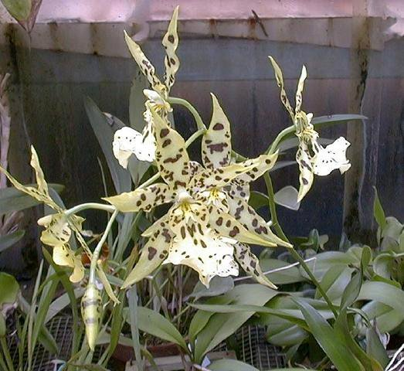

Aliceara Tahoma Glacier 19 Awards 42 F-1 Offspring 72 Progeny
The color of the background and spotting is beautiful, the texture glistening, the flower count and spacing great.
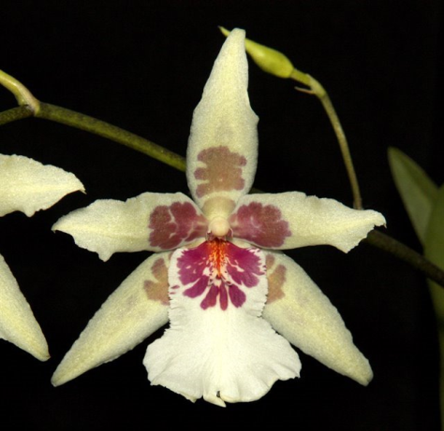

Desirable characteristics which can be passed to progeny:
Flower size and spacing, vigor, inflorescence initiation, color and pattern and heat tolerance.

Undesirable characteristics which can be passed to progeny:
First generation hybrids often pollen sterile, reduced fertility, star-like flower form and sometimes twisted lip. The dilution genes affecting color are apparently stronger in B. verrucosa than the other two building block species.

Other information:
Pronounced: gee-ree-ood-ee-AH-na

