Significant Hybrid Genera Using Brassia
Brassidium (Brsdm)
Brassidium is a orchid hybrid genus using Brassia and Oncidium. OrchidWiz lists 217 registered hybrids using these genera. Because of nomenclatural changes in Oncidium, a number of Brassia grexes have been moved to the genera:
Brassidomesa (Brassia x Gomesa x Oncidium)
Tolassia (Brassia x Tolumnia)
Bramesa (Brassia x Gomesa)
Trichassia (Brassia x Trichocentrum)
Brassiochilum (Brassia x Cyrtochilum)
Psychassia (Brassia x Pyschopsis)
The most significant Brassidium hybrid is Brassidium Longlen with 11 awards and 6 progeny. Two of Longles’s progeny, Brsdm Lillian Oka and Henry Melczer, have 8 and 7 awards respectively. The curse of the Brassia infertility seems to have affected them with only 2 offspring from Henry Melczer.
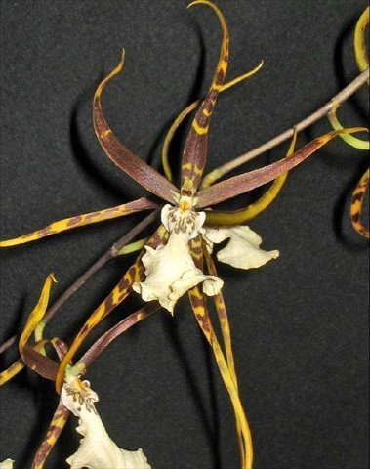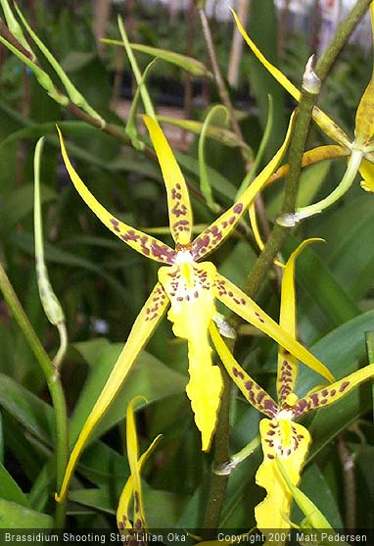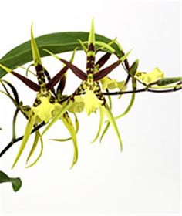
Brassidium Longlen Brsdm Lillian Oka Brsdm Henry Melczer

Bramesa (Bms)
Bramesa is a hybrid genus using Brassia and Gomesa. OrchidWiz lists 31 registered hybrids with a total of 33 awards and 15 progeny. The only significant hybrid in the group is Bramesa Aloha with 10 awards and 5 progeny.
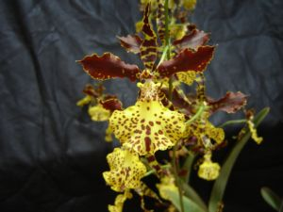
Bramesa Aloha

Bratonia (Brat)
The intergeneric hybrid genus Bratonia results from a cross between Brassia and Miltonia. The genus has 172 registered hybrids. The introduction of Miltonia genes brings colors from the cooler end of the spectrum. The two most significant hybrids in the group are Bratonia Charles M Fitch and Bratonia Aztec. Charles M Fitch has been awarded 14 times and has produced 75 offspring. Bratonia Aztec has 10 awards and 29 offspring.
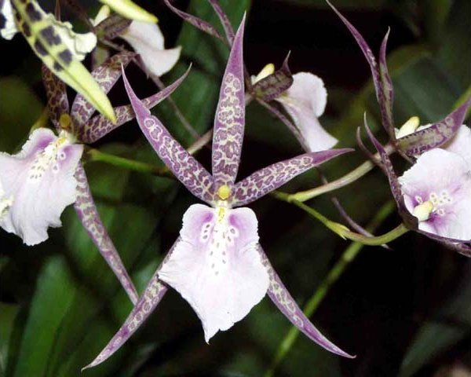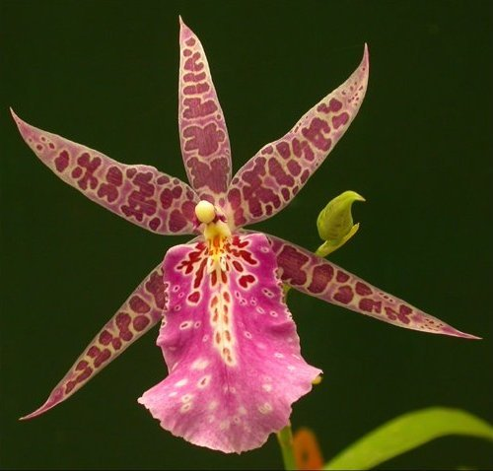
Bratonia Charles M Fitch Bratonia Aztec

Aliceara (Alcra) al-iss-ee-AR-uh
Aliceara orchids are produced by crossing the genera Brassia, Miltonia and Oncidium. They combine cool colors from Miltonia, the open form of Brassia and in some, the shorter and wider sepals and petals on Oncidium. OrchidWiz lists 270 registered grexes. Again, because of the splitters working over Oncidium, Aliceara has lost 20 or so grexes to tongue twisting genera of Gombrassiltonia, Cyrtobrassonia and Vonbismarkara. A lot of the shifts are a result of Oncidium species being moved to the genus Gomesa. Aliceara hybrids have garnered 128 awards and have produced 171 offspring. Three of the most significant offspring are Aliceara Tahoma Glacier, Memoria Teruo Oka and Marfitch. They show off the Oncidium form in Tahoma, the Brassia form in Teruo Oka and the Miltonia pink.
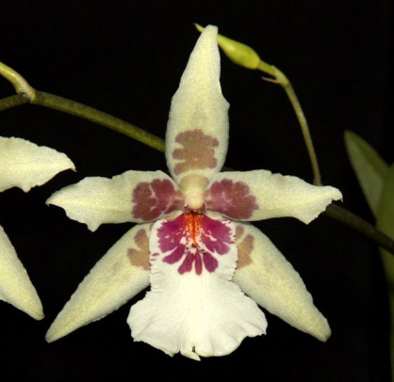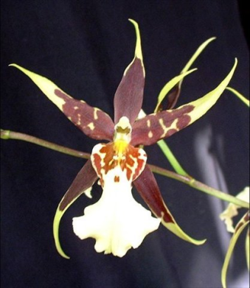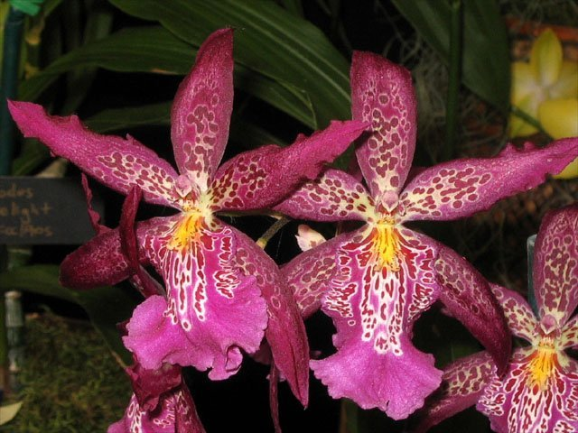
Aliceara Tahoma Glacier Alcra Memoria Teruo Oka Alcra Marfitch

