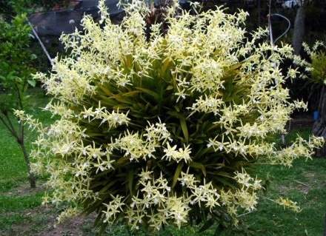
Miltonia flavescens ‘Grand’ CCM
One hundred fifty-seven flowers on forty eight inflorescences on a 107-cm diameter by 70-co high plant in a 38-cm pot; sepals and petals concolor cream; lip white with red-brown stripes; substance light; texture crystalline.

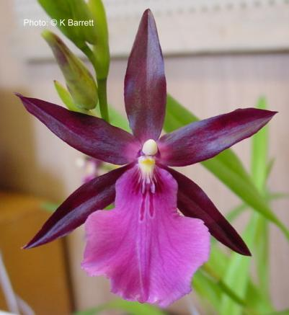
Miltonia Bluntii ‘Prolific’ HCC
Seventeen flowers on five inflorescences; sepals and petals deep burgundy, lip magenta with faint veining, crest of lip has a minimal waterfall pattern, callus yellow, column white, anther cap cream; substance firm; texture waxy.

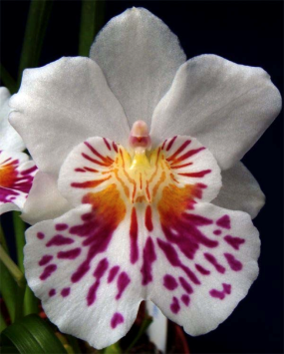
Miltoniopsis phalaenopsis ‘John Leathers’ AM
Ten round, flat flowers and five buds on six inflorescences; petals and sepals white, lip callus yellow, central waterfall pattern fuchsis, the lines breaking into spots distally, anther cap cream; substance firm; texture crystalline.

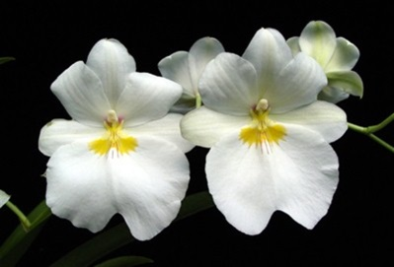
Miltoniopsis Renee Komoda ‘Pacific Clouds’ AM
Eleven white flowers and two buds beautifully shingled on two arched inflorescences; sepals and petals snowy white; light rose lines radiating from a bright yellow mask; substance good; texture matte.

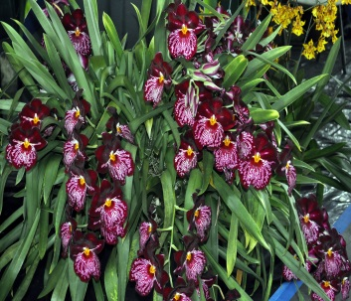
Miltoniopsis Lennart Karl Gottling ‘Hula Skirt’ CCM
Fifty-seven flat, round flowers on 10 inflorescences projecting from seven new growths in a 17-cm container; sepals and petals deep velvety burgundy, lateral sepals repeating the waterfall pattern centrally; lip burgundy, covered by extensive waterfall pattern; column yellow; anther cap white; substance firn; texture matte.

