BUILDING BLOCK DATA
Species Miltonia candida

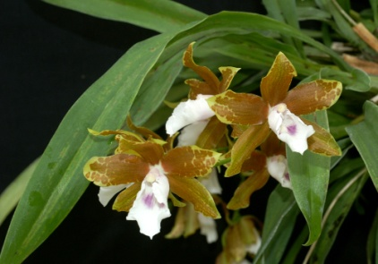
Botanical Varieties : none

Synonyms: Miltonia candida var. grandiflora, flavescens, tenischiana, purpureoviolacea; Anneliesia candida

Awards:

Origin | HCC | AM | FCC | CCM | CBR | CHM | Total
 | 3 | 1 | 0 | 2 | 0 | 0 | 13
Years | 1965 -1995 | 1968 |  | 1967-1968
Other awards and when given: 1 JC (1960), 3 BM (2012), 3 SM (2012)

Outstanding clones of species and reason they are considered outstanding:
none
F-1 Hybrids:
Before  1940 | 1940-49 | 1950-59 | 1960-69 | 1970-79 | 1980-89 | 1990-99 | After 1999
4 | 0 | 1 | 3 | 2 | 0 | 5 | 4
Progeny:
Before  1940 | 1940-49 | 1950-59 | 1960-69 | 1970-79 | 1980-89 | 1990-99 | After 1999
4 | 0 | 1 | 3 | 17 | 59 | 94 | 75
Outstanding progeny and reason they are considered outstanding:

Miltonia Leucoglossa - Nice wide, white lip w/ waterfall; rich color contrast, great form.
Miltonia Minas Gerais – Wide lip with waterfall, rich dark color, good form. 45 F1, 223 total progeny.
Bratonia Aztec – Long rectangular lip with waterfall, great rich colors, inc yellow form, pleasing patterns on tepals, floriferous 10 awards
Bratonia Dark Star – Nice wide lip, great color contrast between lip and tepals, subtle waterfall, 9 awards.

.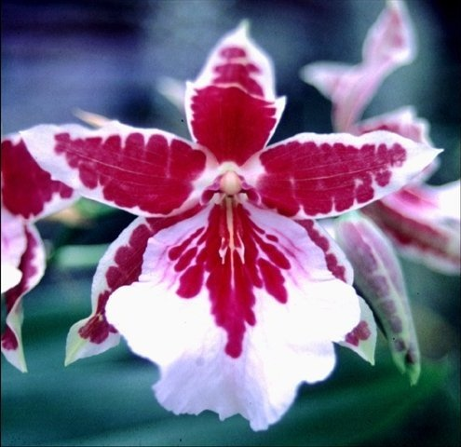 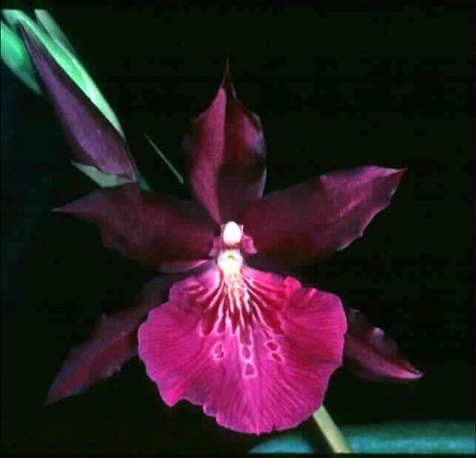
Miltonia Leucoglossa Miltonia Minas Gerais

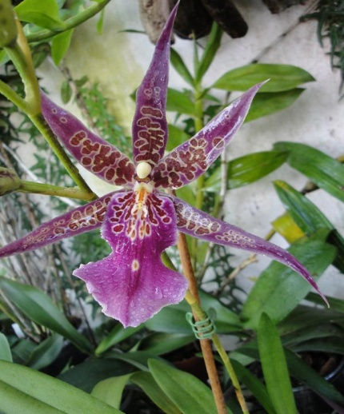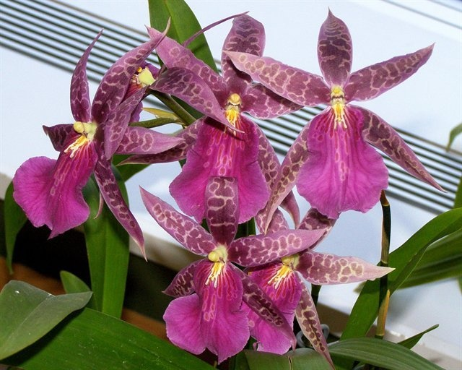
Bratonia Aztec Bratonia Dark Star

Desirable characteristics which can be passed to progeny:
White lip in some crosses, wavy lip margin, patterning on sepals and petals, contrasting color between lip and tepals.

Undesirable characteristics which can be passed to progeny:
Wavy lip margin to some eyes.

Other information:

