BUILDING BLOCK DATA
Species Miltonia clowesii

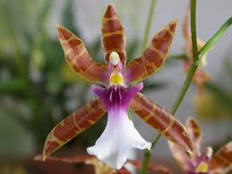
Botanical Varieties : Miltonia clowesii var lamarcheana; forma aquinii

Synonyms: Brassia clowesii, Oncidium clowesii, Odontoglossum clowesii

Awards:

Origin | HCC | AM | FCC | CCM | CBR | CHM | Total
 | 1 | 3 | 0 | 7 | 0 | 1 | 18
Years | 1999 | 1994-2010 |  | 1967-2010 |  | 1985
Other awards and when given: 1 AD 2002, 1 JC 2007, 1 AV3 2010

Outstanding clones of species and reason they are considered outstanding:

F-1 Hybrids:
Before  1940 | 1940-49 | 1950-59 | 1960-69 | 1970-79 | 1980-89 | 1990-99 | After 1999
3 | 0 | 1 | 1 | 1 | 6 | 12 | 12

Progeny:
Before  1940 | 1940-49 | 1950-59 | 1960-69 | 1970-79 | 1980-89 | 1990-99 | After 1999
3 | 1 | 4 | 37 | 55 | 169 | 227 | 219

Outstanding progeny and reason they are considered outstanding:
Aliceara Tahoma Glacier 19 Awards 42 F-1 72 Total Progeny
The color of the background and spotting is beautiful, the texture glistening, the flower count and spacing great.

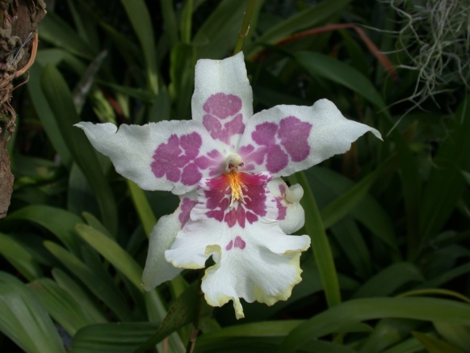
Aliceara Tahoma Glacier

Miltonia Anne Warne 11 Awards 47 F-1 352 Total Progeny
The color contrast between the lip and tepals, very wide lip, great color.

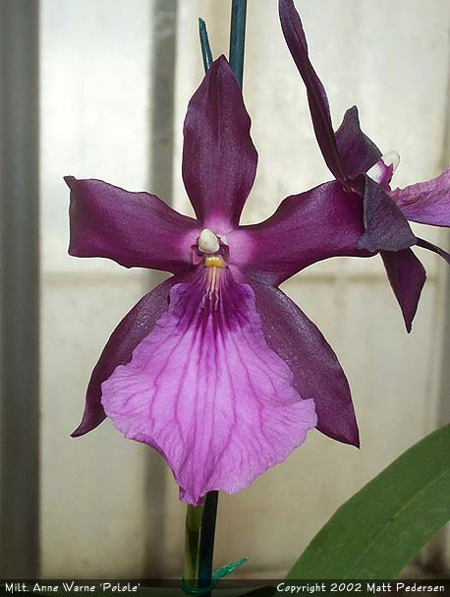
Miltonia Anne Warne
Miltonia Bluntii 11 Awards 35 F-1 625 Total Progeny
Color contrasts similar to Anne Warne. Great form and colors. Very floriferous as attested by 6 CCM’s.

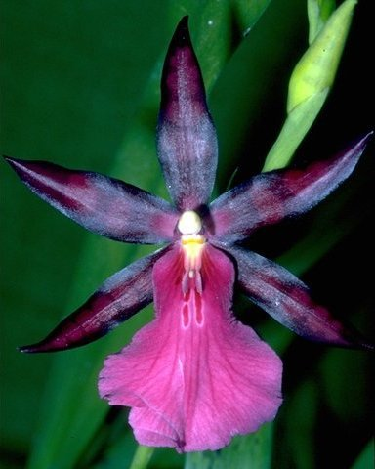
Miltonia Blunti

Desirable characteristics which can be passed to progeny:
Waterfall pattern on lip, pleasing patterns on sepals and petals, white lip in some progeny.

Undesirable characteristics which can be passed to progeny:
Spatulate lip

Other information:
Pronounced: klo-WES-ee-eye

