BUILDING BLOCK DATA
Species Miltonia flavescens
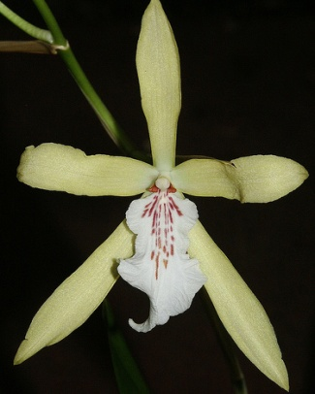

Botanical Varieties :

Synonyms: Oncidium flavescens, Cryptochilum flavescens

Awards:

Origin | HCC | AM | FCC | CCM | CCE | CCA | Total
 | 0 | 0 | 0 | 5 | 2 | 1 | 18
Years |  |  |  | 1980-2006 | 2001 - 2010 | 1976
Other awards and when given:

Outstanding clones of species and reason they are considered outstanding:

F-1 Hybrids:
Before  1940 | 1940-49 | 1950-59 | 1960-69 | 1970-79 | 1980-89 | 1990-99 | After 1999
 | 1 | 1 | 12 | 6 | 17 | 19 | 10
Progeny:
Before  1940 | 1940-49 | 1950-59 | 1960-69 | 1970-79 | 1980-89 | 1990-99 | After 1999
 |  | 7 | 41 | 24 | 50 | 87 | 81

Outstanding progeny and reason they are considered outstanding:

Miltonia Goodale Moir 9 Awards 28 F-1 155 Total Progeny
Seems to have gotten most of its form and color characteristics from its Miltonia clowesii parent but was helped by the high flower count and number of inflorescences of M. flavescens.

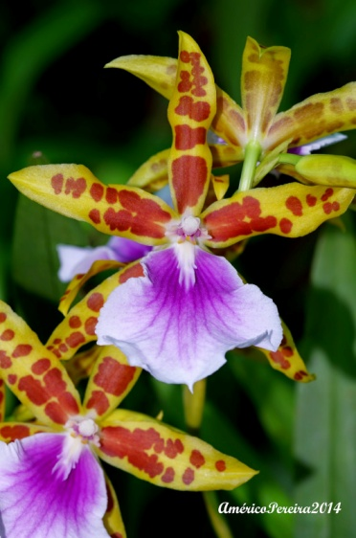
Miltonia Goodale Moir

Miltonia Honolulu 6 Awards 28 F-1 39 Total Offspring
The beautiful color appears to come from a double dose of Miltonia spectabilis in its ancestery. I am assuming again that M. flavescens contributes floriferousness.

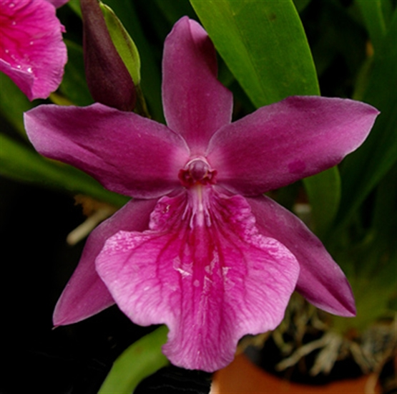
Miltonia Honolulu

Desirable characteristics which can be passed to progeny:
The flowers are nothing to write home to. The awards are mostly cultural with high flower counts. My guess id that this is an inheritable trait.

Undesirable characteristics which can be passed to progeny:
Weak color, very open form.

Other information:
Pronounced:

