BUILDING BLOCK DATA
Species Miltonia spectabilis

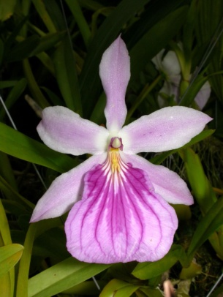
Botanical Varieties : Miltonia spectabilis var. liniata, aspersa, virginalis, rosea, porphyroglossa, radians

Synonyms: Oncidium spectabile, Miltonia bicolor

Awards:

Origin | HCC | AM | FCC | CCM | CBE | CBM | Total
 | 7 | 6 | 0 | 7 | 1 | 1 | 18
Years | 1976 -1996 | 1981-2009 |  | 1971-2001 | 1962 | 1965
Other awards and when given: 2 ACC (‘98), 1 AQ (’91), 3 CCE (2001-05), 2 CCA (’61, ’79), 1 NOM, 1 JC, 1 GM, 2 SM,2 BM

Outstanding clones of species and reason they are considered outstanding:

F-1 Hybrids:
Before  1940 | 1940-49 | 1950-59 | 1960-69 | 1970-79 | 1980-89 | 1990-99 | After 1999
3 | 1 | 6 | 19 | 11 | 15 | 17 | 17

Progeny:
Before  1940 | 1940-49 | 1950-59 | 1960-69 | 1970-79 | 1980-89 | 1990-99 | After 1999
3 | 1 | 10 | 80 | 95 | 222 | 269 | 301

Outstanding progeny and reason they are considered outstanding:

Miltonia Anne Warne 11 Awards 47 F-1 352 Total Progeny
The color contrast between the lip and tepals, very wide lip, great color. Can see the influence of M. spectabilis in the lip.

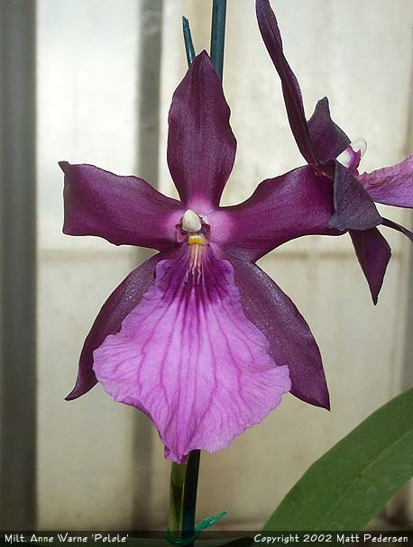

Bratonia Charles M Fitch 14 Awards 45 F-1 75 Total Progeny
This hybrid gets most of its characteristics from its Brassia parent, but the strong color M. spectabilis breeds true.

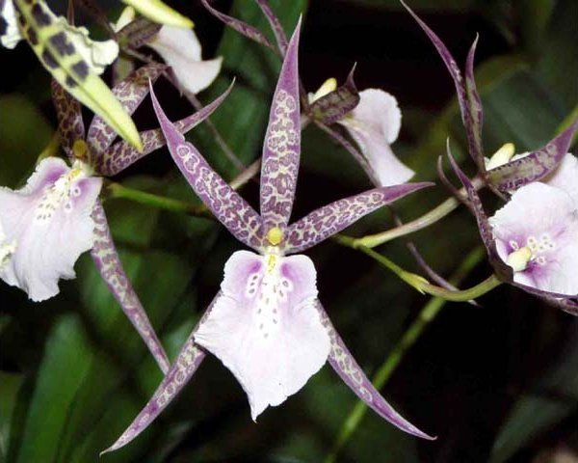
Aliceara Tahoma Glacier 19 Awards 42 F-1 Offspring 72 Progeny
The color of the background and spotting is beautiful, the texture glistening, the flower count and spacing great.
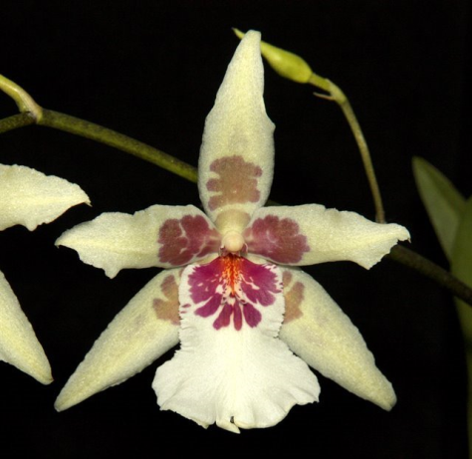

Desirable characteristics which can be passed to progeny:
Wide flat lip with great waterfall pattern, great plum, pink colors.

Undesirable characteristics which can be passed to progeny:

Other information:
Pronounced:

