BUILDING BLOCK DATA
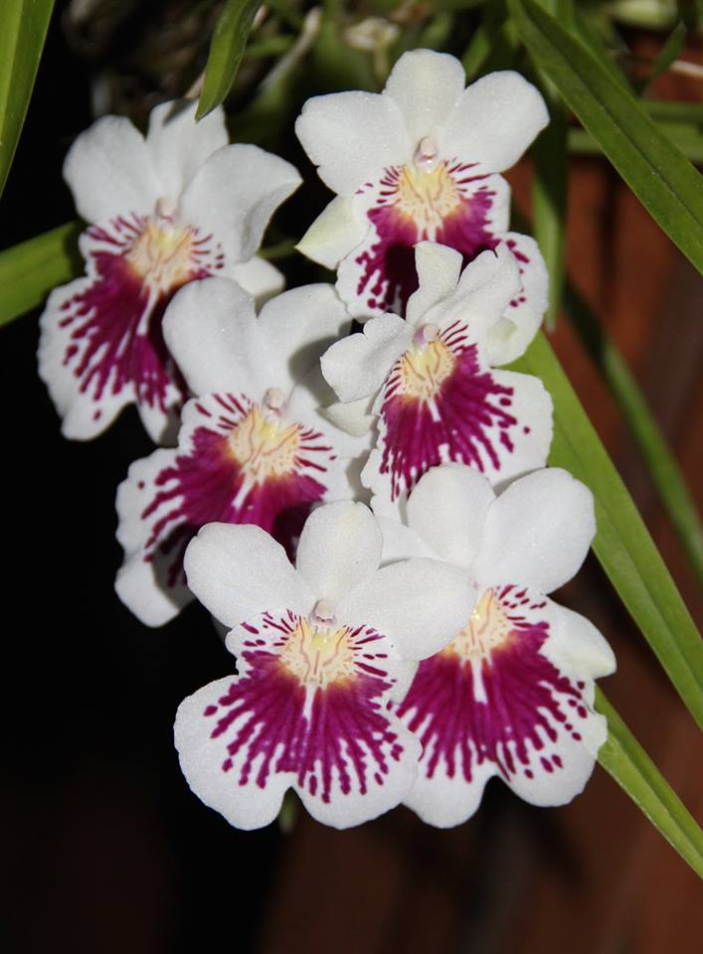
Species Miltoniopsis phalaenopsis

Botanical Varieties (if any):

Synonyms: Miltonia phalaenopsis, Miltonia pulchella, Odontoglossum phalaenopsis

Awards:

Origin | HCC | AM | FCC | CCM | CCE | CHM | Total
 | 4 | 7 | 0 | 6 | 1 | 1
Years | 1983-2011 | 1978-2012 |  | 1976-1993 | 2008 | 2014
Other awards and when given: 4 AWD (2001-2013), 1 BN (2012)

Outstanding clones of species and reason they are considered outstanding:

F-1 Hybrids:
Before  1940 | 1940-49 | 1950-59 | 1960-69 | 1970-79 | 1980-89 | 1990-99 | After 1999
7 | 0 | 0 | 0 | 1 | 4 | 8 | 7
Total Progeny:
Before  1940 | 1940-49 | 1950-59 | 1960-69 | 1970-79 | 1980-89 | 1990-99 | After 1999
174 | 48 | 38 | 100 | 94 | 277 | 434 | 622

Outstanding progeny and reason they are considered outstanding:

Miltoniopsis Jean Carlson 16 Awards 15 Offspring
Great color, very wide lip, nice waterfall.

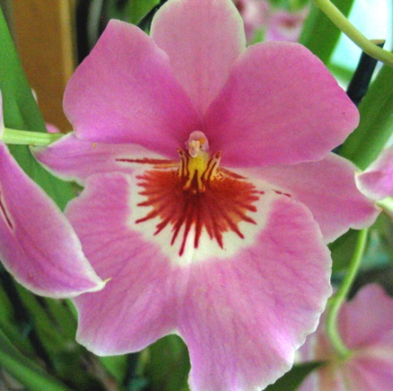
Miltoniopsis Jean Carlson

Miltoniopsis Bert Field 19 Awards
Incredible brilliant color, very pleasing waterfall patterns, wide and flat lip, great form and texture.
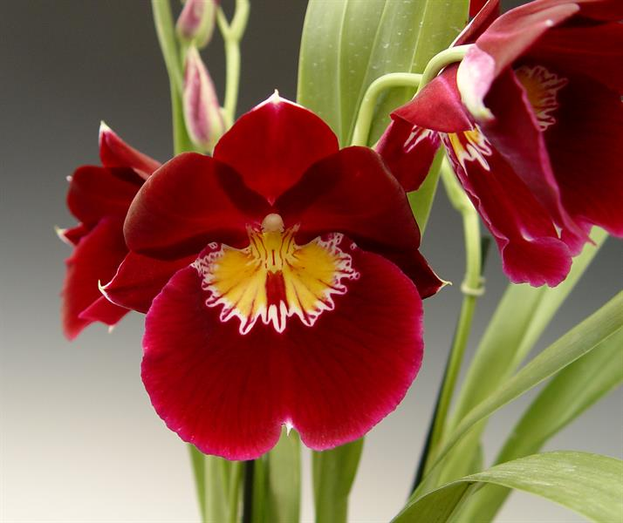
Miltoniopsis Bert Field

Miltoniopsis Hajime Ono 17 Awards 23 Offspring 36 Total Progeny
Again, brilliant color, extensive waterfall from M. Phalaenopsis, very round form.

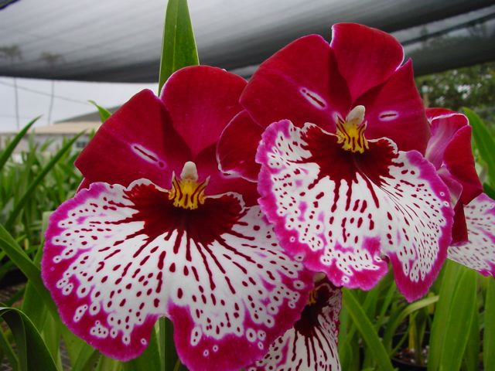
Miltoniopsis Hajime Ono

Desirable characteristics which can be passed to progeny:
Rounded Phalaenopsis shape, large waterfall nearly covering lip,

Undesirable characteristics which can be passed to progeny:

Other information:

