BUILDING BLOCK DATA
Species Miltoniopsis roezlii

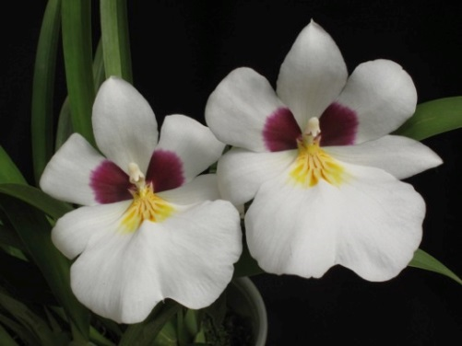
Botanical Varieties (if any):

Synonyms: Miltonia roezlii, M. santanae,

Awards:

Origin | HCC | AM | FCC | CCE | CCM | CHM | Total
 | 8 | 4 | 0 | 1 | 1 | 3
Years | 1977-2014 | 1978-1997 |  | 2005 | 1980 | 1986-2008
Other awards and when given: 1 JC (1963), 1 CCA (1950), 3 AWD (2001-2014)

Outstanding clones of species and reason they are considered outstanding:

F-1 Hybrids:
Before  1940 | 1940-49 | 1950-59 | 1960-69 | 1970-79 | 1980-89 | 1990-99 | After 1999
18 | 0 | 0 | 4 | 7 | 0 | 25 | 31

Total Progeny:
Before  1940 | 1940-49 | 1950-59 | 1960-69 | 1970-79 | 1980-89 | 1990-99 | After 1999
528 | 122 | 67 | 125 | 116 | 321 | 468 | 674

Outstanding progeny and reason they are considered outstanding:

Miltoniopsis Jean Carlson 16 Awards 15 Offspring
Great color, very wide lip, nice waterfall.

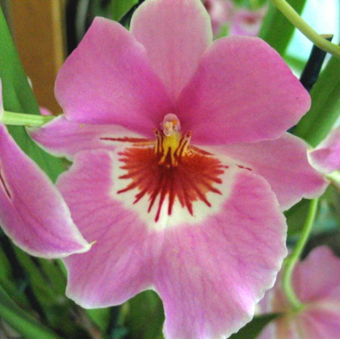
Miltoniopsis Jean Carlson

Miltoniopsis Bert Field 19 Awards
Incredible brilliant color, very pleasing waterfall patterns, wide and flat lip, great form and texture.

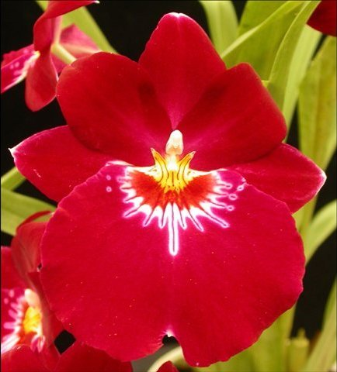
Miltoniopsis Bert Field

Miltoniopsis Hajime Ono 17 Awards 23 Offspring 36 Total Progeny
Again, brilliant color, extensive waterfall from M. Phalaenopsis, very round form.

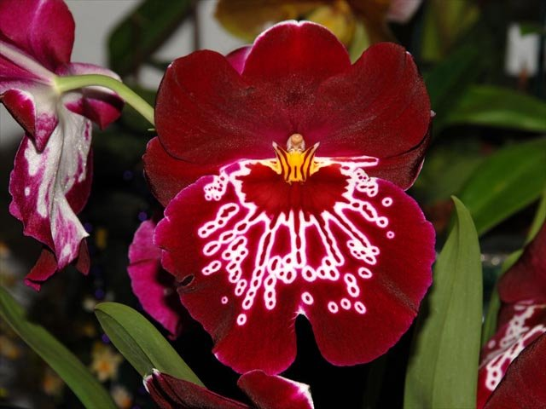
Miltoniopsis Hajime Ono

Desirable characteristics which can be passed to progeny:
White color in some offspring, deep purple-maroon on lateral sepals and petals

Undesirable characteristics which can be passed to progeny:

Other information: Pronounced: (ROHZ-lee-eye)

