BUILDING BLOCK DATA
Species Miltoniopsis vexillaria

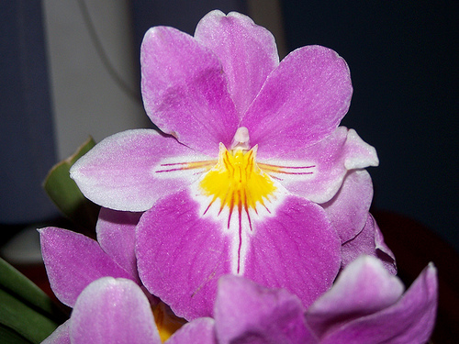
Botanical Varieties (if any):

Synonyms: Miltonia vexillaria, M. vexillaria
var. stupenda, rubella, lropoldii

Awards:

Origin | HCC | AM | FCC | CCE | CCM | CHM | Total
 | 6 | 21 | 1 | 4 | 3 | 2
Years | 1988-2012 | 1959-2011 | 2009 | 2012-2013 | 1961-2012 | 1980-1997
Other awards and when given: 3 JC (1992-2004), 12 AWD (1999-2009)

Outstanding clones of species and reason they are considered outstanding:

Hybrids:
Before  1940 | 1940-49 | 1950-59 | 1960-69 | 1970-79 | 1980-89 | 1990-99 | After 1999
1250 | 133 | 70 | 125 | 126 | 347 | 482 | 709

Outstanding progeny and reason they are considered outstanding:

Miltoniopsis Bert Field 19 Awards
Incredible brilliant color, very pleasing waterfall patterns, wide and flat lip, great form and texture.

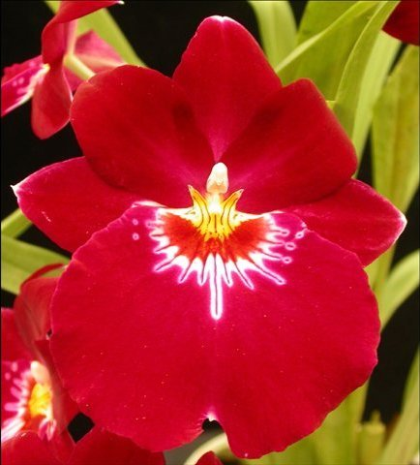
Miltoniopsis Bert Field

Miltoniopsis Hajime Ono 17 Awards 23 Offspring 36 Total Progeny
Again, brilliant color, extensive waterfall from M. Phalaenopsis, very round form.

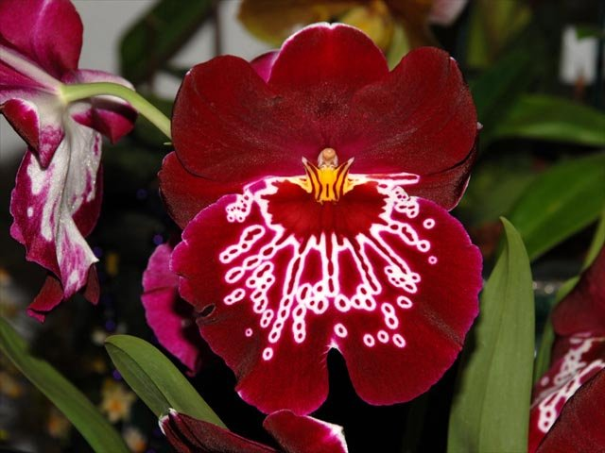
Miltoniopsis Hajime Ono

Miltoniopsis Venus 12 Awards 19 Offspring
A very early hybrid that presents the light pink and yellow throat of vexillaria. Still around and awarded as recently as 2011.

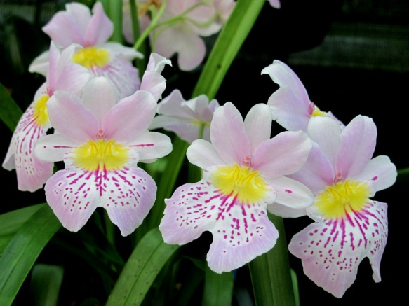
Miltoniopsis Venus

Desirable characteristics which can be passed to progeny:
Very wide and flat lip, very floriferous, yellow throat.

Undesirable characteristics which can be passed to progeny:

Other information:
Pronounced: vex-sil-LAY-ree-ah

