Miltonia is a genus of orchids inhabiting the Atlantic Forest of Brazil, northeast to Argentina and east to Paraguay. The type species, Miltonia spectabilis, was named by John Lindley in 1837. The other species of Miltonia, originally classifies under the genera Cyrtochilum, Oncidium and Odontoglossum, were all described between 1834 and 1850. One species M. kayasimae, was described in 1976. The genus is named in honor of Viscount Milton who was an orchid enthusiast.
These epiphytic orchids have 2 leaves, with a basal foliaceous sheath, arising from the pseudobulbs. This characteristic differentiates Miltonia from Miltoniopsis. The pseudobulbs are ovoid to oblong, somewhat compressed arising from a set of creeping rhizomes. They are subtended by sheaths, arranged in two ranks vertically. The sheaths are sometimes leafy.
The erect or arching inflorescences are axillary, unbranched with one to many flowers. One or two inflorescences arise from the base of the pseudobulb. The flowers are showy with a large, flat lip that lacks a callus at the base. The unlobed lip is often fan or fiddle shaped. The flower has a footless column with two hard pollinia. The flowers, one to twelve per inflorescence, open at the same time or in succession. Late spring to late summer is flowering time. The flowers have a delicate scent, often compared with roses.
Miltonia leaves are narrow (3cm) and long (40cm) with apexes usually rounded.
There are fourteen species of Miltonia and eight natural hybrids. This is an unusual number of hybrids suggesting a common pollinator among a number of species. The natural hybridization has produced a highly complex taxonomic mess. Some of the hybrids have three and four synonyms.

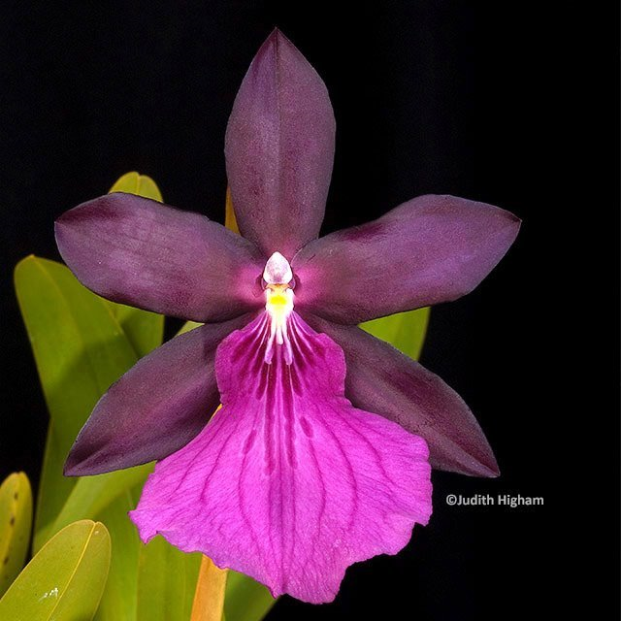
Miltonia Anne Warne

