Significant Hybrid Genera Using Miltonia
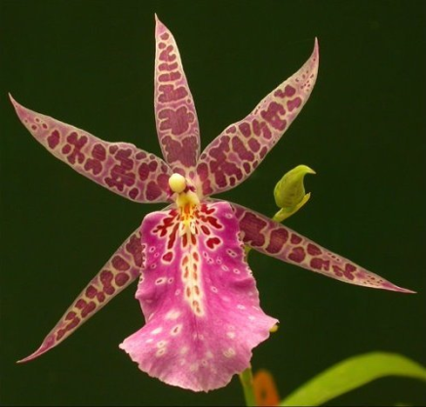
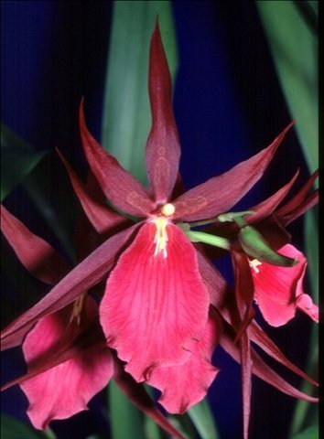
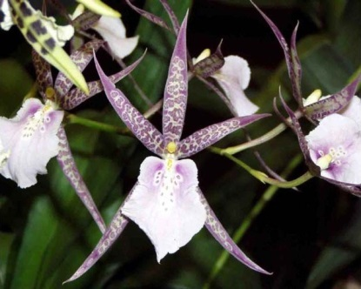
There are two important hybrid genera of Miltonia and a dozen or so of minor significance. The first is a genus resulting from a cross between Miltonia and Brassia. Originally known as Miltassia, the name was changed to Bratonia. Brassia genes are responsible for the large, open star shape of most Bratonias. Miltonia genes, particularly Miltonia spectabilis, give the crosses a wide range of colors. A less desirable inheritance from Miltonia is a low flower count and in some crosses, like Charles M Fitch, a clumping of flowers on the stem. Some problems with first generation Bratonias is a twisting of the Bratonia Charles M. Fitch lip and colors that fade with age. These problems are usually remedied by crossing back to Miltonia or Brassia in the second generation. In addition to Bratonia Aztec Bratonia Royal Robe improving color face and twisting, the second generation crosses have heavier substance, broader segments and stronger stems.
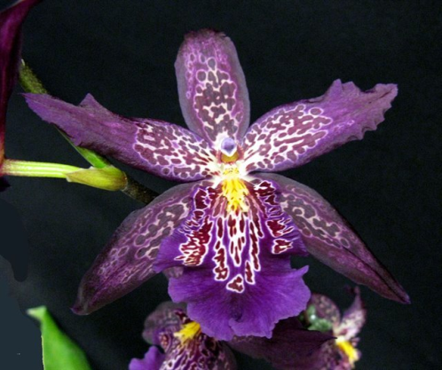
Miltonia crossed with Oncidium and Brassia produces the tri-generic Aliceara. The complexity of a tri-generic hybrid, with an 18-fold pathway of combinations, results in huge potential for successful crosses. Since 1964, 269 grexes of Aliceara have been registered.
Again, the influence of Miltonia can be seen in the rich, cool colors not commonly found in Brassia or Oncidium. The open “spidery” form of Brassia is moderated by the Miltonia genes which also tend to fight the long and nicely spaced inflorescences of Brassia.
Aliceara Marfitch ‘Howard’s Dream’

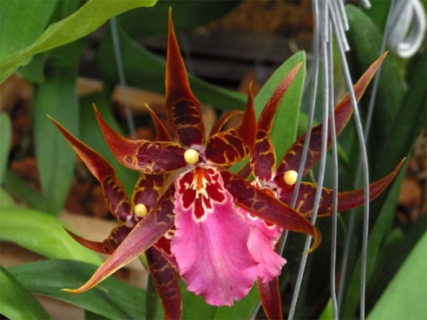
Aliceara Sunday Best crosses Miltonia spectabilis with Brassidium Gilded Urchin (Brassia arcuigera x Oncidium wentworthianum). Dozens of other Oncidium species have been used or are available to create new lines in this versatile genus.

Aliceara Sunday Best

